Removal of Chromium (VI) from Synthetic Wastewater Using Industrial Marble Waste
Segenet Shiferaw¹, Nigus Gabbiye¹, Agegnehu Alemu^{2,3*}
¹Faculty of Chemical and Food Engineering, Bahir Dar Institute of Technology, Bahir Dar University, P.O Box 26, Bahir Dar, Ethiopia
²Bahir Dar University, College of Science, Department of Chemistry, P.O Box 79, Bahir Dar, Ethiopia
³Blue Nile Water Institute, Bahir Dar University, P.O Box 79, Bahir Dar, Ethiopia
*Corresponding author: agegn-bdu@yahoo.com; Mobile phone: +251918703142

Abstract
Chromium (VI) is among the most toxic and persistent pollutants in the environment. Due to its severe ecological and health impacts, extensive efforts have been devoted to identifying low-cost and eco-friendly adsorbents for its removal from wastewater. In this study, waste powdered marble chips were utilized as an adsorbent for the removal of chromium (VI) from aqueous solutions. The adsorbent was characterized using Fourier Transform Infrared Spectroscopy (FT-IR) and Powder X-ray Diffraction (XRD).Batch adsorption experiments were conducted to evaluate the efficiency of powdered marble waste in removing chromium (VI) ions. The experimental results indicated a maximum removal efficiency of 98.15% and an adsorption capacity (qₑ) of 33.6 mg/g under optimal conditions: pH 6, adsorbent dose 40 g/L, contact time 12 hours, initial concentration 20 mg/L, and temperature 55°C. The adsorption data were found to fit well with the Langmuir isotherm model. Overall, the findings demonstrate that powdered marble waste is an efficient, economical, and environmentally friendly adsorbent for the removal of chromium (VI) from aqueous solutions. Further research is recommended using actual tannery wastewater to validate its performance under real-world conditions.
Keywords: Cr (VI), Marble waste chips, Adsorption, Adsorption isotherm
1. Introduction
The discharge of industrial effluents containing heavy metals poses a serious risk to aquatic ecosystems. These inorganic pollutants are particularly concerning because they are non-biodegradable, highly mobile, and extremely toxic. Heavy metals can bioaccumulate in living organisms, including humans, leading to long-term health problems (Pan et al., 2006). Therefore, removing such contaminants from wastewater has become a critical environmental challenge.
Among these metals, chromium stands out as one of the most hazardous due to its extensive industrial applications and severe toxicity. Tannery wastewater is a primary source of chromium pollution, often causing discoloration and degradation of water bodies. In the chrome tanning process, nearly 40% of chromium salts remain unused and are released into the environment, resulting in considerable ecological and health hazards (Chowdhury et al., 2013). Chromium typically exists in two oxidation states: trivalent Cr (III) and hexavalent Cr (VI) ions, which vary significantly in chemical behavior and toxicity. While Cr (III) serves as an essential micronutrient at trace levels, Cr (VI) is extremely toxic, mutagenic, and carcinogenic (Sumathi et al., 2005; Suwalsky et al., 2008). The World Health Organization (WHO) sets the permissible chromium concentration at 0.1 mg/L for surface waters and 0.05 mg/L for drinking water (WHO, 2011). Exceeding these limits can cause liver damage, respiratory problems, and skin irritation (Pokhrel & Pokhre, 2022).
Several treatment methods including chemical precipitation, coagulation, electrocoagulation, ion exchange, reduction, membrane filtration, and adsorption have been applied for the removal of chromium from wastewater (Owlad, 2008). While these methods are generally effective, they often involve high operational costs, complex procedures, and the generation of secondary waste. Among them, adsorption has emerged as a preferred approach due to its simplicity, efficiency, and cost-effectiveness, particularly for treating wastewater containing low metal ion concentrations (Alemu et al., 2018). Nevertheless, the expensive nature of commercial adsorbents restricts their large-scale application, prompting increased interest in developing low-cost adsorbents from natural and waste materials (Yu et al., 2000, Alemu et al., 2018). Agricultural wastes, industrial residues, and biosorbents have demonstrated significant potential as sustainable and economical alternatives (Alemu et al., 2019).
In developing countries like Ethiopia, untreated tannery effluents are frequently discharged into water bodies, causing significant chromium contamination. Studies indicated that abundant agricultural and industrial wastes are showing high treatment potential of chromium from wastewater. A study has demonstrated that marble waste can effectively adsorb different heavy metals from aqueous solutions (Ghazy et al., 2003, Wazwaz et al., 2019). Therefore, investigating the use of locally available marble waste from industrial processing in Bahir Dar City for Cr (VI) adsorption offers both economic and environmental benefits. This study aims to optimize critical parameters including adsorbent dose, contact time, pH, temperature, and initial chromium concentration and to analyze adsorption isotherms to improve chromium removal efficiency.

2. Materials and Methods
2.1 Materials and Reagents
Sodium hydroxide pellet, 98 % purity (SDFCL, India) and hydrochloric acid, 37% for pH adjustments. Potassium dichromate K₂Cr₂O₇ (99.5%, India), was used as a model compound to stimulate the industrial waste. Buffer solutions (pH=4, pH=6.9, pH=10) to calibrate pH meter. Deionized water used for sample preparation, and also for dilution of the reagents and rinsing purposes. Marble chips waste from the marble processing industry was collected. The sources of the marble rock are from the western Ethiopia around Daleti, Bulen, Mora, Zigi, Baruda and Mankush.The powdered marble chips waste used in this study is shown in Figure 1.

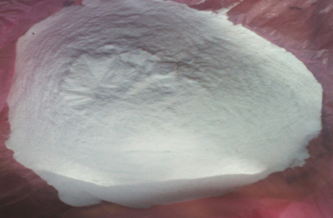
Figure 1. Powdered marble chips waste used for Cr (VI) adsorption.

2.2 Equipment’s used in this study
ICP-Spectrometer (ULTIMA-2, Horiba), provided with, Power: 1150, Plasma Flow: PL2, Sheath Flow: G3, Auxiliary Flow: AUX, Pump Speed: 30, Nebulizer Flow: 0.66, Nebulizer Pressure: 1.77 at wavelength of 267.716nm was used for the determination of chromium concentration. The IR analyses were undertaken with Transform JASCO MODEL 4100 FT-IR spectrophotometer using KBr disc method to analyze the functional groups of powdered marble samples. pH measurements were performed with Bonte 901-uk pH meter, provided with a glass electrode. Stirring of solutions was carried out with a water bath shaker (SW22.SW22, JULABO Labortechnik GmbH 77960 seelbach/Germany). Water deionizer (Master-DUVF) used to water purification.

2.3 Adsorbent preparation from marble chips
The waste marble samples used in this study were obtained from the marble Processing factory located in Bahir Dar, Ethiopia. It is crushed with Jaw crusher(BB50Spezialstahl), washed with de-ionized water followed by drying in oven at105 ⁰C for 24 hour .The dried powdered was sieved well with 75 - 25μm mesh size particles and kept in dry container.

2.4 Preparation of chromium (VI) stock Solutions
A stock solution of hexavalent chromium having concentration of 1000 mg/L was prepared by dissolving 2.8287g of potassium dichromate (K₂Cr₂O₇) in 1000 mL of deionized water. This solution was diluted to obtain working solutions of 20, 40, and 60 mg/L of chromium (VI). The pH of the solution was maintained at desired value by using 0.1M NaOH and 0.1M HCl solution and measured by pH meter.

2.5 Characterization of powdered marble

2.5.1 FTIR Analysis of Adsorbent
The FTIR spectra were for qualitative characterization of functional-groups present in powdered marble. The functional groups of powdered marble was studied by FTIR using KBr disc method spectroscopy at the wavenumber range of 400-4000 cm⁻¹. Approximately 1 g of powdered marble was mixed with 100 mg of KBr and then grounded and pressed to prepare the pellets. The result obtained show the wave lengths of the different functional groups in the sample.

2. 5.2 X-Ray Diffraction (XRD)
First the powdered marble was sieved down to less than 70 μm in diameter and mounted on holders. Then the sample holder was introduced for analysis. Monochromatic x-ray (incident beam) as a source consisted of Cu-Kα radiation (λ = 1.5405 Å) with 40 kV power and 35 mA current was directed toward the sample. Each sample was scanned within the 2θ range of 10–70 and intensity (counts) was measured (Pathinettam Padiyan & Marikani, 2002).

2.5.3 Determination of pH of point zero charge (pHPZC) of marble powder
The pHPZC of the powdered marble sorbent was measured by the batch equilibrium technique (Alemu et al., 2018). Ten series of 50 mL 0.01N NaCl test solutions were prepared in Erlenmeyer flask then their pH values were adjusted in range between 2 and 11 using 0.01N HCl and 0.01N NaOH solution. The initial pH of the solutions were measured with pH meter and noted as pH initial. After constant value of pH initial had been reached, 1 g of the powdered marble sample was added into each Erlenmeyer flask; and the solutions were shaken for 48h at 200 rpm at room temperature. The solution pH was measured after 48 h and noted as pH final, then plotted against pH initial. The pHPZC was then determined from a plot in the pH final versus pH. pHPZC is the point where the pH_{final}= pH_{initial}.

2.6 Batch adsorption experiment
Sorption studies were performed by the batch technique to obtain rate and equilibrium data. The batch technique was selected because of its simplicity. Batch sorption studies were performed at different temperatures, solution pH, particle size, stirring time and initial chrome concentration to obtain equilibrium isotherms and data required in the design and operation of column reactors for the treatment of hexavalent chromium bearing waste water. For isotherm studies, a series of 250-mL conical flasks were employed. Each conical flask was filled with 200mL of Cr (VI) solution of varying concentrations (20, 40, 60mg/L) and adjusted to the desired pH and temperature of 25, 40 & 55 ⁰c.

The concentration range was chosen in accordance with the levels of chromium generally present in wastewater. 6 g of powdered marble was added to each conical flask, and the mixture was agitated on a water bath shaker at 200 rpm for the desired time periods, up to a maximum of about 12h. The contact time and other conditions were selected on the basis of preliminary experiment. After reaction, the solution was filtered using whatman filter paper, centrifuge and analyzed by ICP-OES (ULTIMA-2, Horiba) for the concentration of Chromium remaining in the solution. The desired pH of the solution was adjusted by 0.1 M HCl or 0.1 M NaOH. Adsorption of Cr (VI) was also studied at different doses of adsorbent, different particle sizes and contact time .The concentration of Cr (VI) retained in the adsorbent phase was calculated as the difference between the original concentration of the solution and the measured concentration in solution after equilibrium using equation 1.
q_{e} = $\frac{\left(Co-Ce\right)V}{W}$ ………………………………………………………………………………….(1)
Where q_{e} is equilibrium concentrations of Cr(VI) on the adsorbent (mg/g) respectively; C_{o} and C_{e} are correspondingly the initial and equilibrium concentrations of Cr(VI) in solution (mg/L); V is the volume (L); and W is the weight (g) of the adsorbent.
3. Results and Discussion
3.1 Characterization of Powdered Marble Chips
3.1.1 FTIR analysis of powdered marble chips
The FTIR spectra obtained for the powdered marble is shown in Figure 2. An infrared spectrum was obtained for the adsorbent solid sample before the adsorption process. The absorption bands observable at about 473, 600, 1396, 2109 and 2506 cm⁻¹ coincided with pure CaCO₃, The band at 1007 was due to si-o, band around 3500 characteristic of OH (Diouri et al., 2015)

Figure 2. FIR spectrum of the powder of marble

3.1.2 X-Ray Diffraction (XRD) analysis
From Figure 3 analysis of X-ray diffraction showed that the natural sample has (calcite and dolomite) major and (quartz or magnesite) minor mineralogical components.It was characterized by a series of peaks at 2θ =25º,28º,30° ,32.25° ,35°, 50° and 60° diffraction peaks of calcite and dolomite and a few small peaks at 2θ =25°, 40°,54 and 62° which is characteristic of the presence a small amount of Silica (quartz), so the calculated powder pattern (lowest diffratogramme) fits well with powder pattern of the natural marble sample (Duliu et al., 2009).
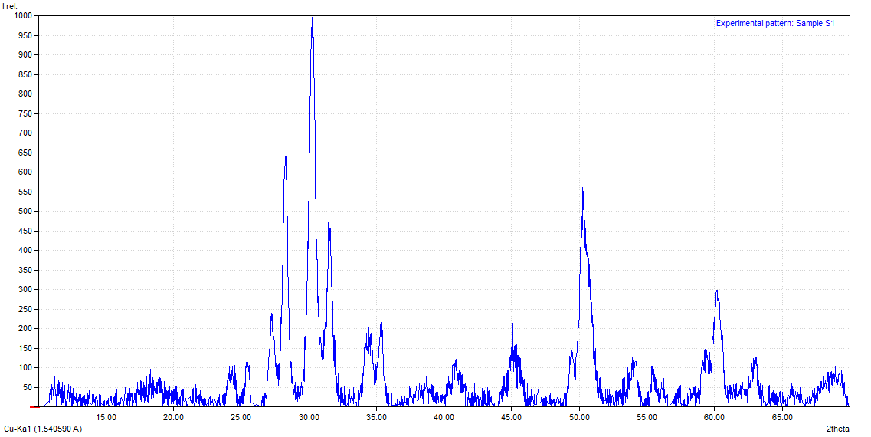
Caco₃
Caco₃
Sio₂
Sio₂
Mg (oH)₂
CaMg(CO3)2
Figure 3. X-Ray diffraction (XRD) of white powdered marble
3.1.3 pH of Point zero charge (pHPZC)
The point of zero charge (pHPZC) of the adsorbent (powdered marble) was determined from the plot of final pH against initial pH as illustrated in Figure 4. As shown in the figure, the pHPZC value obtained for this study is 6. When the solution pH is below the PZC, the acidic medium provides more protons than hydroxide ions, resulting in a positively charged adsorbent surface that attracts anions. In contrast, at pH values above the PZC, the surface becomes negatively charged, thereby attracting cations and repelling anions (Hameed et al., 2008).

Figure 4. pHpzc determination using pH drifts method

3.2 Effects of operating conditions

3.2.1 Effects of solution pH
pH is an important parameter for adsorption of metal ions from aqueous solution because it affects the solubility of the metal ions, concentration of the counter ions on the functional groups of the adsorbent and the degree of ionization of the adsorbate. Chromium formed stable anions, such as Cr₂O₇²⁻, HCrO₄⁻, CrO₄²⁻, and HCr₂O₇⁻, and the stability of these forms is mainly depending on the pH of the solution.

In this study adsorption of chromium (VI) on PMW was studied at varying pH values to optimize the metal removal (Figure 5). It was apparent that the uptake is quite low at low pH values. However, with increasing the pH, a significant enhancement in adsorption is recorded reaching a maximum value, at pH 6 from a solution with initial chromium concentration of 20 mg/L. At pH values below 2.0, the removal of Cr ions reaches zero because of near solubility of the sorbent (consists mainly of CaCO₃), there by hindering the sorption process. Between pH 3 and 6, the percentage removal increases sharply which may be attributed to a possible ion-exchange mechanism between Cr(VI) ions and calcium containing marble powder (Mandjiny et al., 1995). Adsorbed chromium(VI) ions generally occupy calcium sites within the calcite lattice ( Ghazy & Gad, 2014). Above pH 6, there is a possibility of chromium precipitation on the surface of the adsorbent as CrCO₃ and or Cr (OH) forming successive layers on the adsorbent surface.

Figure 5. Effect of pH on Cr(VI) removal efficiency (Temprature =55 ºc, Dose = 40 g/L, t =12hrs and initial Conc = 20 mg/L).

3.2.2 Effect of Adsorbent dose
The dependence of Cr adsorption on dose was studied by varying the amount of adsorbents (20, 30, 40& 60 g/L), by keeping the other parameters (pH, contact time, temperature, initial chrome concentration) constant at optimum condition (Figure 6). It has been observed that removal efficiency of the adsorbent generally increased with increasing dose. This was expected due to the fact that the higher dose of adsorbents in the solution, the greater availability of exchangeable sites for the ions. The composite showed no further increase in adsorption after a certain amount of adsorbent was added (40 g/L). At 20 mg/L concentration of Cr, the maximum Cr removal efficiency was about 98.15% at the dosage of 40 g/L. The observation suggested that after a certain dose of adsorbent, the maximum adsorption cites in and hence the amount of ions bound to the adsorbent and the amount of free ions remains constant even with further addition of the dose of adsorbent.

The effect of adsorbent dosage on chromium (VI) removal was investigated by varying the adsorbent amount (20, 30, 40, and 60 g/L) while maintaining other parameters such as pH, contact time, temperature, and initial chromium concentration at their optimal conditions (Figure 6). The results showed that the removal efficiency increased with rising adsorbent dosage, which is attributed to the greater availability of active sites for ion exchange at higher doses. However, beyond a certain level (40 g/L), no significant improvement in adsorption was observed. At an initial Cr concentration of 20 mg/L, the maximum removal efficiency reached approximately 98.15% at a dosage of 40 g/L. This indicates that once the available adsorption sites are saturated, the number of bound ions and remaining free ions in the solution remain nearly constant, even with further increases in adsorbent dose.

Figure 6. Effect of adsorbent dose on Cr (VI) removal (Temprature =55 ºc, pH = 6, contact time =12 hrs, and initial conc. = 20 mg/L)

3.2.3 Effect of Particle size
It was observed from Figure 7, the experimental results of adsorption at 20 mg/lit concentration that percent adsorption decreases with increases in adsorbent particle size. The rate of chemical reactions that involve solids depends on the particle size of the solid. A finely powdered solid has a larger surface area than an equal mass of a coarsely powdered solid. A larger surface area is a much easier target for colliding molecules which increase the mass transfer. The bigger the target, the easier it is to hit. Fine powders therefore react faster than coarse powders, if all other factors are the same(Kaczmarski & Bellot, 2003).

Figure 7. Effect of particle size on Cr (VI) adsorption ( Temprature =55⁰c, pH = 6, contact time =12hrs, initial conc.C = 20 mg/L, dose= 40 g/L)

3.2.4 Effects of initial chromium concentration
In this study, the adsorption of chromium (VI) onto powdered marble chips was investigated at different initial concentrations (20, 40, and 60 mg/L) to determine the optimal metal removal efficiency (Figure 8). The results showed that as the initial chromium (VI) concentration increased, the percentage removal decreased. This decline can be attributed to the limited number of active adsorption sites, which became saturated at higher metal concentrations. However, the adsorption capacity increased with rising initial Chromium (VI) concentrations, likely due to enhanced collisions between chromium ions and the adsorbent surface (Ghazy & Gad, 2014). The highest removal efficiency, approximately 98.15%, was achieved at an initial concentration of 20 mg/L.
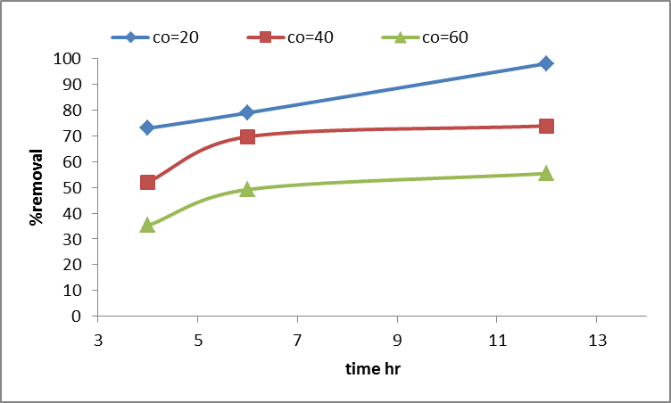

Figure 8. Effect of initial chromium (VI) concentration on removal efficiency of the adsorbent (Temprature =55⁰c, pH = 6, contact time =12 hrs, dose = 40 g/L).
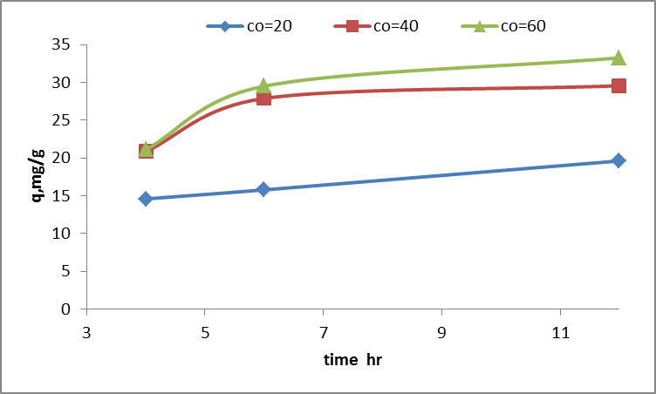
Figure 9. Influence of initial Cr (VI) ion concentration on adsorption (mg/g) (dose= 40 g/L, pH=6 , Temprature 55 ºc, contact time 12 hrs).

3.2.5 Effect of contact time
The variation in chromium adsorption capacity on powdered marble with time is illustrated in Figure 9&10. Both the adsorption capacity and the time required to achieve equilibrium reflect the kinetics of adsorbate transfer from the liquid phase to the adsorbent surface. An adsorption equilibrium of 98.15% for chromium (VI) was attained within 12 hours. In the initial stage, the adsorption rate increased rapidly due to the abundance of active sites on the adsorbent surface. As these active sites became fewer, the rate of adsorption gradually slowed down until equilibrium was reached (Marín et al., 2009).

Figure 10. Effect of contact time on chromium (VI) removal (Temperature =55⁰c, pH = 6, initial conc.= 20 mg/L, and dose = 40 g/L).

3.2.6 Effect of temperature and thermodynamic parameters.
Temperature significantly influences adsorption by affecting both diffusion rates and the equilibrium capacity of the adsorbent. In this study, adsorption of 20 mg/L Chromium (VI) ions onto 40 g/L powdered marble chip waste was examined at 25, 40, and 55 °C. As shown in Figure 11, adsorption increased with temperature, indicating an endothermic process. This enhancement may result from the generation of new active sites, faster adsorption kinetics, or improved ion mobility toward the adsorbent surface. Additionally, the equilibration time decreased, reaching 98.15% Cr (VI) removal. The findings suggest that adsorption likely involves chemical bonding and ion exchange, possibly forming CrCO₃ through interaction with oxygen sites on the marble surface (Al-Asheh & Banat, 2001). Given that many industrial effluents are hot, this adsorption method could be suitable for treating Cr (VI)-contaminated wastewater.
Top of Form
Bottom of Form

Figure 11 Effect of temperature on removal efficiency: pH = 6, rpm=200 and dose = 6 mg/L.

3.3 Adsorption Isotherm
The adsorption behavior of Cr (VI) on powdered marble waste under optimal conditions was studied. Equilibrium data from batch experiments were used to evaluate the suitability of Langmuir and Freundlich isotherm models, as expressed in equations (4) and (5) (Langmuir, 1918; Freundlich, 1906).
$$\frac{Ce}{qe}=\frac{1}{bqm}+\frac{Ce}{qm} ------------------------------(2)$$
$$\log{qe}=\log{Kf}+\frac{logCe}{n}----------------------------(3)$$
Where qₘ is the maximum adsorption capacity (mg g⁻¹), b is the Langmuir constant (L mg⁻¹), and Kf is the Freundlich constant (L kg⁻¹). The Langmuir parameters b and qₘ are obtained from the intercept and slope of the Cₑ/qₑ vs. Cₑ plot (equation 2), while the Freundlich constants 1/n and Kf are determined from the slope and intercept of the log qₑ vs. log Cₑ plot using equation (3).

Table 2 Adsorption Equilibrium results
pH | c_{o} | c_{e} | q_{e} |  | lnce | Lnqe
  ce/qe
4 | 20 | 5.12 | 14.88 | 0.34408602 | 1.63315444 | 2.7001803
5 | 20 | 2.29 | 17.71 | 0.1230548 | 0.82855182 | 2.87412945
6 | 20 | 0.37 | 19.63 | 0.0188487 | -0.9942523 | 2.99705901

3.3.1 Langmuir isotherm model.
The equilibrium adsorption isotherm is one of the most important ways for characterizing adsorbent. In this study, the Langmuir and Freundlich isotherm equations are used to interpret the mechanism of adsorption .A plot of $\frac{ce}{qe}$ versus (Ce) for chromium adsorption onto powdered is presented in the Figure 12 & Table 2 & 3 .The Langmuir sotherm parameters b and qm were determined from the intercept and the slope of Ce/qe versus Ce graph. The R² value of 0.9911 indicated that the adsorption data of chromium onto powdered marble best fitted the Langmuir isotherm model. The essential features of Langmuir adsorption isotherm parameter can be used to predict the affinity between the sorbate and sorbent using a dimensionless constant called separation factor or equilibrium parameter (RL), which is expressed by the following equation 4.
RL=$\frac{1}{(1+bci)}$ ------------------------------------------------------------------------------------------ (4)
Where b is the Langmuir constant and ci is the initial concentration. The value of indicated the type of Langmuir isotherm to be irreversible RL=0, linear RL=1, unfavorable RL>1, and favorable 0< RL>1(Bhatti et al., 2017).

Figure 12. Langmuir plots for the adsorption of chromium ion on powdered marble

The applicability of the linear form of Langmuir isotherm model to powdered marble was proved by the high correlation coefficient R²=0.9911. This suggests that the Langmuir isotherm provides a good model of the chromium adsorption system. The fact that Langmuir isotherm fits the experimental data very well confirms the monolayer coverage of chromium onto powdered marble.

3.3.2 Freundlich Iisotherm model
The Freundlich adsorption isotherm can be used successfully for modeling the equilibrium data in metal-surface systems. It is an empirical equation based on adsorption on a heterogeneous surface. Figure 13 & Table 2 & 3 shows that the plot of lnqe vs. lnCe gave a straight line with a correlation coefficient of 0.9016 suggesting the applicability of the Freundlich model to Cr (VI) adsorption onto powdered marble chips waste. The Freundlich equilibrium constants kf and 1/n for adsorption of Cr (VI) ions onto the adsorbent were calculated from the intercept and slope of the figure, on the basis of the linear form of Freundlich equation. The value of n indicates the degree of nonlinearity between solution concentration and adsorption as follows: if n=1, then adsorption is linear; if n<1, then adsorption is a chemical process; if n>1, then adsorption is a physical process (Foo & Hameed, 2010). In this study the value of n is -9.506 is less than 1, indicating that the adsorption process is a chemical process

Figure 13. Freundlich plots for the adsorption of chromium ion on powdered marble

Table 3 Langmuir and Freundlich isotherm model constants and correlation coefficients for adsorption of chromium on powdered marble
 |  |  | Langmuir constants
  Freundlich constants
R² | 1/n | Kf | R² | B | q_{m(mg/g)}
0.9016 | -0.1052 | 1.77 | 0.9911 | 0.017 | 33.9

As indicated from the figures above, the correlation coefficient (R²) value of the Langmuir model (0.9911) was greater than Freundlich model R² value (0.9016); this indicates that Langmuir isotherm model best explains the adsorption system of Cr(VI) by powdered marble; so the adsorption process may be chemisorption.

3.4 Comparison of Chromium (VI) Adsorption with Various Adsorbents
The adsorptive capacities of the adsorbents used in this work have been compared with those of others reported in the literature and the values of adsorption capacity as presented in Table 4. The experimental data of the present investigation were compared with reported values. Results of our investigation revealed that the adsorbents have higher adsorption capacity than rice bran, potato peel waste, sunflower and activated carbon. The difference in adsorption capacity of the powdered marble in this report to those previously reported could be due to the difference in experimental conditions for the study of adsorption of Cr (VI)(Mekonnen et al., 2015).

Table 4 Comparison of adsorption capacity of different adsorbents for the adsorption of Chromium (VI)
Adsorbents | Adsorbent capacity Qm (mg g^{–1}) | Reference
Common ﬁg(Ficus carica) | 28.9 | Gupta et al., 2013
Rice straw | 3.15 | Gao et al., 2008
Modiﬁed oak sawdust | 1.7 | Argun et al.,2007
Eucalyptus bark | 45 | Sarin & Pant, 2006)
Vesicular basalt rock | 0.079 | Alemu et al., 2019
Kaolinite | 6.1 | Bhattacharyya & Sen Gupta (2006)
Clay (treated) | 0.2 | Khan, T. A., & Singh, V. V. (2010)
Powdered marble | 33.6 | This study

4. Conclusion and Recommendations
In this study, waste powdered marble chips generated from marble processing industries were evaluated for their efficiency in removing Cr(VI) from aqueous solutions. The adsorbent was characterized using FT-IR and XRD analyses, which revealed that CaCO₃, SiO₂, Mg(OH)₂, and CaMg(CO₃)₂ were the principal constituents of the marble powder. The highest Cr(VI) removal efficiency of 98.15% was achieved under optimal conditions: pH 6, adsorbent dose of 40 g/L, contact time of 12 hrs, initial Cr(VI) concentration of 20 mg/L, and temperature of 55 °C. The adsorption data closely followed the Langmuir isotherm model (R² = 0.9911), suggesting a homogeneous and favorable adsorption surface. Hence, powdered marble waste shows strong potential as a low-cost and effective adsorbent for Cr(VI) removal from contaminated water, though further testing with actual industrial effluents is recommended.

Acknowledgments
The authors are grateful to the Department of Chemical and Food Engineering, Bahir Dar Institute of Technology, Bahir Dar University, Ethiopia for providing the necessary facility to conduct the study.

Reference

Alemu, A., Lemma, B., Gabbiye, N., Alula, M. T., & Desta, M. T. (2018). Removal of chromium (VI) from aqueous solution using vesicular basalt: A potential low-cost wastewater treatment system. Heliyon, 4(7), e00682.
Alemu, A., Lemma, B., & Gabbiye, N. (2019). Adsorption of chromium (III) from aqueous solution using vesicular basalt rock. Cogent Environmental Science, 5(1), 1650416. https://doi.org/10.1080/23311843.2019.1650416
Al-Asheh, S., & Banat, F. (2001). Adsorption of zinc and copper ions by the solid waste of the olive oil industry. Adsorption Science & Technology, 19(2), 117–129.
Argun, M. E., Dursun, S., Ozdemir, C., & Karatas, M. (2007). Heavy metal adsorption by modified oak sawdust: Thermodynamics and kinetics. Journal of Hazardous Materials, 141(1), 77–85.
Bhattacharyya, K. G., & Sen Gupta, S. (2006). Adsorption of chromium (VI) from water by clays. Industrial & Engineering Chemistry Research, 45(21), 7232–7240.
Bhatti, A. A., Oguz, M., & Yilmaz, M. (2017). Magnetizing calixarene: Azo dye removal from aqueous media by Fe₃O₄ nanoparticles fabricated with carboxylic-substituted calix[4]arene. Journal of Chemical & Engineering Data, 62(11), 3595–3604.*
Chowdhury, M., Mostafa, M., Biswas, T. K., & Saha, A. K. (2013). Treatment of leather industrial effluents by filtration and coagulation processes. Water Resources and Industry, 3, 11–22.
Diouri, K., Chaqroune, A., Kherbeche, A., Bentama, J., & Lahrichi, A. (2015). Kinetics of yellow dye adsorption onto marble powder sorbents. Journal of Materials and Environmental Science, 6(1), 79–92.
Duliu, O. G., Grecu, M. N., & Cristea, C. (2009). EPR and X-ray diffraction investigation of some Greek marbles and limestones. Romanian Reports in Physics, 61(3), 487–499.
Foo, K. Y., & Hameed, B. H. (2010). Insights into the modeling of adsorption isotherm systems. Chemical Engineering Journal, 156(1), 2–10. https://doi.org/10.1016/j.cej.2009.09.013
Freundlich, H. M. F. (1906). Über die Adsorption in Lösungen. Zeitschrift für Physikalische Chemie, 57A, 385–470.
Gao, H., Liu, Y., Zeng, G., Xu, W., Li, T., & Xia, W. (2008). Characterization of Cr(VI) removal from aqueous solutions by a surplus agricultural waste—rice straw. Journal of Hazardous Materials, 150(2), 446–452.
Ghazy, S., Samra, S., Mahdy, A., & El-Morsy, S. (2003). Removal of copper (II) ions from aqueous solutions. I. Adsorption studies using powdered marble wastes as sorbent. Adsorption Science & Technology, 21(3), 285–296.
Ghazy, S. E., & Gad, A. H. (2014). Lead separation by sorption onto powdered marble waste. Arabian Journal of Chemistry, 7(3), 277–286.
Gupta, V. K., Pathania, D., Sharma, S., Agarwal, S., & Singh, P. (2013). Remediation of noxious chromium (VI) utilizing acrylic acid grafted lignocellulosic adsorbent. Journal of Molecular Liquids, 177, 343–352.
Hameed, B., Tan, I., & Ahmad, A. (2008). Adsorption isotherm, kinetic modeling and mechanism of 2,4,6-trichlorophenol on coconut husk-based activated carbon. Chemical Engineering Journal, 144(2), 235–244.
Kaczmarski, K., & Bellot, J. C. (2003). Effect of particle-size distribution and particle porosity changes on mass-transfer kinetics. Acta Chromatographica, 13, 22–37.
Khan, T. A., & Singh, V. V. (2010). Removal of cadmium (II), lead (II), and chromium (VI) ions from aqueous solution using clay. Toxicological and Environmental Chemistry, 92(8), 1435–1446.
Langmuir, I. (1918). The adsorption of gases on plane surfaces of glass, mica and platinum. Journal of the American Chemical Society, 40(9), 1361–1403. https://doi.org/10.1021/ja02242a004
Owlad, M., Aroua, M. K., Daud, W. A. W., & Baroutian, S. (2008). Removal of hexavalent chromium-contaminated water and wastewater: A review. Water, Air, & Soil Pollution, 187(1–4), 323–336. https://doi.org/10.1007/s11270-007-9511-0
Mandjiny, S., Zouboulis, A., & Matis, K. (1995). Removal of cadmium from dilute solutions by hydroxyapatite. I. Sorption studies. Separation Science and Technology, 30(15), 2963–2978.
Marín, A. P., Aguilar, M., Meseguer, V., Ortuno, J., Sáez, J., & Lloréns, M. (2009). Biosorption of chromium (III) by orange (Citrus sinensis) waste: Batch and continuous studies. Chemical Engineering Journal, 155(1), 199–206.
Pan, B., Pan, B., Chen, X., Zhang, W., Zhang, X., Zhang, Q., & Chen, J. (2006). Preparation and preliminary assessment of polymer-supported zirconium phosphate for selective lead removal from contaminated water. Water Research, 40(15), 2938–2946.
Pokhrel, G. R., & Pokhre, G. (2022). The effect of chromium on human health: A review. BMC Journal of Scientific Research, 5(1), 27–35. https://doi.org/10.3126/bmcjsr.v5i1.50669
Sarin, V., & Pant, K. (2006). Removal of chromium from industrial waste by using eucalyptus bark. Bioresource Technology, 97(1), 15–20.
Umathi, K., Mahimairaja, S., & Naidu, R. (2005). Use of low-cost biological wastes and vermiculite for removal of chromium from tannery effluent. Bioresource Technology, 96(3), 309–316.
Suwalsky, M., Castro, R., Villena, F., & Sotomayor, C. (2008). Cr(III) exerts stronger structural effects than Cr(VI) on the human erythrocyte membrane and molecular models. Journal of Inorganic Biochemistry, 102(4), 842–849.
Wazwaz, A., Al-Salaymeh, A., & Khan, M. S. (2019). Removing heavy metals through different types of soils and marble powder found in Oman. Journal of Ecological Engineering, 20(4), 136–142.
World Health Organization. (2011). Guidelines for drinking-water quality (4th ed.). World Health Organization.
Yu, B., Zhang, Y., Shukla, A., Shukla, S. S., & Dorris, K. L. (2000). The removal of heavy metal from aqueous solutions by sawdust adsorption—removal of copper. Journal of Hazardous Materials, 80(1), 33–42.

