A Review of Water Footprints for Irrigated Vegetables under Conservation Agriculture in the Ethiopian Highlands
Sisay A. Belay ^{1,2*}, Tewodros T. Assefa ¹
¹Faculty of Civil and Water Resources Engineering, Bahir Dar Institute of Technology, Bahir Dar University, Ethiopia
² Blue Nile Water Institute Bahir Dar University
* Correspondence: asressisay@gmail.com

Abstract
Water footprint (WF) accounting has the potential to provide crop water use metrics and can assist farmers to improve water uses. However, WFs for smallholder irrigated vegetables under conservation agriculture (CA) practices have not been accounted in the Ethiopian highlands. This research was conducted aiming to better understand the potential advantages of irrigated technologies for saving water in the sub-humid highlands. Results showed that the highest irrigation water saving (25%) was found under CA for overhead irrigation application on tomato in the dry period while the lowest water saving (9%) was found under CA compared with CT under Majipump drip system of onion. On the other hand, the evapotranspiration (ET) in the conventional tillage (CT) under the overhead irrigation, when compared with the CA, was in the ranges of 38-96% while the value is lowered to the range of 7-10% for drip irrigation. In the dry phase of vegetable production, blue WF in CA was reduced by about 1.7 times when compared with the CT while the green water was reduced by about 5.7 times when compared with the CT. In general, the total WF was about 2.2 times lower under the CA when compared with the CT.
Keywords: water footprint, blue water, conservation agriculture, Ethiopian highland

Introduction
Global freshwater withdrawal has increased nearly sevenfold in the past century [1]. Consumptive water use or water withdrawal is also expected to increase in the coming decades due to the growing population and the changing diet preferences [2,3]. Currently, the agricultural sector accounts for about 85% of global water consumption [4] which will no more be enough for the future generation without proper management. One of the important prospects to curb the everincreasing water scarcity is to reduce the consumptive water use in the agricultural sector, which makes up the largest share of theglobal freshwater consumption [5].
Ethiopia is seriously affected by uneven rainfall distribution where water supply no longer meets the domestic and agricultural water demand [6]; the vulnerability of which was seriously emphasized by the drought of 1974, the driest calendar year [7]. Climate change, population growth, and rising water use have exacerbated the challenge even during normal rain periods. Under all such pressures, only about 5% of the landmass of Ethiopia has been used for irrigated agriculture using only approximately 2% of Ethiopia’s exploitable surface water [8]. On the contrary, agricultural products account for approximately 85% of total national exports, contributing 90% of gross domestic product [9]. Approximately about 90% of the national vegetable and fruit products have been grown under irrigation in dry and supplementary periods using surface water [9]. However, the loss of water from a particular field through evaporation or along the entire production chain per yield of product in the context of water footprint is not known in the nation [10].
Water Footprint (WF) accounting is an emerging approach first proposed by the Water Footprint Network (WFN) in 2002, aiming to better quantify the impacts of human activities on water quantity and quality for better decision-making and management [10]. The contextual meaning of the terms “blue”, “green” and “grey” WFs have been distinguished by Hoekstra et al. (2011). In a crop production context, blue water consists predominantly of the irrigation water applied to crops while green water originates from rainfall that is stored in the soil and is only available for evapotranspiration (ET). The variations in water use among different crops can affect the WFs, which are most commonly expressed as the volume of water used per fresh crop yield [11]. Water footprint accounting has the potential to provide crop water use metrics, and can also assist farmers to improve the management of their water resources by informing production decisions. WF accounting can be a potentially useful tool to quantify direct and indirect water use with greater flexibility to various entities, including vegetable products, consumers, farms and catchments. WF is also found useful to assess water to be used for agriculture and to inform policymakers to improve water resource development. The importance of calculating WFs with local data and interpreting WFs within the local context has to be emphasized. Several studies have been conducted globally and also in Ethiopia on the WFs of various crops [10]. However, WFs for vegetables such as cabbage, tomatoes, onion, garlic, and pepper cultivated under different irrigation systems, management practices, and conservation agriculture practices have not been sufficiently accounted and limited studies are available.
This research was conducted aiming to better understand the potential intricacies involved in calculating WFs of vegetable crops using a case study on the plot level observed and simulated data in the sub-humid areas of Ethiopian highlands. In this paper, we report on how WF outcomes are influenced by several factors, including seasonal variations in weather conditions between growing seasons,and irrigation and conservation agriculture practices [12,13].

Materials and Methods

Site Description and Experiment Features
The study area is located in the Dengeshita watershed , the headwaters of the Abay basin in the state of Amhara, Ethiopia at a geographic location of around 11.32º N and 36.85º E at an altitude of 2042 m (Fig.1).
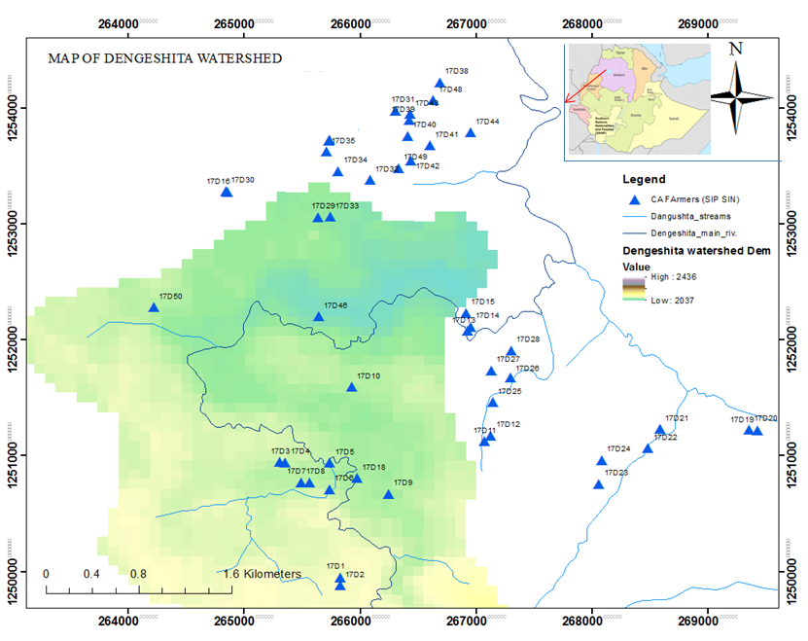
Fig.1: Location map of the study area
The average rainfall of the area is about 1450mm. The site has slopes ranging from two to five percent. The texture of the top 30 cm soil was loam soil. The soil was slightly acidic with a pH level of 6. Field capacity, permanent wilting point, bulk density, total nitrogen, available phosphorus, and available potassium in the top 30 cm were 0.31 cm³ cm⁻³, 0. 22 cm³ cm⁻³, 1.1 g cm⁻³, 0.93 g kg⁻¹, 9.57 mg kg⁻¹, and 191 mg kg⁻¹, respectively. The climate data used for calculating the reference evapotranspiration (ETo) with the FAO Penman-Monteith equation [14] were obtained from the Dangila weather station from 1995 to 2016. The climate data processed for the purpose include temperature (maximum and minimum), relative humidity, sunshine hours, and wind speed.

Experimental Design and Layout
A total of 45 experimental plots were established on 100 m² in size [12,13]. Ten plots were randomly assigned for the conservation agriculture (CA) experiment, where 50 m² was randomly assigned for conservation agriculture (CA) and another 50 m² for conventional tillage (CT) practice under dry and supplementary irrigated phase (Figure 1). The remainders of 35 plots were assigned to CA treatment with irrigation amount and schedule determined by farmers (FP) [12,13]. The experimental plots were initially selected based on the availability of productive shallow groundwater wells adjacent to irrigable farms and farmers’ willingness to participate in the experiment. CA consists of no-tillage and the application of grass mulch at the rate of 2 t ha⁻¹, while CT is the current farmers’ tillage practice using an animal-drawn plow and without mulch cover [12,13].. Irrigation water was managed by the estimated reference evapotranspiration based on the methods explained by [14]. The crop rotation (onion– pepper–garlic–pepper–onion–pepper-onion-pepper) was the same for both CA and CT agricultural practices. Irrigation was provided using the overhead irrigation method for the 1st one and a half years (onion-pepper-garlic), while drip irrigation was used for the 2nd one and a half years (pepper-onion-pepper). Each treatment subplot was subjected to an equal amount of irrigation water for a week to ensure the uniform recovery of transplanted seedlings.
The depth of water applied to each irrigation event was the sum of the daily crop water use (ETc) between irrigation events. Overhead bucket irrigation application (OHI) was used in the dry phase of 2016/2017 and 2017 (May to the beginning of June) while drip irrigation (DI) was used in 2018 and 2019 (March to mid of June). Considering conveyance and other losses in using buckets or drip systems are negligible, and the maximum irrigation efficiency of 80% was used for bucket application and 90% for drip application for the purpose of irrigation water demand determination before irrigation [12,13].

Crop management practices
Adama Red Onion (Allium cepa L.) local variety in 2016/2017 and 2018/2019 and garlic (Allium Sativium L.) local variety in 2017/2018 were transplanted or planted at a spacing of 20 cm between rows and between plants as shown in table 1 [12,13].
Table 1. Crop stages, length of the growing period in days, and crop coefficients (Allen it al. 1998).
Year | Crop Type | Crop Parameters | Growth Stages
Year | Crop Type | Crop Parameters | Initial | Development | Mid-Season | End
2016/2017, 2018/2019 | Onion | Length of growth (days) | 20 | 45 | 35 | 20
2016/2017, 2018/2019 | Onion | Crop coefficient (Kc) | 0.7 | 0.7–1.05 | 1.05 | 0.7
2017/2018 | Garlic | Length of growth (days) | 20 | 50 | 30 | 20
2017/2018 | Garlic | Crop coefficient (Kc) | 0.7 | 0.7–0.95 | 0.95 | 0.7

Local variety pepper (Capsicum annuum L.) was transplanted on May 1, 2017, March 13, 2018, and March 19, 2019, experimental years. Transplanting of pepper was conducted at a spacing of 40 cm between rows and between plants. For pepper, the initial stage, excluding the age of seedlings at the nursery site, lasted for 20 days; the development stage lasted for 30 days; the mid-season growth stage (flowering and fruiting) stage lasted for 50 days, and the late-season stage lasted for 20 days. The single crop coefficient was used for each growth stage (0.7 for initial, 0.95 for development, 1.05 for mid, and 0.7 for end). All experimental plots were equally treated for the amount of fertilizer, organic manure, and grass mulch applications under local management practices. Pepper was harvested from July to September in 2017, and from June to August in 2018 and 2019 [12,13].

Data Collection
Runoff and leachate were measured as described by [12]. Total water consumption or actual evapotranspiration (ETc, mm) was calculated during the growing season using the soil water balance equation as cited by Kresovic et al. [15]: ETc =I+Rf+Cr − Ro – P40 ± ΔS, where ETc is evapotranspiration (mm) during the growing season, I is amount of irrigation water applied (mm), Rf is rainfall (mm), Cr is the capillary rise(mm), considered to be zero because the groundwater table was >4 m (minimum value record for 45 wells) below the surface in the growing months, P40 is percolation (mm) at 40 cm soil depth, considered because the soil water content below 40 cm reached ﬁeld capacity on rainfed months during sampling dates, Ro is runoﬀ (mm), considered using runoff collectors because the ﬁeld was saturated in rainy months (June to August) and ΔS is changing in soil moisture content (mm) measured using the gravimetric method at transplanting and after harvest.
Irrigation water applied to each plot in 2016/2017 and 2017 was measured by using a known volume of the bucket (usually 10 to 15 liters) for the overhead irrigation method, and a 500-liters reservoir and a water meter attached to it were used for drip application method in 2017/2018 to 2019. Irrigation dose and scheduling were differently treated in CA and CT treatments in 2017 while the same dose (250 liters per application) was applied with different scheduling in 2018 and 2019 [12,13]. Irrigation was ceased immediately, after the onset of rainfall. All data were presented as means and statistically analyzed after the normality test.

Data Analysis
All data are presented with arithmetic means and were statistically analyzed using analysis of variance (ANOVA) after checking the normality (Jarque–Berra,1980). All the results shown in tables and figures are means of treatment plots. Mean values were compared for any significant differences using the least significant difference (LSD) method. LSD was calculated from data, where the differences among means were tested at α = 0.05 [12,13].

Results and Discussion

Irrigation water use and evapotranspiration (ET)
In almost all the periods, the total irrigation water applied to vegetables in the CA was lowest when compared with the CT treatment except for the onion-PO in 2016/2017 period where same amount of water was applied and the yield difference was recorded (Table 2). As stated by Belay et al. [13], these sites were newly established and optimum amount of fertilizer (200 kg/ha) was applied and the yield of onion was high (Table 2). In the 1st irrigation period, the highest irrigation water saving (25%) was found under the CA management of pulley system overhead irrigation application to tomato (tomato-PO) while the lowest water saving (9%) was found under CA compared with CT under Majipump drip system of onion (onion-MD) vegetable (Table 2). For other vegetables, irrigation water used in the CA was reduced in the range of 15 – 20% as compared with CT (Table 2). The irrigation water in CA was 25% lower than the CT for tomato-PO, which was due to the higher evapotranspiration (99%) from the soil as well as from leaf interceptions under CT treatment (Table 2). Because the particular irrigation technique influences the percentage of surface wetting, which again influences ET. In this case, mulching practice improved soil cover and in this way reduced non-productive evaporation (Table 2). In other words, the CT with an overhead system of irrigation has exposed the vegetable to more ET (13-99%) when compared with the CA. As shown in Table 2, the ET in the CA with a drip system of irrigation was lowered to the range of 7-10% when compared with the ET in the overhead irrigation system which was in the range of 13-99% (Table 2). This showed that the method of irrigation significantly reduced the variation in ET between CA and CT.
Similarly in the 2nd period of irrigation, the ET in the CT under the overhead irrigation system, when compared with the CA, was in the range of 38-96% while the value is lowered to the range of 7-10% for drip irrigation system (Table 3). This indicated that the blue WF management interventions had been highly associated with the irrigation system, tillage system, cover system (CA), and the integration between dry and wet (supplementary irrigation) systems.
Table 2 Vegetable productions using a pulley and overhead irrigation method (PO), pulley and drip irrigation method (PD), and Majipump and drip irrigation method (MD) and used rainfall (green water), irrigation water used (blue water), and evapotranspiration (ET) and yields under CA and CT treatments in the Ethiopian highland.
crop | year | Rainfall |  | Irrigation (mm) |  |  |  | ET (mm) |  |  |  | Yield (t/ha) |  |  |  | Ref.*
crop |  |  |  | CA |  | CT |  | CA |  | CT |  | CA |  | CT
1st irrigation cycle
Garlic-PO | 2015/16 | 203 |  | 320 |  | 370 |  | 232 |  | 416 |  | 4 |  | 2.8 |  | [17]
Tomato-PO | 2016/2017 | 80 |  | 280 |  | 350 |  | 248 |  | 494 |  | 9.8 |  | 3.2 |  | [17]
Onion-PO | 2016/2017 | 98 |  | 520 |  | 520 |  | 339 |  | 373 |  | 24.3 |  | 17.9 |  | [13]
Garlic-PO | 2017/2018 | 68 |  | 260 |  | 309 |  | 315 |  | 355 |  | 5.3 |  | 3.8 |  | [13]
Cabbage-PO | 2017/2018 | 0 |  | 305 |  | 360 |  | 251 |  | 349 |  | 21 |  | 18.3 |  | [18]
Onion-MD | 2018/2019 | 110 |  | 256 |  | 306 |  | 321 |  | 342 |  | 9.5 |  | 7.8
Onion-MD | 2019/20 | 125 |  | 289 |  | 315 |  | 345 |  | 378 |  | 11.3 |  | 8.9
2nd irrigation cycle

Onion-PO | 2016/2017 | 378 |  | 140 |  | 215 |  | 280 |  | 420 |  | 3.3 |  | 3 |  | [13]
Garlic-PO | 2017 | 316 |  | 95 |  | 130 |  | 252 |  | 494 |  | 4.5 |  | 2.6 |  | [18]
Pepper-PO | 2017 | 791 |  | 50 |  | 50 |  | 258 |  | 356 |  | 5.1 |  | 5.5
Pepper-PD | 2018 | 594 |  | 367 |  | 475 |  | 658 |  | 704 |  | 11.7 |  | 9.1 |  | [12]
Pepper-MD | 2019 | 618 |  | 255 |  | 288 |  | 548 |  | 603 |  | 6.2 |  | 5.9 |  | [12]
Pepper-MD | 2020 | 820 |  | 215 |  | 267 |  | 589 |  | 642 |  | 8.6 |  | 7.3

Water Use Efficiency (WUE)
Water use efficiency (WUE) which is defined as the ratio of fresh yield of onion to the evapotranspiration of onion field is shown in Fig.2. It showed that irrigation interventions at a particular location improved water use while also reducing the yield. On the other hand, the yield of onion was increased while irrigation water use was decreased at another location (Fig.2). However, the best interventions were those which used optimum water without reducing its yield. In fig., our yield and WUE results in the CA agree with that the findings of [16]. Lower yield (<10 Mg ha⁻¹) and lower WUE (<5 ton m⁻³) were found in CT probably due to the use of overhead irrigation application which experienced higher interception of water by plant parts and associated evaporation loss. However, the yield in CA was increased when the root-soil moisture was improved by mulching which was consistent with the findings of Kabir et al. [19] from an experiment that used water hyacinth mulch combined with zero tillage practices. In agreement with our results,[20], for example, reported a WUE ( 5 to 10 ton m⁻³), and the yield (25 to 44 Mg ha⁻¹) for onions that used farmyard manure at the rate of 40 t ha⁻¹ and inorganic fertilizers at the rate of 160 kg N ha⁻¹, 115 kg P ha⁻¹ and 95 kg K ha⁻¹.
The highest onion yield (30 to 44 Mg ha⁻¹) and WUE (13 to 16 ton m⁻³) results were also reported by Juan et al.[21] due to real-time measurements of soil moisture and replacing the lost water to the plant due to evapotranspiration and other possible losses by irrigation. Despite its cost, applying the exact value of the lost water is the most acceptable intervention of all. Besides, [22] reported varying WUE (5 to 14 ton m⁻³) with an almost similar yield response of onion (45 to 50 Mg ha⁻¹) which was the highest yield increase in furrow irrigation coupled with a high level of N application (N treatments of 0, 90 and 360 kg·ha⁻¹ of N as ammonium nitrate).
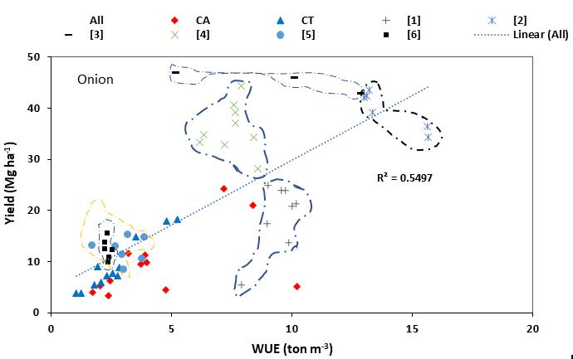
Fig. 2: Onion yield and WUE at different locations with different water-saving strategies * [1]=[16]; [2]=[21]; [3]=[20]; [4]=[20]; [5]=[23] and [6]=[19] and [12,13].
Similarly, WUE for pepper showed a better correlation (r²=0.71) with yield than onion crops (Fig.3). However, the yield results of pepper and its WUE values were far from the findings of Yin-Li et al [24] which was a greenhouse precision irrigation experimental result using different mulching materials (straw, plastic film, and both) combined with a high level of nutrient application. It showed that the yield of pepper (12-51 Mg ha⁻¹) and WUE (12-35 ton m⁻³) was much higher according to Liang et al. [24] while the yield of pepper (<10 Mg ha⁻¹) and WUE (<5 Mg ha⁻¹) was lower in our experiment and other results in Ethiopia with similar (drip) irrigation water application system [12,25-27].
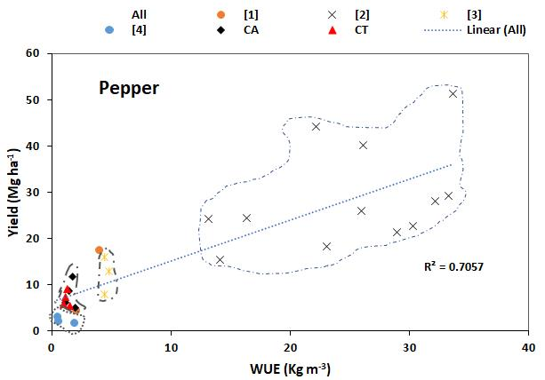
Fig.3: Pepper yield and WUE at different locations with different water-saving strategies *[1]=[25]; [2]=[24]; [3]=[26]; [4]=[27] and [12].

Water footprint
In the 1st irrigation cycle of vegetable production using conservation agriculture, blue WF in CA was significantly reduced by about 1.7 times when compared with the CT treatment while the green water was reduced by about 5.7 times when compared with the CT (Table 3). The total WF was improved in the CA management by about 2 times. There is also a reduction of about 40% in grey WF.
Similarly, in the 2nd irrigation cycle of vegetable production using conservation agriculture, blue WF in CA was significantly reduced by about 77% when compared with the CT treatment while the green water was reduced by about 3.9 times when compared with the CT (Table 3). The total WF was improved in the CA management by about 2 times. Similarly, a grey WF reduction of about 78% was also obtained in the 2nd irrigation cycle. In general, total WF in the 2nd cycle was 2.2 times lower under the CA when compared with the CT (Table 3).

Table 3 Blue, green, and grey water requirements for vegetables
crop | Blue WF |  | Green WF |  | GREY WF |  | TOTAL WF
crop | (m³ ton⁻¹) |  | (m³ ton⁻¹) |  | (m³ ton⁻¹) |  | (m³ ton⁻¹)
crop | CA | CT | CA | CT | CA | CT | CA | CT
1st irrigation cycle
Onion-PO | 139.51 | 208.38 | ND* | ND | 0.00 | 0.00 | 139.51 | 208.38
Onion-MD | 263.18 | 373.12 | 59.10 | 58.47 | 0.00 | 0.00 | 322.28 | 431.59
Garlic-PO | 490.57 | 813.16 | 103.77 | 121.05 | 0.01 | 0.01 | 594.35 | 934.22
Tomato-PO | 253.06 | 1093.75 | ND | 450.00 | 0.00 | 0.01 | 253.06 | 1543.76
Cabbage-PO | 119.52 | 190.71 | ND | ND | 0.00 | 0.00 | 119.53 | 190.71
Mean | 253.17 | 535.82 | 81.44 | 209.84 | 0.00 | 0.00 | 285.74 | 661.73
St. Dev | 147.68 | 400.31 | 31.59 | 210.32 | 0.00 | 0.00 | 191.48 | 577.18
2nd irrigation cycle
Onion-PO | 424.24 | 716.67 | 424.24 | 683.33 | 0.01 | 0.01 | 848.49 | 1400.01
Garlic-PO | 211.11 | 500.00 | 348.89 | 1400.00 | 0.00 | 0.01 | 560.00 | 1900.01
Pepper-PO | 98.04 | 90.91 | 407.84 | 556.36 | 0.00 | 0.00 | 505.89 | 647.28
Pepper-PD | 313.68 | 521.98 | 248.72 | 251.65 | 0.00 | 0.00 | 562.40 | 773.63
Onion-MD | 330.65 | 426.94 | 453.73 | 523.80 | 0.00 | 0.00 | 784.38 | 950.75
Pepper-MD | 330.65 | 426.94 | 453.73 | 523.80 | 0.00 | 0.00 | 784.38 | 950.75
Mean | 284.73 | 447.24 | 389.53 | 656.49 | 0.00 | 0.00 | 674.26 | 1103.74
St. Dev | 113.83 | 204.33 | 79.07 | 390.55 | 0.00 | 0.00 | 147.33 | 466.04
*ND stands for No data.

3.2.1 WF Reducing Strategies
WF and WUE have an inverse relation [28]. To reduce the WF of a crop we should follow strategies that increase WUE which include deficit irrigation, increasing irrigation interval, reducing ET through surface mulching, using greenhouse systems, promoting drip irrigation systems, and introducing conservation agriculture with appropriate fertilizer uses through it also increases grey WFs [29]. Reducing the irrigation water from the crop's optimum requirement (100% crop need) (Figure 4a), use of surface mulches during the crop growth period (Figure 4c), and use of drip irrigation and appropriate fertilizers (Figure 4e) had reduced the WF with proportional onion yield reduction (Figure 3b,d,f) under various experiments and locations [22,30, 31]. In general, strategies that increase soil water by reducing deep percolation and those which reduce surface soil evaporation had minimized the WFs.
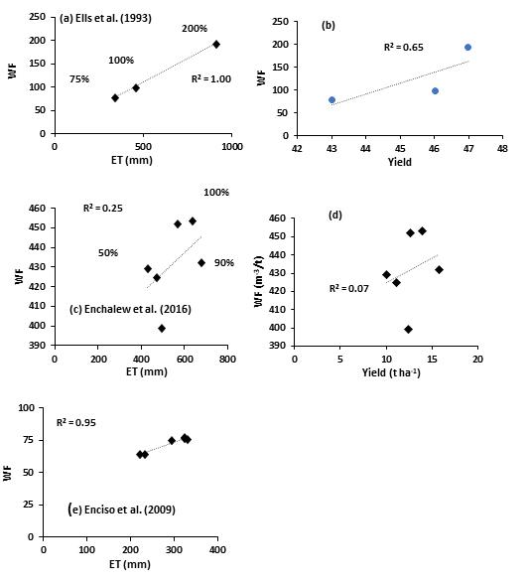
Figure 4: Relation of WF with ET, and Yield of onion under different experiments.

3.2.2 WF Increasing conditions
Blue WF can be reduced by many potential strategies and interventions, particularly which ensure water security in dryland areas of the world. It is known that WF increases with ET (Figure 5a) depending on the local management and soil conditions. Allowing about >20% water reduction during irrigation (Fig.5a) increased the blue WF with the corresponding increase in onion yield (Fig.4b) in soils with available soil holding capacity of 10-15% [20,16]. However, regulating about 20% irrigation water reduction decreased blue WF among all strategies used (Fig.5a). Similarly, the lowest blue WF was observed in drip irrigation systems with 50% irrigation water reduction compared with sprinkler and furrow irrigation strategies, which again shows WF increased with ET (or Irrigation water use) (Fig.5c) while it showed inversely related with garlic yield [23] and for onion yield [16] as shown in Fig.4d and f.
The higher blue WF in the surface irrigation method (Furrows), according to [32], could be attributed to inefficient use of irrigation water, deep percolation and uneven distribution of irrigation water (Fig.4c). The irrigation practice primarily influences the water balance of the soil, but as a side effect, it influences nutrient movement in the soil. The advantage of deficit irrigation compared to full irrigation is that there may be less leaching and runoff of nutrients. The disadvantage of deficit irrigation is that it may result in reduced crop N demand (N uptake) as crop growth diminishes due to water stress and in reduced N supply as N transporting agent is reduced [33].
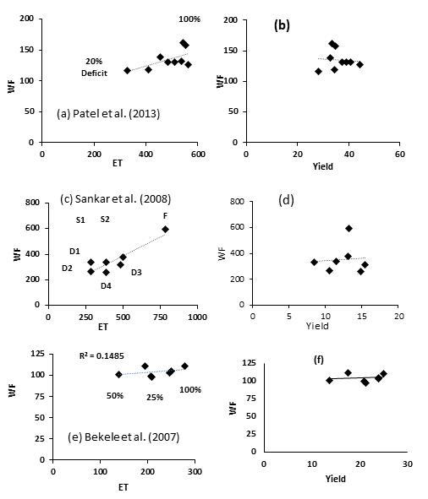
Fig.5: Relation of blue WF with Evapotranspiration and irrigation water (a and C), and with onion (b) and garlic (d) yield.

Effect of Conservation Agriculture on Blue WF
Field plot experiments showed that conservation agriculture has reduced ET and then contributed to reducing blue WF (Fig.6a) while at the same time it increased the yield of onion compared with the conventional tillage (Fig.5b). Compared with the water reduction strategy, grass mulching and no-tillage strategy as conservation agriculture look the best strategy to reduce WF (Fig.6a) while at the same time increasing onion yield (Figure 6b). Mulching and no-tillage practices contributed to the minimize evapotranspiration while at the same time mulch has increased the soil fertility which was responsible for the increase in the yield of onion. Nouri et al. [34] found blue water saving of 5% from the combination of mulching with organic material and drip irrigation. Chukalla et al. [28] tested the effect of mulching and drip irrigation in a modeling study for four different environments and three different crops (maize, potato and tomato) and found a consistent WF reduction from mulching and drip irrigation.
Field operation practices such as tillage affect the water holding capacity of the soil, the movement of moisture and nutrients in the soil, surface runoff, and eventually crop yield and nutrient load to freshwater [35]. There are various good reasons why conventional tillage is being practiced: it mixes fertilizer, organic matter, and oxygen in the soil; breaks up surface soil crusts; and reduces weeds. However, conventional tillage disrupts aggregates within the soil and life cycles of beneficial organisms resulting in soil compaction due to repeated plowing. Alternatively, no-tillage maintains the crop residue that serves as mulch cover, improves the soil water holding capacity, increases hydraulic conductivity, and creates a conducive environment for reductions in WF. Due to such natural links, CA in general lowered the WF as compared with the CT. The yield of onion vegetables is related exponentially to WF (Fig.6).

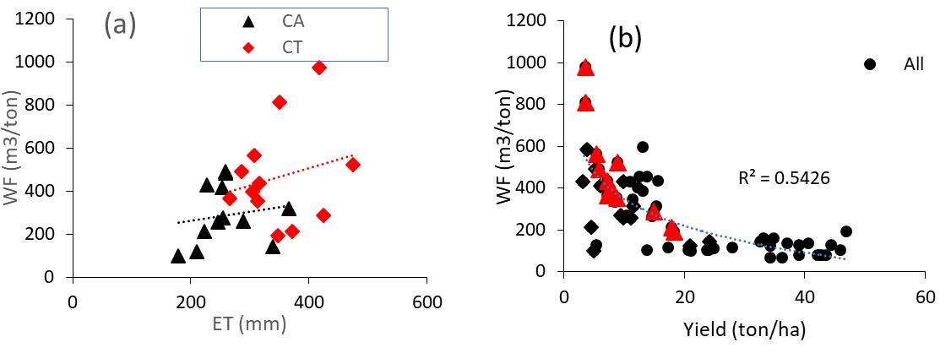
Figure 6: The relationship between WF and onion ET (a) and productivity (b) for CA and CT treatments

Conclusion
In the 1st irrigation cycle, the highest reduction in irrigation water (25%) was obtained under the CA management of the pulley system of overhead irrigation under tomato while the lowest variation (9%) in irrigation water use was obtained under the Majipump drip system of onion vegetable. The highest yield to water use ratio was the best technology for reducing water footprint (WF). On the other hand, in the 1st irrigation cycle of vegetable production, blue WF in CA was significantly reduced by about two-folds when compared with the CT treatment while the green water was reduced by about six-folds when compared with the CT. this implies that the total WF was reduced (water use improved) in the CA management by about 2 times. In the 2nd irrigation cycle of vegetable production, blue WF in CA was significantly reduced by about 77% when compared with the CT treatment while the green water was reduced by about 3.9 times when compared with the CT. Similarly, the total WF in the 2nd cycle was about 2.2 times lower under the CA when compared with the CT implying a significant water use improvement. To reduce the WF of a crop, deficit irrigation, increasing irrigation interval, reducing ET through surface mulching, using greenhouse systems, promoting drip irrigation systems, and introducing conservation agriculture with appropriate fertilizer uses were some of the irrigation strategies. Grass mulching and no-tillage interventions in conservation agriculture were the best strategies to reduce WF while at the same time providing an increased onion yield. However, reducing the irrigation water from the crops' optimum requirement (100% crop need), use of surface mulches during the crop growth period, and use of drip irrigation and appropriate fertilizers had reduced the WF with proportional onion yield reduction under various experiments and locations. The lowest blue WF was observed in drip irrigation systems with approximately 50% irrigation water reduction compared to furrow irrigation strategies.

Author contribution statement
S.A.B. wrote the main manuscript text and prepared figures while G.G reviewed and refined the manuscript.

Acknowledgements
The authors sincerely thank the Blue Nile Water Institute for initiating and supporting the team's focus on This review.

Financial Disclosure statement
The author(s) received no specific funding for this work
Data Availability Statement: Not Applicable
Declaration of Interests: The authors declare no conflict of interest.
Consent to Publish: The authors agree to publish.
Ethics declaration: The authors accept all ethical statements of the journal
Consent to participate: The authors participated in this work.

Reference
Gleick, P.H., 2000. A look at twenty-first century water resources development. Water international, 25(1), pp.127-138.
Rosegrant, M.W. and Ringler, C., 2000. Impact on food security and rural development of transferring water out of agriculture. Water Policy, 1(6), pp.567-586.
Liu, J., Zehnder, A.J. and Yang, H., 2009. Global consumptive water use for crop production: The importance of green water and virtual water. Water Resources Research, 45(5).
Wallace, J.S., 2000. Increasing agricultural water use efficiency to meet future food production. Agriculture, ecosystems & environment, 82(1-3), pp.105-119.
Hoekstra, A.Y. and Mekonnen, M.M., 2016. Imported water risk: the case of the UK. Environmental Research Letters, 11(5), p.055002.
Temam, D., Uddameri, V., Mohammadi, G., Hernandez, E.A. and Ekwaro-Osire, S., 2019. Long-term drought trends in Ethiopia with implications for dryland agriculture. Water, 11(12), p.2571.
Wolde-Georgis, T., 1997. El Nino and drought early warning in Ethiopia. Internet Journal of African Studies, (2).
Worqlul, A.W., Jeong, J., Dile, Y.T., Osorio, J., Schmitter, P., Gerik, T., Srinivasan, R. and Clark, N., 2017. Assessing potential land suitable for surface irrigation using groundwater in Ethiopia. Applied Geography, 85, pp.1-13.
Awulachew, S.B., 2019. Irrigation potential in Ethiopia: Constraints and opportunities for enhancing the system. Gates Open Res, 3(22), p.22.
Hoekstra, A.Y., Chapagain, A.K., Aldaya, M.M. and Mekonnen, M.M., 2011. The water footprint assessment manual: Setting the global standard. Routledge.
Roux, B.L., Van der Laan, M., Vahrmeijer, T., Annandale, J.G. and Bristow, K.L., 2016. Estimating water footprints of vegetable crops: Influence of growing season, solar radiation data and functional unit. Water, 8(10), p.473.
Belay, S.A., Assefa, T.T., Prasad, P.V., Schmitter, P., Worqlul, A.W., Steenhuis, T.S., Reyes, M.R. and Tilahun, S.A., 2020. The response of water and nutrient dynamics and of crop yield to conservation agriculture in the Ethiopian highlands. Sustainability, 12(15), p.5989.
Belay, S.A., Schmitter, P., Worqlul, A.W., Steenhuis, T.S., Reyes, M.R. and Tilahun, S.A., 2019. Conservation agriculture saves irrigation water in the dry monsoon phase in the Ethiopian highlands. Water, 11(10), p.2103.
Allen, R.G.; Pereira, L.S.; Raes, D.; Smith, M. 1998. Crop evapotranspiration-Guidelines for computing crop water requirements-FAO Irrigation and drainage paper 56. FaoRome , 300, D05109
Kresović, B., Tapanarova, A., Tomić, Z., Životić, L., Vujović, D., Sredojević, Z. and Gajić, B., 2016. Grain yield and water use efficiency of maize as influenced by different irrigation regimes through sprinkler irrigation under temperate climate. Agricultural Water Management, 169, pp.34-43.
Bekele, S. and Tilahun, K., 2007. Regulated deficit irrigation scheduling of onion in a semiarid region of Ethiopia. Agricultural water management, 89(1-2), pp.148-152.
Yimam, A.Y., Assefa, T.T., Adane, N.F., Tilahun, S.A., Jha, M.K. and Reyes, M.R., 2020. Experimental evaluation for the impacts of conservation agriculture with drip irrigation on crop coefficient and soil properties in the Sub-Humid Ethiopian Highlands. Water, 12(4), p.947.
Assefa, T.; Jha, M.; Reyes, M.; Worqlul, A.; Doro, L.; Tilahun, S. Conservation agriculture with drip irrigation: Effects on soil quality and crop yield in sub-Saharan Africa. J. Soil Water Conserv. 2020, 75, 209–217
Kabir, M.; Rahim, M.; Majumder, D.; Iqbal, T. 2013. Effect of mulching and tillage on yield and keeping quality of Garlic (Allium sativum L.). Bangladesh J. Agric. Res. , 38, 115–125. [Google Scholar]
Patel, N.; Rajput, T. 2013. Effect of deficit irrigation on crop growth, yield and quality of onion in subsurface drip irrigation. Int. J. Plant Prod. , 7, 417–436.
Enciso, J.; Wiedenfeld, B.; Jifon, J.; Nelson, S. 2009. Onion yield and quality response to two irrigation scheduling strategies. Sci. Hortic. 120, 301–305
Ells, J.E., McSay, A.E., Soltanpour, P.N., Schweissing, F.C., Bartolo, M.E. and Kruse, E.G., 1993. Onion irrigation and nitrogen leaching in the Arkansas Valley of Colorado 1990-1991. HortTechnology, 3(2), pp.184-187.
Sankar, B., Jaleel, C.A., Manivannan, P., Kishorekumar, A., Somasundaram, R. and Panneerselvam, R., 2008. Relative efficacy of water use in five varieties of Abelmoschus esculentus (L.) Moench. under water-limited conditions. Colloids and Surfaces B: Biointerfaces, 62(1), pp.125-129.
Liang, Y.L., Wu, X., Zhu, J.J., Zhou, M.J. and Peng, Q., 2011. Response of hot pepper (Capsicum annuum L.) to mulching practices under planted greenhouse condition. Agricultural Water Management, 99(1), pp.111-120.
Tolossa, T.T., 2020. Effect of mulching techniques and irrigation levels on onion (Allium cepa L.) growth parameters under drip irrigation system during dry season of Western Ethiopia. Turkish Journal of Agriculture-Food Science and Technology, 8(10), pp.2081-2088.
Hassen, E. and Alamirew, D.T., 2017. EVALUATION OF IRRIGATION LEVEL AND MULCHING UNDER DRIP IRRIGATION FOR PEPPER PRODUCTION, WESTERN WOLLEGA, ETHIOPIA (Doctoral dissertation, Haramaya University).
Gadissa, T. and Chemeda, D., 2009. Effects of drip irrigation levels and planting methods on yield and yield components of green pepper (Capsicum annuum, L.) in Bako, Ethiopia. Agricultural Water Management, 96(11), pp.1673-1678.
Chukalla, A.D., Krol, M.S. and Hoekstra, A.Y., 2015. Green and blue water footprint reduction in irrigated agriculture: effect of irrigation techniques, irrigation strategies and mulching. Hydrology and earth system sciences, 19(12), pp.4877-4891.
Zhuo, L. and Hoekstra, A.Y., 2017. The effect of different agricultural management practices on irrigation efficiency, water use efficiency and green and blue water footprint. Frontiers of Agricultural Science and Engineering, 4(2), pp.185-194
Enchalew, B., Gebre, S.L., Rabo, M., Hindaye, B., Kedir, M., Musa, Y. and Shafi, A., 2016. Effect of deficit irrigation on water productivity of onion (Allium cepal.) under drip irrigation. Irrigat Drainage Sys Eng, 5(172), p.2.
Enciso, J., Wiedenfeld, B., Jifon, J. and Nelson, S., 2009. Onion yield and quality response to two irrigation scheduling strategies. Scientia horticulturae, 120(3), pp.301-305.
Tripathi, P.C., Sankar, V. and Lawande, K.E., 2017. Microirrigation in onion (Allium cepa) and garlic (A. sativum)-a review. Current Horticulture, 5(1), pp.3-14.
Gonzalez-Dugo, V., Durand, J.L. and Gastal, F., 2010. Water deficit and nitrogen nutrition of crops. A review. Agronomy for sustainable development, 30(3), pp.529-544.
Nouri, H., Stokvis, B., Galindo, A., Blatchford, M. and Hoekstra, A.Y., 2019. Water scarcity alleviation through water footprint reduction in agriculture: the effect of soil mulching and drip irrigation. Science of the total environment, 653, pp.241-252.
Chukalla, A.D., Krol, M.S. and Hoekstra, A.Y., 2018. Grey water footprint reduction in irrigated crop production: effect of nitrogen application rate, nitrogen form, tillage practice and irrigation strategy. Hydrology and earth system sciences, 22(6), pp.3245-3259.

