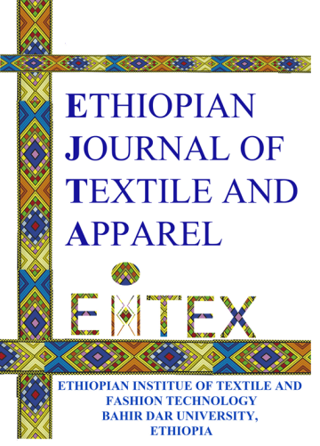

**Adisu Yirga , Seid Shiferaw & Leykun Fentaw**

Wollo University, Department of Textile Engineering, 208, Kombolcha-Ethiopia

Corresponding Author: adisuyirga82@gmail.com

OPTIMIZATION OF FIBER CHARACTERIZATION AND MACHINERY SETTINGS FOR HIGH-QUALITY POLYESTER/COTTON (P/C) BLEND YARN PRODUCTION

ISSN: (Print) (Online) Journal homepage: <https://journals.bdu.edu.et/index.php/ejta>

To cite this article: Adisu Yirga , Seid Shiferaw & Leykun Fentaw (2025) OPTIMIZATION OF FIBER CHARACTERIZATION AND MACHINERY SETTINGS FOR HIGH-QUALITY POLYESTER/COTTON (P/C) BLEND YARN PRODUCTION, Ethiopian Journal of Textile and Apparel, 68-79,

DOI: <https://journals.bdu.edu.et/index.php/ejta>

# OPTIMIZATION OF FIBER CHARACTERIZATION AND MACHINERY SETTINGS FOR HIGH-QUALITY POLYESTER/COTTON (P/C) BLEND YARN PRODUCTION

Adisu Yirga , Seid Shiferaw & Leykun Fentaw

Wollo University, Department of Textile Engineering, 208, Kombolcha-Ethiopia

Email: adisuyirga82@gmail.com

# ABSTRACT

The textile industry relies on fiber mixing and blending to enhance product quality and profitability. Understanding the impact of fiber properties on yarn quality is crucial for maintaining consistent product performance and optimizing manufacturing costs. The inconsistencies in yarn quality and profitability in spinning mills are often attributed to raw material variability, processing conditions, and lot-wise supply challenges. Key concerns include fluctuations in fiber diameter (Micronaire), inconsistent fiber color management, and uncontrolled fiber properties, all of which impact mixing efficiency and overall profitability. This study characterizes polyester and cotton fibers to optimize the production of polyester/cotton (P/C) blended yarns. Virgin polyester exhibited 46.25% higher tenacity compared to recycled polyester, whereas recycled polyester had 30.33% higher elongation. Recycled polyester also demonstrated higher crimp age value and greater crimp age stability, contrasting with findings in previous literature. Fourier-transform infrared spectroscopy (FTIR) analysis revealed greater chemical degradation in recycled polyester compared to virgin polyester. Scanning electron microscopy (SEM) images showed that recycled polyester fibers had a more entangled structure and coarser texture, resembling a spider-web appearance, which affects the fiber's spinnability. The study also examined the influence of drafting force on yarn properties. Results indicated that yarn tenacity improved with adjustments in breaker and finisher draw frame roller settings, with a more significant increase observed for 27 Nm yarn count. Conversely, elongation decreased under these conditions, while irregularity was reduced, particularly for finer yarn counts. These findings highlight the importance of precise process parameter optimization to achieve high-quality P/C blended yarns.

**KEYWORDS:** Cotton, Blending, Mixing, Polyester

# INTRODUCTION

The textile industry plays a crucial role in the global economy, supplying fabrics for various applications, including apparel, home textiles, and industrial uses. Among the different types of yarns produced, polyester/cotton (P/C) blend yarn is widely used due to its combination of polyester’s durability and cotton’s comfort. The blend provides improved tensile strength, better resistance to abrasion, and reduced shrinkage, making it a preferred choice in the textile industry (Choudhary, 2022; Patel, 2017; Zhao, 2017). However, ensuring high-quality P/C blend yarn is a challenge, as variations in fiber properties and inappropriate machinery settings can lead to inconsistent yarn quality, defects, and production inefficiencies (Goyal, 2020; Kothari, 2016).

The primary challenge in P/C blend yarn production is achieving uniformity and strength while minimizing imperfections such as neps, unevenness, and breakages. Fiber properties, including fineness, length, tensile strength, and moisture content, significantly impact the final yarn quality (Miao, 2019; Zhang, 2019). Cotton fibers, being natural, exhibit variations in length and fineness, while polyester fibers, being synthetic, have more uniform characteristics (Ahmed, 2021; Hussein, 2018). The differences in these fibers require careful selection and blending techniques to optimize the properties of the final yarn (Smith, 2021; Zhao, 2017). In addition to fiber properties, the spinning process plays a crucial role in determining yarn quality. Spinning machinery parameters such as draft ratio, spindle speed, twist, and tension settings influence the structure and mechanical properties of the yarn (Choudhary, 2022; Hussein, 2018). Incorrect settings can lead to excessive breakages, poor fiber alignment, and variations in yarn diameter, which affect fabric performance in subsequent processes like weaving and knitting(Goyal, 2020; Patel, 2017).

The optimization of fiber characterization and machinery settings is essential to enhance the quality of P/C blend yarn and improve overall manufacturing efficiency. Advanced fiber testing techniques, such as High-Volume Instrument (HVI) testing, can provide detailed insights into fiber properties, enabling better selection of raw materials (Smith, 2021; Zhang, 2019). Furthermore, statistical and experimental methods can be employed to analyze the effects of different machinery settings on yarn properties, leading to data-driven recommendations for process improvement (Barker, 2018; Choudhary, 2022). Implementing these optimizations can help reduce waste, improve productivity, and ensure consistent yarn quality, ultimately benefiting textile manufacturers and end-users (Kothari, 2016; Miao, 2019; Patel, 2017).

This study aims to analyze the influence of fiber properties such as fineness, length, and tensile strength on P/C blend yarn quality. Additionally, it evaluates the effect of critical machinery settings, including draft ratio, spindle speed, and tension, on yarn performance. By conducting experimental trials and statistical analysis, the research seeks to develop optimized processing parameters for achieving high-quality P/C blend yarn with enhanced uniformity and mechanical properties. Furthermore, recommendations for industrial applications will be provided to improve production efficiency and minimize defects. The findings of this study will be valuable for textile manufacturers looking to enhance their P/C blend yarn production process through scientific and systematic approaches (Goyal, 2020; Smith, 2021).

# LITRATURE REVIEW

**2.1 Fiber Properties and Their Impact on Yarn Quality**

Previous studies have shown that fiber properties, such as length, fineness, and strength, are critical in determining yarn quality (Miao, 2019; Zhang, 2019) highlighted the importance of blending ratios in achieving optimal yarn performance, emphasizing that improper mixing of polyester and cotton fibers can lead to inconsistencies in yarn strength and appearance. Similarly, Ahmed et al. (2021) demonstrated that cotton fiber maturity plays a significant role in reducing neps and improving yarn evenness. Polyester fibers, being more uniform in nature, can complement the inconsistencies of cotton, leading to better spinnability and improved final yarn properties(Patel, 2017).

Studies by Zhao et al. (2017) and Choudhary & Gupta (2022) indicated that fiber fineness plays a crucial role in yarn strength and evenness. Finer fibers tend to produce smoother and more uniform yarn, whereas coarser fibers contribute to irregularities. Additionally, fiber length distribution impacts the spinning process, influencing yarn tenacity and breakage rates (Smith, 2021). Fiber strength is another critical factor, with higher-strength fibers leading to improved tensile properties and lower yarn breakage rates (Barker, 2018).

**2.2 Machinery Settings and Their Influence on Yarn Performance**

The spinning process and machinery settings significantly influence the final yarn quality. Goyal and Mehta (2020) explored the impact of spindle speed and twist on yarn strength, demonstrating that higher spindle speeds can lead to increased breakages if not optimized properly. Hussein and Ramesh (2018) examined the role of draft ratio and tension, concluding that improper adjustments could lead to excessive fiber slippage and increased irregularities in yarn structure. Patel and Shah (2017) further emphasized that maintaining optimal draft ratios can help achieve better fiber alignment, reducing yarn hairiness and improving overall fabric performance.

Several sudies have also focused on the relationship between twist factor and yarn properties. Zhang et al. (2019) noted that excessive twist results in higher yarn strength but may compromise elasticity and fabric drape. On the other hand, insufficient twist can lead to weak yarn structure and poor weaving efficiency. The selection of appropriate machinery settings based on fiber characteristics remains a key challenge in achieving high-quality P/C blend yarn(Ahmed, 2021; Zhao, 2017).

**2.3 Identified Research Gaps**

Despite the existing body of research, significant gaps remain in understanding the combined effects of fiber characterization and machinery optimization on P/C blend yarn quality. Most studies have either focused on fiber selection or machinery settings independently, without integrating both aspects into a comprehensive optimization model (Smith, 2021; Zhao, 2017). Additionally, there is a lack of research employing advanced statistical modeling techniques, such as response surface methodology (RSM) and machine learning, to predict and optimize yarn properties (Barker, 2018; Choudhary, 2022).

Moreover, while several studies have explored the impact of individual fiber properties and machine settings, limited research has been conducted on the real-time monitoring and adaptive control of spinning parameters to dynamically adjust to fiber variations (Miao, 2019; Zhang, 2019). This study aims to bridge these gaps by systematically analyzing the interaction between fiber properties and machinery settings to establish optimized production parameters. The findings will contribute to the development of more efficient and precise manufacturing processes, reducing waste and improving overall production.

# RESEARCH METHODOLOGY

3.1**Materials**  
The study focuses on cotton, recycled polyester fibers, and a cotton/polyester blend yarn.

**3.2 Equipment and Apparatus**

The study utilized various machines and equipment, including blow room, carding, drawing, roving, and ring frame machines for fiber processing. Characterization was done using the High-Volume Instrument (HVI), FAVIMAT, SEM, and FTIR spectroscopy. Yarn strength and irregularity were measured with the ATO DYN 300 tester and Uster tester, providing a comprehensive evaluation of the fibers and yarn.

**3.3Methods**  
This research involves the development of a cotton/polyester mixed yarn intended for weaving fabric production, followed by its characterization.

**3.3.1 Material Selection and Data Collection**

**Cotton Fiber:** Test data for cotton fibers were directly sourced from Kombolcha Textile Share Company.

**Polyester Fiber:** Recycled polyester fiber data was obtained from Kombolcha Textile Share Company, and tests were conducted at Adama Science and Technology University, Leather Industry Research and Development Institute, and the Textile and Garment Industry Research and Development Institute.

**3.3.2 Characterization of Cotton and Polyester Fibers**

The cotton fibers were characterized according to the SITC Testing Guideline, which covers sampling and testing procedures for HVI lines. Key properties considered included micronaire (fineness and maturity), staple length (2.5% and 50%), short fiber content, trash content, strength, and fiber stickiness. For polyester fibers, characteristics such as fineness, strength, crimp percentage, surface morphology (via SEM), and functional group and crystallite structure (via FTIR) were examined.

**3.3.3 Adjusted Parameters**

The main parameters optimized in this study are the drawing frame break draft and the cotton/polyester blending ratios. Specifically, the study focuses on the breaker and finisher draw frame break drafts, and the fiber ratio of cotton to polyester is set at 65/35.

Table 3. 1 break draft setting adjustment

|  |  |  |  |
| --- | --- | --- | --- |
| **Draw Frame** | **Back Zone** | **Front Zone** | **Delivery Speed** |
| Breaker | 38 mm, 40 mm | 37 mm, 39 mm | 550 m/min |
| Finisher | 44 mm, 46 mm | 40 mm, 42 mm | 500 m/min |

**3.3.4 Production and Characterization of the Yarn**

The fibers were spun into yarn at Kombolcha Textile Share Company, with adjustments made to the settings on the draw frame and ring frame, as detailed below.

Table 3. 2 draw frame setting adjustment

|  |  |  |
| --- | --- | --- |
| **Draw Frame Machine Type** | **Sample 1** | **Sample 2** |
| Breaker Draw Frame | Back Zone: 38 | Back Zone: 40 |
|  | Front Zone: 39 | Front Zone: 37 |
|  | Speed: 550 m/min | Speed: 550 m/min |
| Finisher Draw Frame | Back Zone: 46 | Back Zone: 44 |
|  | Front Zone: 42 | Front Zone: 40 |
|  | Speed: 500 m/min | Speed: 500 m/min |

Table 3. 3 yarn parameter and measuring equipment

|  |  |  |
| --- | --- | --- |
| **Yarn Parameter** | **Equipment to Measure** | **Testing Standard Method** |
| Irregularity | Uster Tester 5 (Electronic Capacitance Method) | ASTM D1425 |
| Strength & Elongation | ATO DYN 300 Yarn Strength Tester | ASTM D2256 (Tensile Yarns Testing) |

# RESULT AND DISCUSSION

**4.1 Characterization of Fiber**

**4.1.1 Polyester Fiber**

In this research work the properties of both recycled and virgin polyester fibre materials and how they are affected by recycling has been analyzed.

As it was shown in table 4.1 and table 4.2 the tenacity of virgin polyester was 46.25% higher than recycled polyester. Researcher Luiz Gustavo Barbosa, Matheus Piaia and Gustavo Henrique Ceni had also shown that there was a change in the value of 3.87% for such property in their research work of “Analysis of Impact and Tensile Properties of Recycled Polypropylene”. Against to tenacity the crimpage of recycled polyester showed maximum number than virgin polyester as listed in the table 4.1 and table 4.2.

Table 4. 1 Favimate test result of virgin polyester

|  |  |  |  |
| --- | --- | --- | --- |
| S. No | Test parameters | Test result |  |
| 1 | Max. elongation (%) | 17.06 |  |
| 2 | Max. force (cN) | 8.28 |  |
| 3 | Work (break) | 1.39 |  |
| 4 | Tenacity (cN/tex) | 61.25 |  |
| 5 | Lin. Density(den.) | 1.23 |  |
| 6 | Time to rupture(sec) | 8.23 |  |
| 7 | Num. crimp/cm | 2.65 |  |
| 8 | Crimp % | 3.19 |  |
| 8 | Remaining crimp | 2.67 |  |
| 9 | Crimp force (cN) | 0.08 |  |
| 10 | Crimp stability | 78.6 |  |

Recycled polyester has a greater number of crimpage with higher number of crimp stability. Due to its consequential nature these properties will affect the spinnability and mixing ability of the fibre during yarn manufacturing. Similarly, the elongation of recycled polyester 30.33% higher than that of virgin polyester. But the test result in our research was against the literature analysis explained.

Table 4. 2 Favimate test result of recycled polyester

|  |  |  |  |
| --- | --- | --- | --- |
| S. No | Test parameters | result |  |
| 1 | Max. elongation (%) | 24.49 |  |
| 2 | Max. force (cN) | 10.56 |  |
| 3 | Work (break) cN*cm | 1.45 |  |
| 4 | Tenacity (cN/tex) | 32.92 |  |
| 5 | Lin. Density(den.) | 2.89 |  |
| 6 | Num. crimp/cm | 3.26 |  |
| 7 | Crimp % | 3.29 |  |
| 8 | Remaining crimp | 2.88 |  |
| 9 | Crimp force (cN) | 0.10 |  |
| 10 | Crimp stability | 87.63 |  |

The spectra of both virgin and recycled polyester showed little variation in the amplitude of the peaks. The maximum amplitude of the peaks for virgin polyester was seen at 95% of transmittance and 2200cm-1 wavenumber.

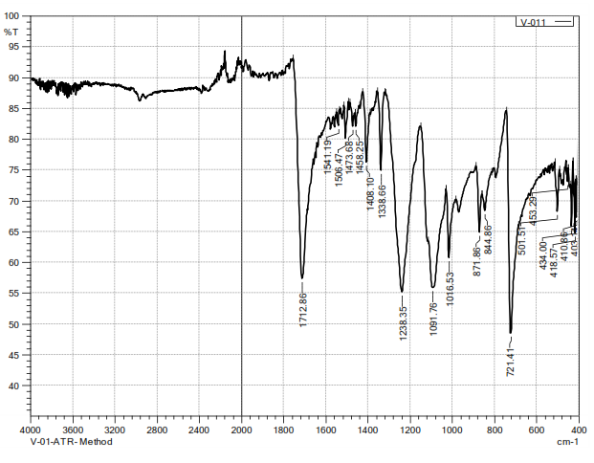

Figure 4. 1 FTIR result of virgin polyester

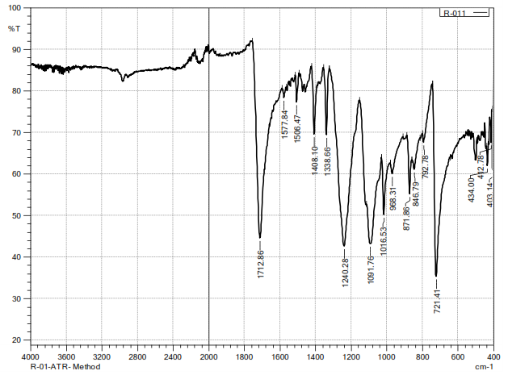

Figure 4. 2FTIR result of recycled polyester

whereas the maximum amplitude of the peaks for recycled polyester was seen at 92% transmittance and 1750 cm-1 wavenumber which all depends on the surface connection between the samples and the ATR-probe and does hence reflect the concentration of a given functional group as clearly shown in figure 4.1 and 4.2.

Both has been investigated under scanning electron microscope in order to compare their morphology and identify surface characteristics. It is clearly shown in scanned image at figure 8 and 9 there is a clear difference in between the surface of virgin and recycled polyester. The image was 200X magnified than the original fibre image.

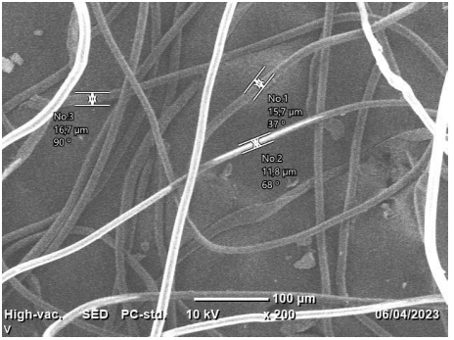

Figure 4. 3 SEM result of virgin polyester

Relatively the surface of virgin polyester is smoother than the surface of recycled polyester. Regarding to their micronaire value even virgin polyester has smaller figure (14.7 micrometer) than regenerated one that has 15.9 micrometer micronaire value. It is obvious that the higher the number of the micronaire value the courser the fibre is. Therefore, virgin polyester fibre is finer than recycled one as per the measured value displayed at SEM scanned image at figure 4.3 and 4.4. It has been explained profoundly in the literature review part of the research; despite of the type of the fibre the fibre fineness plays an important role during spinning. As it was explained in the literature review section low micronaire value (courser) causes high neps generation in blow room and carding, which lead to higher neps and imperfection in final yarn and white spots or dots in dyed fabric. Fibre with low fineness (course) always have tendency to form fibre entanglement or neps and fibre with higher micronaire (finer) will results to higher unevenness in ring spun yarn.

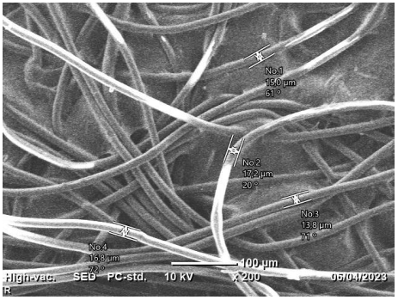

Figure 4. 4 SEM result of recycled polyester

On the other side too much variation in micronaire values different fibre that are intended to be mixed can lead to barre problem or shade variation in fabric. As a result, it is recommended to use right micronaire value for a particular spin plan. The third point that can be clearly observed from SEM image is that regenerated fibre has more entangled and complicated surface appearance whereas the number of entanglements in the virgin polyester is less. The entangled tube-like component in addition of being entangled it is connected with the smooth component which is resembled to spider web in recycled polyester and this phenomenon is not observed in virgin polyester.

**4.1.2 Cotton Fiber**

Cotton fibers are four different origins, the length level is described in Table 4.3. The length uniformity index is very important for yarn production efficiency as well as yarn strength and evenness. The average length of the upper half of cotton fiber is defined as the length of the cotton fiber.

The length uniformity indices (2.5% and 50% span length) provide an indication of short fiber percentags; it can be predicted that yarn quality would be low because of the inefficiency of processing with short cotton fibers. The length of selected areas of cotton samples is between 28.6 and 29.4 mm. The areas to be selected Nassa, Awash, Middle Awash and Genda Wuhu, the average 2.5% span length are 29.4, 28.6, 28.6 and 28.6 respectively.

Therefore, according to the above data described, the Nassa cotton fiber, which are longer will increase the yarn efficiency because of an increase in the fiber friction and cohesion between each other; thus, they will exhibit better properties resulting in increased yarn strength (Negm et al., 2015).

Table 4. 3 Cotton fiber test result

|  |  |  |  |  |  |
| --- | --- | --- | --- | --- | --- |
| Origen | 2.5% staple length(mm) | 2.5% staple length(mm) | short fibre(%) | trash content (%) | strength g/tex |
| Nassa | 29.4 | 13.23 | 11.4 | 7.34 | 24.7 |
| Awash | 28.6 | 12.7 | 13.1 | 6.1 | 24.3 |
| Middle awash | 28.6 | 12.9 | 12.2 | 4.8 | 23.4 |
| Genda wuha | 28.6 | 12.25 | 14.15 | 3.71 | 23.63 |

There are a number of reasons that influence the resulting amount of short fiber content; among them, harvesting and ginning are the most important factors that influence short fiber contents (Garner et al., 2007). In the drawing process, the short fiber is often not easy to be controlled, resulting in poor yarn evenness and reduction in yarn strength (Lawrence, 2003).

HVI test method used for the fiber shows that the above table 4.3, short fiber percentage of cotton fibers of Nassa, Awash, middle Awash and Genda Wuhu are 11.4, 13.1, 12.2 and 14.15 respectively. The short fiber percentage of Genda Wuhu and A wash fibers is significantly higher than that of Nassa and Middle Awash cotton fibers, indicating that Nassa and middle awash cotton samples will give relatively better yarn uniformity than other cotton fibers.

Tensile strength is corresponding to a maximum tensile load of fiber that can bear, expressed in units of g/tex. Tensile properties that depend on the structure of cotton fibers have a great influence on textile end products. Cotton fibers are not homogeneous in their physical properties and dimensions. Their maturity, diameter, and fineness are different from fiber to fiber (Hosseinali, 2012).

According to the evaluation criteria of the tensile strength, we can see from Table 7 that the tensile strength of cotton fiber for Nassa, Awash, middle awash and Gunda Wuhu are 24.7, 24.3 23.4 and 23.63 respectively. Nassa and Awash cotton fiber breakage intensity indicates a strong breaking strength.

Trash is measured in terms of the amount of nonlint substances in the cottonfiber. The obove Table shows the comparison of four origin cotton fiber trash contents. From the Table, we can see that the trash of Nassa, Awash, middle awash and Genda Wuhu are 7.34, 6.1, 4.8, and 3.71 respectively. Nassa and middle awash cottons are the higher number of impurities and impurity areas.

**4.2 Yarn Test Results**

Draw frame process avails the last chance to improve the sliver irregularities and to eliminate the dust and impurities present in the carded sliver. There is no other chance to eliminate the irregularities and impurities left in the sliver in the further process of yarn manufacturing.The hooked and curled fibres are straightened and fibre arrangement in the sliver is improved by making fibres parallel along the sliver length. Draft setting and distribution are imperative for spinners; it affects yarn evenness and strength.

Figure 4. 5 Yarn strength test result

Where, Trial 1: Only Braker DF draft roller distance changed for 27 Nm

Trial 2 : both Braker and Finisher DF draft roller distance changed for 27 Nm

Trial 3 : Only Braker DF draft roller distance changed for 34 Nm

Trial 4 : both Braker and Finisher DF draft roller distance changed for 34 Nm

The result revealed from figure 10. showed that, Changing the drafting roller distance between back roller and middle roller and also between middle roller and front roller have effect on tenacity. Because, if the space between rollers are short the probability of short fiber move out to central axis of the sliver decrease and get the required draft appropriately but the space will optimized otherwise frequently cause a drafting wave in the drafted roving, thus undermining the quality of the spun yarn.

The improvement in strength of the yarn from trials to trials is more for coarser yarn. However, when compared to ktsc produced yarn strength result the changes on draft roller setting the finer count have more improvements. Yarn elongation refers to the percentage increase in length that a yarn can undergo when subjected to a specific amount of tension or stress. It is a measure of the ability of a yarn to stretch or elongate under applied load. Yarn elongation is an important characteristic in various textile applications as it affects the flexibility, stretchability, and overall performance of fabrics and products. It is influenced by factors such as fiber type, yarn structure, twist level, and processing conditions.

Figure 4. 6 yarn elongation test result

Fig 4.6 Shows that when the researcher changes both breaker and finisher DF the yarn exhibits low elongation properties for both counts this may be the result of uniformity of the fiber distribution increases however, for 27 Nm count the difference is high

When we compare the result with control samples 27 Nm count have more decreases elongation percentage than 34 Nm count samples.

Table 4. 4 yarn irregularity test result

|  |  |  |  |  |  |
| --- | --- | --- | --- | --- | --- |
| Sample No. | U% | CVm [%] | Neps/KM | Thick/Km  50% | Thin/Km  -50% |
| Trial 1 | 11.08 | 14.16 | 83.2 | 138.0 | 1.2 |
| Trial 2 | 10.04 | 14.09 | 74.6 | 109.6 | 4.2 |
| Trial 3 | 11.78 | 14.99 | 152.0 | 211.0 | 6.0 |
| Trial 4 | 12.78 | 16.88 | 165.0 | 326.0 | 16.0 |
| Control for 27 Nm | 11.6 | 14.78 | 125 | 157.6 | 14.8 |
| Control for 34 Nm | 12.12 | 15.71 | 165 | 272.5 | 20.2 |

The overall yarn irregularity expressed in unevenness (U%), coefficient of variation (CVm), nonstick and thin places observed from table 4.4 shows that, the irregularity of the yarn is less when we change both breaker and finisher DF draft roller setting changed when compare with control yarn test results due to proper drafting force given to the fiber which align every fiber on the axis of the yarn cross section. Finer count yarns exhibit more decrease unevenness and irregularity than courser count yarn during experiments result.

# Conclusion

The analysis of recycled polyester from Kombolcha Textile Share Company reveals significant deviations from previously established research findings. Morphological examination shows multiple defects that could negatively impact yarn quality, while FTIR results indicate no substantial difference between recycled and virgin polyester. Findings from FAVIMATE, FTIR, and SEM suggest that deficiencies in fiber properties contribute to challenges in the spinning process.

Cotton fibers sourced from Nassa, Awash, Middle Awash, and Gunda Wuhu were evaluated using the HVI testing system. Tensile strength emerged as a critical factor influencing mechanical performance, with stronger fibers contributing to improved crystallinity. Yarn tenacity increases with optimized braker and finisher DF roller settings, particularly for 27 Nm count. However, the relationship between drafting force and yarn strength is nonlinear—both excessive and insufficient force can lead to defects. Higher drafting force reduces elongation by limiting fiber stretchability, whereas lower force increases elongation but may cause irregularities. Yarn evenness is also influenced by drafting force, with improper tension leading to defects such as thin places, slubs, or neps.

Careful optimization of fiber properties and drafting parameters is essential to improving yarn strength, elongation, and uniformity, ensuring high-quality production that meets industrial standards.

# Referance

Ahmed, S., Khan, M., & Rahman, A. (2021). Advances in fiber blending technology. Textile Science Journal, 45(2), , 125-139.

Barker, R. (2018). The role of fiber characterization in modern textile engineering. International Journal of Textile Technology, 33(4), 231-245.

Choudhary, P., & Gupta, N. (2022). Statistical optimization of spinning parameters for blended yarns. , . Journal of Textile Engineering, 50(1), 57-72.

Garner, W. E., Shanklin, E. H., & LaFerney, P. E. (2007). Fiber quality and ginning performance of machine picked and stripped cotton, southeastern area, 1964-66.

Goyal, D., & Mehta, P. . (2020). Influence of spinning speed on polyester/cotton blended yarn properties. Fiber & Textile Research Journal, 47(3), 189-204.

Hosseinali, F. (2012). Investigation on the tensile properties of individual cotton (Gossypium hirsutum L.) fibers

Hussein, R., & Ramesh, T. . (2018). Effect of twist and tension on yarn evenness and strength. Textile Research International, 42(5), 345-360.

Kothari, V. (2016). Advances in polyester/cotton blending techniques. Polymer & Fiber Science Review, 29(6), 278-293.

Lawrence, C. A. (2003). Fundamentals of spun yarn technology. Crc Press.

Miao, Y., Wang, Z., & Li, P. . (2019). Understanding fiber morphology for better textile applications. Journal of Textile Materials, 38(8), 398-414.

Negm, M. A., Sanad, S. H., & Kugler, G. (2015). A comparison of HVI, AFIS and CCS cotton testing method. 12th Meeting of the Inter-Regional Cooperative Research Network on Cotton for the Mediterranean and Middle East Region,

Patel, A., & Shah, R. . (2017). Process control techniques in yarn manufacturing. Textile Manufacturing Insights, 36(2), 89-104.

Smith, J., Thompson, L., & Williams, R. . (2021). The impact of fiber selection on blended yarn properties. Journal of Textile & Apparel Technology, 48(4), 213-226.

Zhang, X., Chen, H., & Liu, J. . (2019). High Volume Instrument testing in fiber characterization. Fiber Quality Assessment Journal, 40(9), 512-530.

Zhao, W., Sun, K., & Dong, L. . (2017). Polyester/cotton blends: Challenges and innovations. Textile Science & Technology Review, 32(1), 15-28.