

PREPARATION OF NANOFIBER MEMBRANES FOR AIR

FILTRATION APPLICATIONS

**Abdul Wahid1, Hongnan Zhang1, Xiaohong Qin1\***

1Key Laboratory of Textile Science & Technology, Ministry Education, College of Textiles, Donghua University, Shanghai 201620, China

*Corresponding Author: xhqin@dhu.edu.cn

ISSN: (Print) (Online) Journal homepage: <https://journals.bdu.edu.et/index.php/ejta>

To cite this article: Abdul Wahid, Hongnan Zhang & Xiaohong Qin, (2025) PREPARATION OF NANOFIBER MEMBRANES FOR AIR FILTRATION APPLICATIONS, Ethiopian Journal of Textile and Apparel 81 - 87,

DOI: <https://journals.bdu.edu.et/index.php/ejta>

# PREPARATION OF NANOFIBER MEMBRANES FOR AIR

# FILTRATION APPLICATIONS

Abdul Wahid1, Hongnan Zhang1, Xiaohong Qin1*

1 Key Laboratory of Textile Science & Technology, Ministry Education, College of Textiles, Donghua University, Shanghai 201620, China

*Corresponding Author: xhqin@dhu.edu.cn

**ABSTRACT**

Polyacrylonitrile (PAN) nanofibers have been increasing in interest due to their unique morphology and characteristics. The morphology of PAN fibers can make it a promising candidate for air filtration applications. The nonwoven nanofiber membranes with surface morphology that can be produced by the electrospinning techniques in this research. PAN was chosen as a functional polymer especially for this purpose; it tends to produce a unique pore structure and nanoscale fiber diameters, while the distinct concentrations of polymer produce membranes. The relative amount of N,N-dimethylformamide (DMF) used as a solvent and fabricated beadles nanofibers was investigated. The air filtration experiment shows that nonwoven membranes with pore structures have advantages of higher filtration capability. The results indicate that the filtration efficiency of the nanofiber membranes is higher in the smallest pore size compared to the largest pore size structures. The maximum filtration efficiency is 99.99% at a 32 l/min airflow rate achieved. These membranes are used for the removal of contaminations from the air. The FESEM analysis shows that the surface morphology of membranes is a key factor for the high filtration efficiency. In addition, the nonwoven PAN nanofiber membranes can make their potential applications candidates in fields such as medicine, separation, and intelligent devices.

**KEYWORDS**: Electrospinning; Pan nanofibers; Unique pore structure; nanoscale diameter; Filtration.

**INTRODUCTION**

Massive amounts of pollution in the environment and diseases caused by airborne particles led to the creation of filter materials with strong antibacterial and filtering capabilities (He et al., 2016, Yao et al., 2002). Bacteria make up over 80% of inhalable microorganisms in PM, causing respiratory diseases and allergies, making bactericidal air filters highly desirable (Cao et al., 2014). Membrane filtration, a widely accepted physical approach for screening against air contaminants, is the most efficient and reliable (Givehchi and Tan, 2015). Filters should be durable, easy to handle, low-production-cost, flexible to meet specific requirements, low-pressure drop, and sustainable (Vinh and Kim, 2016). Traditional, glass-based material, melt-blown, and spun-bond fibrous filters are all commonly utilized for air filtration; however, due to their immense pores and nanoscale diameter, they are not highly efficient at filtering tiny particles (Wang et al., 2016). Nanofibers typically produced by electrospinning, which is attracting creativity due to their narrow diameters, enormous surface areas, and controllable pore size (Al-Attabi et al., 2018, Matulevicius et al., 2016). However, producing suitable nanofibers for separation and filtration applications remains a challenge (Li et al., 2013), such as face masks that protect against PM2.5 (Huang et al., 2018). To evaluate the parameters of electrospinning, concentration of solution, flow rate, distance between collector and needle, voltage, and spinning time investigated. The concentration of polymers influences the viscosity of the solution; a higher viscosity favors the electrospinning of fibers without beads, whereas the same lower surface tension (Huang et al., 2018).

A nonwoven filtering subtract, polyacrylonitrile (PAN) has excellent solvent resistance, strong durability, thermal stability, and simplicity in fiber fabrication (Wang et al., 2014). High filtration efficiency for fine particles is typically an advantage of nanofiber membranes, although they also have an excessive pressure drop (Wang et al., 2016). Selecting an appropriate substrate for nanofiber deposition is also essential to producing a permeable and durable fiber filter.

In this research, we prepare uniform and beadles PAN nanoﬁber membranes for outstanding air ﬁltration performance. PAN nanoﬁbers were deposited on the nonwoven substrate by the electrospinning technique. In order to determine the optimum manufacturing conditions, the eﬀects of several electrospinning process parameters were analyzed such as concentration of polymer, distance between collector and needle, ﬂow rate, high voltage, and spinning time. PAN nanoﬁbers were characterized by field emission scanning electron microscopy (FESEM), water contact angle (WCA), and Air permeability performance were determined. In addition, an automated filtration-testing machine with a mass median diameter of 260 nm and a count median diameter of 75 nm. The sample tested air filters with solid NaCl particles, using EN779: 2012 and IEST-RP-CC52.2-2007 standards, and measured five FNMs specimens under the same conditions.

**EXPERIMENTAL METHOD**

Polyacrylonitrile (PAN, Mw 150,000 Sigma-Aldrich) was purchased from Beijing Yili Fine Chemical Co., Ltd., China. N, N-dimethylformamide (DMF; 0.945−0.950 g/mL at 20 °C) and tetrahydrofuran (THF; 0.887−0.889 g/mL at 20°C) were purchased from Sigma-Aldrich. All of these materials were used without further purification.

A homogeneous polymeric solution was prepared by dissolving the PAN powder in a DMF solvent and stirring for 12 h at 60°C temperature, and all experiments were performed at about 25°C in air at 40−60 % relative humidity.

**Experimental Setup**

In this work, we used a single needle based electrospinning setup, which was introduced in previous work . The electrospinning setup is shown in Fig. 1 and blunt-type stainless 14Ga needle was used. The solutions were fed into the spinneret via corresponding syringe and pump (KDS 220, KD Scientific, Inc. USA). A high-voltage supply (ES-60P 10W/DDPM, Gamma High Voltage Research, USA) was applied to the spinneret and the collector, the rotating speed of cylinder is 100 RPM.

**Characterization**

The morphology of the resultant nanofibers was observed under a field emission scanning electron microscope (FESEM, SU8010 Japan Hitachi Corporation) after gold coating (coating time was 60 s). The average nanofiber diameter was calculated from the FESEM images using ImageJ software*.*

Human breath exhalation contains moisture with a relative humidity of 40–90% (Mansour et al., 2020). Hydrophobic membrane materials are ideal for wicking away moisture and providing comfort for the wearer. Therefore, the sessile drop method was used on a contact angle meter to determine the contact angle and surface wetting property of nanofiber membranes. Approximately 10 µl of DI water was applied to the nanofiber membranes surface, and the system's picture- capture feature was used to measure the contact angle.

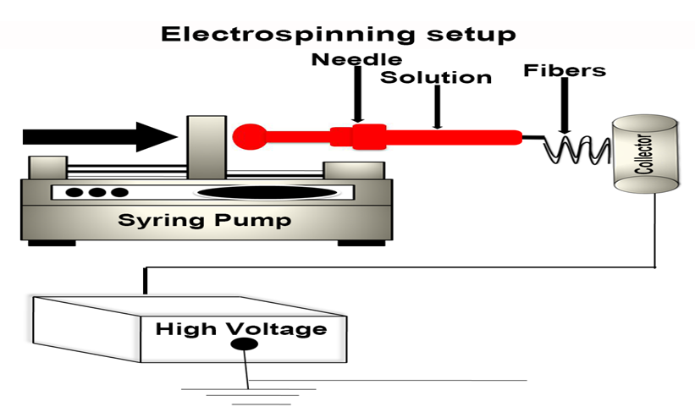

**Figure 1.** Schematic of single needle based electrospinning setup.

The YG461E air permeability tester was used to measure the air permeability of the nanofiber membrane. The configuration provides a firm hold on the membrane while allowing perpendicular airflow through an area of the membrane surface area of about 20 cm2 (diameter ~ 5 cm). For each thickness, three samples underwent testing. The inlet airflow rate across the membrane is gradually changed during testing, and the flow rate that corresponds to a specific predefined pressure drop is recorded in accordance with the ISO standard (EN ISO 9237:1995).

The nanofiber membrane filtration efficiencies were assessed on an automated filtration testing machine (Models 8130 and 3140, TSI Group, America). This machine's mass median diameter of 260 nm and a count median diameter of 75 nm for the charge-neutralized monodisperse solid NaCl particles were provided by the TSI 8130 and 3140. According to the most recent European standard (EN779: 2012) and USA standard (IEST-RP-CC52.2-2007) used air filters, the solid NaCl particles passed through the filter with an effective area of 100 cm2, and all filtration tests were conducted at room temperature under a continuous airflow face velocity of 5.33 cm s−1. There are five nanofiber membranes specimen that were measured under the same conditions.

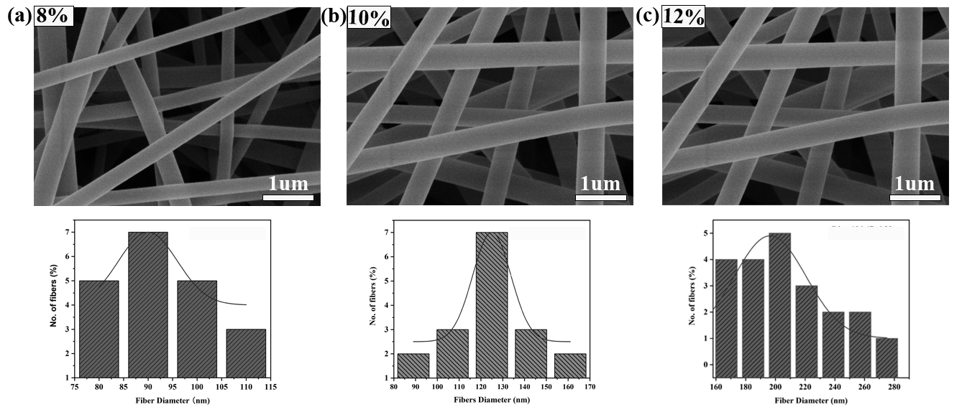**Figure 2**SEM images of the nanofiber with (a) PAN 8%, (b) PAN 10%, and (c) PAN 12% membranes, and the diameter distribution curves of each nanofiber membranes, respectively.

**RESULTS AND DISCUSSION**

**Morphologies and properties of PAN nanofiber membranes**

Initially, by varying the fiber diameter, the impacts of the fiber diameter on the nanofiber membranes filtration performance were examined. PAN-8, PAN-10, and PAN-12 nanofiber membranes were separately prepared, and the fabric substrate feeding speeds of 1.0 ml/h were used to adjust the nanofiber membrane thickness and pore size. As shown in Figure 2 the nanofibers had smooth surfaces, uniform distribution, and randomly oriented membranes. This mean diameter of the PAN-12 nanofibers was ∼196 nm, and the diameters of the PAN-10 and PAN-8 fibers decreased to ∼124 nm and ∼89 nm, respectively; narrow diameter distributions for the PAN-8 and PAN-10 fibers were shown in Fig. 2.

**Design and construction of nanofiber membranes**

Nanofiber membranes with in a range of fiber sizes and densities were devised to achieve multi-level filtering in the construction of air filter with high efficiency and low resistance. To achieve high efficiency, low resistance, large dust holding capacity, and long service life of the nanofiber filter, it serves a specific role in efficiently sieving and filtering particles of different dimensions. The electrospinning setup was used to electrospun nanofiber membranes with three distinct diameters and pore sizes. In addition, measurements of the pore structures were made in order to investigate the relationship between the pore size and the fiber internal structural arrangement. The aperture channels going through the airflow on the front and back sides were changed. It’s mainly attributed to the pore size distribution of the fiber membrane.

**Contact angle of nanofiber membranes**

Contact angle of nanofiber membranes was illustrated in Figure 3. The average contact angle of the nanofiber membrane was > 90°, ~ 109°, ~ 120°, ~ 125°, respectively, indicating their hydrophobic nature. Its properties are thought to be responsible for drying out PAN nanofibers.

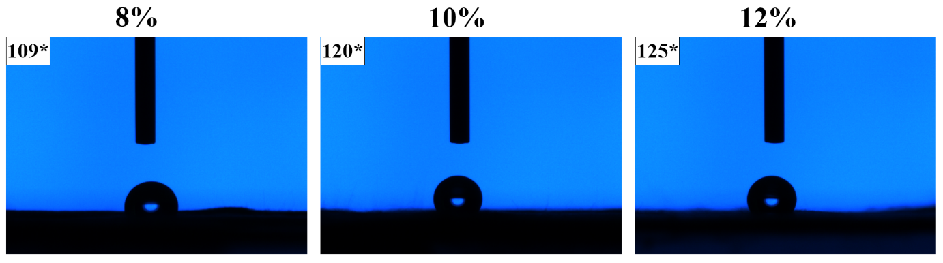

**Figure 3** Water contact angles of PAN nanofiber membranes (fine, medium, and coarse). respectively.

**Air permeability performance of nanofiber membranes**

The air permeability of nanofiber membranes of different thicknesses was measured at the same pressure drops of 100 Pa. When the pressure drops to 100 Pa were applied to membranes of varying thickness, it was found that the air permeability of the thinnest membranes increased as shown in Figure 4. Since there were fewer tortuous paths for air to go across the membranes with varying thicknesses, the air permeability was higher in the thinner membranes. The measured air permeability for the nanofiber membranes was in the range reported in the literature (Kucukali-Ozturk et al., 2017, Ruan et al., 2020).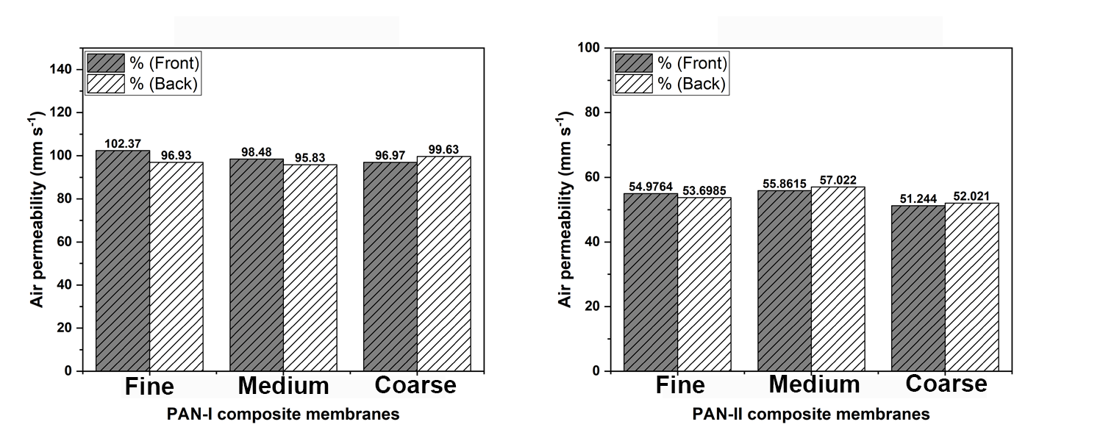

**Figure 4** Air permeability performance of nanofiber front and back (fine, medium, and coarse) membranes.

**Particles filtration efficiency of nanofiber membranes**

The particles filtration efficiency test was performed on (fine, medium, and coarse) nanofiber membranes, and each test was repeated five times on nanofiber membrane specimen, respectively. Figure 5 shows the different sizes of airborne particles filtered at nanofiber membranes. It means that lager thickness of membrane was optimum result that filtered particles of all sizes effectively. The performance of particles filtration efficiency increased at thick and decreased at thin thickness of nanofiber membranes

**Figure 5** Particle filtration efficiency of nanofiber membranes at different thicknesses and particle sizes. 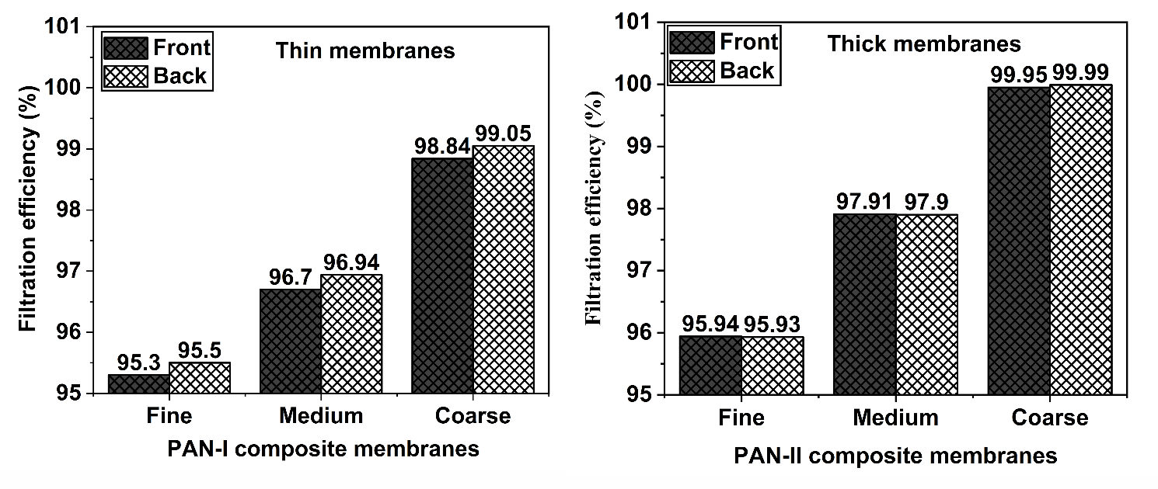

**CONCLUSION**

This research work was synthesized nanofiber membranes to the high-efficiency air filtration through electrospinning for larger-scale manufacturing. These nanofiber consisting of C, M, and F membranes was successfully designed as 3D-dimensional membrane for filtration media. It was observed how to works of these membrane affected the functionality of the nanofiber membranes; among these, nanofiber membranes displayed optimal air permeability to NaCl aerosol particles at an airflow velocity of 5.33 cm s-1, with a filtration efficiency of 99.99%. The F membrane primarily enhanced filtration efficiency, while the C and M membranes reduced air resistance. it's cost-effective filter with small width could be produced by electrospinning with a single needle process. This work a versatile approach to design for high-efficiency performance filters that effectively separate PM0.3 and PM0.19 pollutants for use in indoor air purification and respiratory protection, as well as commercial applications at industrial scale.

**Acknowledgements**

This work was partly supported by the grants (52003044, 52373069 and 52373032) from the National Natural Science Foundation of China, International Cooperation Fund of Science and Technology Commission of Shanghai Municipality (21130750100), and Major Scientific and Technological Innovation Projects of Shandong Province (2021CXGC011004). This work has also been supported by the Chang Jiang Scholars Program to Prof. Xiaohong Qin.

**REFERENCES**

AL-ATTABI, R., DUMÉE, L. F., SCHÜTZ, J. A. & MORSI, Y. 2018. Pore engineering towards highly efficient electrospun nanofibrous membranes for aerosol particle removal. Sci Total Environ, 625, 706-715.

CAO, C., JIANG, W., WANG, B., FANG, J., LANG, J., TIAN, G., JIANG, J. & ZHU, T. F. 2014. Inhalable Microorganisms in Beijing’s PM2.5 and PM10 Pollutants during a Severe Smog Event. Environmental Science & Technology, 48, 1499-1507.

GIVEHCHI, R. & TAN, Z. 2015. The effect of capillary force on airborne nanoparticle filtration. Journal of Aerosol Science, 83, 12-24.

HE, M., ICHINOSE, T., KOBAYASHI, M., ARASHIDANI, K., YOSHIDA, S., NISHIKAWA, M., TAKANO, H., SUN, G. & SHIBAMOTO, T. 2016. Differences in allergic inflammatory responses between urban PM2.5 and fine particle derived from desert-dust in murine lungs. Toxicol Appl Pharmacol, 297, 41-55.

HUANG, X., JIAO, T., LIU, Q., ZHANG, L., ZHOU, J., LI, B. & PENG, Q. 2018. Hierarchical electrospun nanofibers treated by solvent vapor annealing as air filtration mat for high-efficiency PM2.5 capture. Science China Materials, 62, 423-436.

KUCUKALI-OZTURK, M., OZDEN-YENIGUN, E., NERGIS, B. & CANDAN, C. 2017. Nanofiber-enhanced lightweight composite textiles for acoustic applications. Journal of Industrial Textiles, 46, 1498-1510.

LI, J., GAO, F., LIU, L. Q. & ZHANG, Z. 2013. Needleless electro-spun nanofibers used for filtration of small particles. Express Polymer Letters, 7, 683-689.

MANSOUR, E., VISHINKIN, R., RIHET, S., SALIBA, W., FISH, F., SARFATI, P. & HAICK, H. 2020. Measurement of temperature and relative humidity in exhaled breath. Sensors and Actuators B: Chemical, 304, 127371.

MATULEVICIUS, J., KLIUCININKAS, L., PRASAUSKAS, T., BUIVYDIENE, D. & MARTUZEVICIUS, D. 2016. The comparative study of aerosol filtration by electrospun polyamide, polyvinyl acetate, polyacrylonitrile and cellulose acetate nanofiber media. Journal of Aerosol Science, 92, 27-37.

RUAN, D., QIN, L., CHEN, R., XU, G., SU, Z., CHENG, J., XIE, S., CHENG, F. & KO, F. 2020. Transparent PAN: TiO 2 and PAN-co-PMA: TiO 2 nanofiber composite membranes with high efficiency in particulate matter pollutants filtration. Nanoscale Research Letters, 15, 1-8.

VINH, N. D. & KIM, H.-M. 2016. Electrospinning Fabrication and Performance Evaluation of Polyacrylonitrile Nanofiber for Air Filter Applications. Applied Sciences, 6, 235.

WANG, Y., LI, W., XIA, Y., JIAO, X. & CHEN, D. 2014. Electrospun flexible self-standing γ-alumina fibrous membranes and their potential as high-efficiency fine particulate filtration media. Journal of Materials Chemistry A, 2, 15124-15131.

WANG, Z., PAN, Z., WANG, J. & ZHAO, R. 2016. A novel hierarchical structured poly(lactic acid)/titania fibrous membrane with excellent antibacterial activity and air filtration performance. J. Nanomaterials, 2016, Article 39.

YAO, X., CHAN, C. K., FANG, M., CADLE, S., CHAN, T., MULAWA, P., HE, K. & YE, B. 2002. The water-soluble ionic composition of PM2.5 in Shanghai and Beijing, China. Atmospheric Environment, 36, 4223-4234.