

**Demise Alebachewa, Getabalew Shifera Weldegruma*, Aknachew Mebreku Demekub,c, Tekalign Tesfayea, Endashaw Tilahun Gizawud,Nigus Maregu Demewoze, f, Beshir A. Husseing, Shimeles Addisu Kitteh, Cheru Talibachew Hailec**

aDepartment of Chemistry, Mettu University, Mettu Ethiopia, P.O.Box 318

bDepartment of Materials Science and Engineering, National Taiwan University of Science and Technology, Taipei 106335, Taiwan

cDepartment of physics, Debre Berhan University, P.O. Box: 445, Debre Berhan, Ethiopia

dDepartment of physics, Woldia university, Woldia 400 , Ethiopia

eDepartment of Mechanical & Industrial Engineering, University of Toronto, Toronto, Ontario M5S 3G8, Canada

fDepartment of Physics, Wollo University, Dessie, Ethiopia

gDepartment of Chemistry, MekdelaAmba University, Ethiopia, P.O.Box 32

hDepartment of Chemistry, Jimma University, Jimma Ethiopia, P.O.Box 378

Corresponding author email: getabalewsos@gmail.com

ENSET PLANT CORM DERIVED REDUCED GRAPHENE OXIDE (E-RGO/FE3O4/PANI) NANOCOMPOSITE FOR ENERGY PRODUCTION AND TOXIC METAL BIOREMEDIATION VIA MICROBIAL FUEL CELLS

ISSN: (Print) (Online) Journal homepage: <https://journals.bdu.edu.et/index.php/ejta>

To cite this article: Getabalew Shifera Weldegrum et al. (2025) ENSET PLANT CORM DERIVED REDUCED GRAPHENE OXIDE (E-RGO/FE3O4/PANI) NANOCOMPOSITE FOR ENERGY PRODUCTION AND TOXIC METAL BIOREMEDIATION VIA MICROBIAL FUEL CELLS, Ethiopian Journal of Textile and Apparel, 7-42,

DOI: <https://journals.bdu.edu.et/index.php/ejta>

# ENSET PLANT CORM DERIVED REDUCED GRAPHENE OXIDE

# (E-RGO/FE3O4/PANI) NANOCOMPOSITE FOR ENERGY PRODUCTION AND TOXIC METAL BIOREMEDIATION VIA MICROBIAL FUEL CELLS

Demise Alebachewa, Getabalew Shifera Weldegruma*, Aknachew Mebreku Demekub,c, Tekalign Tesfayea, Endashaw Tilahun Gizawud,Nigus Maregu Demewoze, f, Beshir A. Husseing, Shimeles Addisu Kitteh, Cheru Talibachew Hailec

aDepartment of Chemistry, Mettu University, Mettu Ethiopia, P.O.Box 318

bDepartment of Materials Science and Engineering, National Taiwan University of Science and Technology, Taipei 106335, Taiwan

cDepartment of physics, Debre Berhan University, P.O. Box: 445, Debre Berhan, Ethiopia

dDepartment of physics, Woldia university, Woldia 400 , Ethiopia

eDepartment of Mechanical & Industrial Engineering, University of Toronto, Toronto, Ontario M5S 3G8, Canada

fDepartment of Physics, Wollo University, Dessie, Ethiopia

gDepartment of Chemistry,MekdelaAmba University, Ethiopia, P.O.Box 32

hDepartment of Chemistry, Jimma University, Jimma Ethiopia, P.O.Box 378

Corresponding author email: [getabalewsos@gmail.com](mailto:getabalewsos@gmail.com)

**ABSTRACT**

Microbial fuel cell (MFC) technology is currently receiving a great deal of attention as a promising and sustainable technology for generating electricity and reducing environmental pollution. However, low energy generation and the cost of producing anode materials have hindered the commercial viability of MFCs. In this work, the double chamber of MFCs was equipped with an anode made of enset corm biomass-waste-derived graphene derivatives (E-rGO). Furthermore, composite-based anodes (E-rGO/Fe3O4 and E-rGO/Fe3O4/PANI) have been developed to remediate Cr (VI) and Pb (II) ions in wastewater while producing energy in order to increase the electron transmission rate. The synthesis materials were analyzed through UV-Vis, SEM, and XRD, FTIR, RAMA and TGA spectroscopy to examine their optical, morphological, structural properties, molecular vibration states, structural defects, and thermal stability of the materials, respectively. CV and EIS were also utilized to investigate the electrochemical characteristics of the synthesized materials. For Cr (VI), the anodes made using E-rGO, E-rGO/Fe3O4, and E-rGO/Fe3O4/PANI nanocomposites (NCs) had remediation efficiencies of 70.6%, 79.2%, and 88.3%, while for Pb (II), they were 65.1%, 73.8%, and 86.5%.Furthermore, the composite anode (E-rGO/Fe3O4/PANI NCs) delivered a maximum power density of (63mW/m2) and a current density of (1312mA/m2), higher than E-rGO and E-rGO/Fe3O4 modified anode electrode power density (8.75 and 39.77mW/m2) and current density (609 and 1171 mA/m2), respectively.

**KEYWORDS:** Anode modification, Energy production, Graphene Oxide, Microbial fuel cells, Wastewater treatment

**1. INTRODUCTION**

Currently, research on energy production and bioremediation of toxic pollutants through microbial fuel cell (MFC) technology is receiving a great deal of attention (A. A. Yaqoob, Ibrahim, Yaakop, Umar, & Ahmad, 2021). MFCs have emerged as a favorable way to remove toxic pollutants and simultaneously convert chemical energy into electrical energy with the help of biocatalysts (Hein, Evans, & Jones, 2008). In this approach, electro active bacterial species known as exoelectrogens act as catalysts, oxidizing the provided organic substrate to produce electrons and protons (Du, Li, & Gu, 2007; Logan, 2009). The generated electrons move from the microbe to the anode, then through an external circuit to the cathode, where they are used to produce electricity and reduce electron acceptors. Meanwhile, protons move from the anode to the cathode through the proton exchange membrane (PEM) to complete the circuit (Sonawane, Yadav, Ghosh, & Adeloju, 2017). Microorganisms can also transfer electrons to electron acceptors that exist in an insoluble state, significantly reducing the toxic effect of pollutants from wastewater (G. Yang et al., 2019) . The energy production and contaminant ion removal efficiency of MFCs are limited and hindered by electrical conductivity (Hindatu, Annuar, & Gumel, 2017; Palanisamy et al., 2019), porosity and surface area (Santoro, Arbizzani, Erable, & Ieropoulos, 2017), biocompatibility (Tan et al., 2017; A. A. Yaqoob, Ahmad, et al., 2020), stability of the electrode (Erable, Byrne, Etcheverry, Achouak, & Bergel, 2017) ,availability cost of the anode electrode (Rahimnejad, Adhami, Darvari, Zirepour, & Oh, 2015) and cost of the anode electrode (Kaur, Marwaha, Chhabra, Kim, & Tripathi, 2020). To address this challenge, a wide variety of materials and modification strategies have been developed over the past decade (Kirubaharan et al., 2019).Carbon-based materials, such as carbon black, carbon nanotubes (CNTs), and graphene, are most often used as anode electrodes due to their high conductivity, excellent electron transfer kinetics, reasonable chemical activity, mechanical and thermal stability. Additionally, metal-based anodes, such as gold, copper, nickel, titanium, and aluminum, can offer high electrochemical performance in MFC technology due to their high electrical conductivity and good mechanical stability (W. Yang & Chen, 2020). However, all the above-mentioned materials (carbon and metal-based) have some drawbacks for MFC applications. For example, CNTs and carbon black-based anodes exhibit toxicity to bacterial populations, while the high surface area and good biocompatibility of commercial graphene and its derivatives used to fabricate MFC anodes are limited due to high cost and non-affordability (Cai et al., 2020). Similarly, metal-based materials show corrosion under long-term operation, high cost, and a lack of strong bacterial adhesion due to less biocompatibility toward microbes (A. A. Yaqoob, Ibrahim, & Guerrero-Barajas, 2021; A. A. Yaqoob, Mohamad Ibrahim, Rafatullah, et al., 2020).

Currently, researchers have begun synthesizing graphene and its derivatives from bio-waste materials for anode preparation as a cost-effective solution. Graphene oxide (GO) has been produced from agricultural waste materials using a variety of synthetic methods, making it a more affordable option that is readily available, cost-effective, and stable as a biocompatible carbon-rich material compared to commercial alternatives, for example, Yaqoob et al. (A. A. Yaqoob, Mohamad Ibrahim, Umar, et al., 2020) describe the preparation of GO derived from cellulose waste as anodes for MFC. The maximum energy density and power density achieved were 24.56 mA/m2 and 0.11 mW/m2, respectively, and the removal efficiency of Pb2+ ions was 53.50%. In addition, another study by Yaqoob et al. (A. A. Yaqoob, Ibrahim, Yaakop, et al., 2021) investigated the modification of waste-derived graphene oxide (GO)-based anodes to improve their electron transport and Pb2+ ion purification capabilities. Nevertheless, the electrical conductivity of graphene oxide (GO) is limited by the breakdown of the conjugated sp² hybrid system. This disruption occurs when hydrophilic functional groups, such as hydroxyl and epoxy groups, bind to graphene sheets. These groups disrupt the electronic structure of graphene and prevent efficient electron flow (A. A. Yaqoob, Mohamad Ibrahim, Umar, et al., 2020). In contrast, reduced graphene oxide (rGO) overcomes these limitations by partially reducing the oxygen-containing groups, rGO offers improved electrical conductivity, chemical inertness, large electro active surface area, excellent mechanical robustness, enhanced thermal stability, and bio high biocompatibility during film formation (Jawaid, Ahmad, Ismail, & Rafatullah, 2021). In this study, reduced graphene oxide was synthesized from the corm of the enset plant as a carbon-rich material after harvesting. The corm of the enset plant is a major by-product in the agricultural areas of Ethiopia. In addition, doping or bonding metal oxides and conductive polymer to naturally occurring carbon could lead to breakthroughs in the field of microbial fuel cells (MFCs). Metal oxide based materials offer a better electron transfer rate and good microbial adhesion on anode electrode (Firdous et al., 2018). Metal oxide-based nanoparticles (NPs) such as zinc oxide, cobalt oxide, Titanium dioxide and iron oxide have recently been investigated as cost-effective anode electrode modifiers for MFCs because they are available from natural waste sources (Bhowmick, Das, Verma, Neethu, & Ghangrekar, 2019; T.-S. Song et al., 2015). Because of its abundance, affordability, high affinity, and great biocompatibility, magnetite (Fe3O4) stands out among other metal oxides as a suitable anode material for MFCs. These attributes should be very beneficial in the development of MFCs with a long service life and high production. Furthermore, magnetite (Fe3O4) highly heavy metal ions adsorbent beaver due to the magnetic nature materials (Malitha et al., 2025). However, Fe3O4's poor conductivity might limit MFC performance. Combining Fe3O4 nanoparticles with graphene derivative (rGO) carbon material composites can effectively address the poor electron transfer behavior associated with Fe3O4. This hybrid approach not only enhances conductivity, but also increases the bioaffinity of the composite materials for exoelectrogenic microbes, making them desirable anode materials for MFCs. Several studies have indicated that hybridizing metal oxide materials, such as magnetite (Fe3O4) decorated reduced graphene oxide and graphene improving bacterial interaction with the electrode surface can enhance electron transfer efficiency (ETE) in MFC applications while reducing chemical toxicity effects (Ma, Shi, & Jia, 2020; A. A. Yaqoob, Ibrahim, Yaakop, et al., 2021).Conductive polymers like poly (3-hydroxybutyrate-co-3-hydroxyvalerate), poly (aniline-co-o-aminophenol), polyaniline (PANI), and polypyrrole have been used as anodes in microbial fuel cells (MFCs) to enhance their electrical conduction properties. PANI was emphasized in a prior study as being especially desirable for energy generation applications because of its affordability, superior doping qualities, environmental stability, electrical conductivity, and simplicity of synthesis (Thambidurai & Pandiselvi, 2018). These polymers' reversible redox activity and capacity to form ordered nanostructures make them perfect materials for bioelectricity production systems. Their electrical characteristics can be altered by doping, dedoping, and protonation (Ahmed & Kim, 2024). Additionally, it has excellent bioelectric-catalytic activity because of its many active sites, resistance to corrosion, anti-fouling, adherence to anodic microorganisms, ecological stability, and biocompatibility. It can also facilitate extracellular electron transfer between bacteria and the anode. PANI, however, is prone to quick deterioration in fuel cell stability and performance. This restriction can be lessened by combining PANI with metal oxide and carbon compounds, which have been shown to increase the capacitance value and strengthen PANI's stability. For instance, Asim Ali Yaqoob et al. (A. A. Yaqoob, Mohamad Ibrahim, Umar, et al., 2020) reported the fabrication of a GO-PANI nanocomposite anode, achieving an impressive energy efficiency of 87.71 mA/m2inMFCs. The incorporation of PANI increased the electron transfer rate, leading to significant improvements in energy output (Yong, Dong, Chan-Park, Song, & Chen, 2012). Additionally, according to a recent study by Fang et al. (2019) MFCs produced energy while performing satisfactorily in the bioremediation of harmful metal ions from wastewater.

Today, metal contamination is one of the most urgent environmental issues. Lead (Pb), arsenic (As), mercury (Hg), and chromium (Cr) are very harmful to human health (A. A. Yaqoob, Ahmad, et al., 2020). Therefore, there is a need to develop environmentally friendly remediation approaches for highly toxic metal ions (Mathuriya & Yakhmi, 2014). Microbial Fuel Cell (MFC) technology has been shown to outperform conventional wastewater treatment methods. It offers advantages such as producing more stable sludge than aerobic processes, generating less carbon dioxide compared to biological treatments, and achieving higher conversion efficiencies than enzymatic fuel cells. As a result, MFCs are becoming a viable and environmentally responsible way to remove hazardous metals from watery settings. According to several previous research, MFC technology, which uses manufactured anode electrodes made of conductive polymers, metal oxides, graphene derivatives, and their composites, is the most effective way to remove metal ions from wastewater (Malitha et al., 2025; Olad & Nabavi, 2007). The cost of the anode material and its slow reaction kinetics, however, continue to be major obstacles to the implementation of this new technology. Therefore, to mitigate this challenge as well as improve the performance of the anode electrode this study focuses on low-cost agricultural bio-waste which is enset corm-derived reduced graphene oxide (E-rGO) modified by metal oxide (Fe3O4) and conductive polymer (PANI) fabricated anode electrode is reported. In this work, further study was also conducted on Cr (VI) and Pb (II) as wastewater contaminants to assess the efficacy of MFCs in treating wastewater using the E-rGO, E-rGO/Fe3O4, and E-rGO/Fe3O4/PANI modified anode.

**2. LITERATURE REVIEW**

Recent years have seen a notable increase interest in research on energy production and the bioremediation of hazardous substances through the use of microbial fuel cells (MFCs) technology. It's starting to show promise as a way to remove dangerous pollutants from water and convert chemical energy into electrical energy with the help of a biocatalyst. MFCs is an approach in which bacterial species serve as catalysts to oxidize the supplied organic substrate to generate the electrons and protons. In MFCs the electro active bacteria species degraded and oxidized the organic wastes substrates and produce electrons and protons. Thus produced electrons transfer from the microbes to anode and further travel through the external circuit to the cathode where they are used to reduce the electron acceptors. Meanwhile, protons migrate through a proton exchange membrane (PEM) from the anode to the cathode and complete the circuit, this is the basic working mechanism of MFC, which results in the generation of electrical power, removal of organic waste and pollutant ions simultaneously

**2.1. MFCs: Mechanisms of Energy Generation and Pollutant Remediation**

A fuel cell is usually defined as the conversion of the organic energy into electrical energy without using any kind of combustion. MFCs approach is also a form of electrochemical fuel cell. MFCs approach promotes the growth of bacteria to oxidize the organic substrate in wastewater to generate the electrical energy. However, prior to knowing the mechanisms of pollutant biodegradation or biotransformation through the utilization of MFCs, it is necessary to know the proper mechanisms of energy generation through MFCs. In the MFCs chambers several strains of bacteria may present the capability of transferring the electrons and protons through electrodes. It has been found that there are five dominant groups of microorganisms such as Firmicutes, Proteobacteria, Acid bacteria, fungi, and algae that present the characteristic of electricity generation associated to their respiration process in the MFCs chamber (A. A. Yaqoob, Ibrahim, & Guerrero-Barajas, 2021). Furthermore, there are some bacterial species that can transfer the electrons directly to the anode without transference to an exogenous acceptor. The bacterial species that carry out this process are known as exoelectrogens. In MFCs, the bacterial species break down different organic compounds and heavy metals complexes to produce electrons and protons in order to empower their respiration system while exhibiting the capability of producing a flow of electrons by means of the electrodes. However, microorganisms can transfer electrons into electron acceptors that are present in an insoluble state. For example, some Geobacter sp. have pili, which are as conductive as metal and are actively expressed. Microorganisms grow on the surface of the electrodes and develop a biofilm to transfer electrons more efficiently than through the utilization of insoluble electron acceptors (A. A. Yaqoob, Ibrahim, & Guerrero-Barajas, 2021). The formation of biofilm on the surface of the anode is the most significant type of interaction to transfer the electrons. To minimize the competition between redox mediators and oxygen, anaerobic conditions must be applied. The oxygen supply (oxygen is an electron acceptor) in the anodic chamber leads to poor energy generation.

So far, in regard to the biofilm, both types of bacterial cultures have been reported in literature, bacterial consortia and pure bacteria cultures (single bacterial species). According to (A. A. Yaqoob, Ibrahim, & Guerrero-Barajas, 2021) the mixed consortia offer higher power efficiency than pure cultures. The key advantage of the bacterial consortia is that they can oxidize the organic substrate more effectively. This is due to the syntrophic dynamic between exoelectrogens and fermentative bacteria, such interaction may improve the exoelectrogenic activities. On the other hand, the pure single bacterial colonies are easy to investigate in the biofilm in regard to the electron transfer mechanisms. However, the anaerobic atmosphere in the anodic chamber is an essential condition to carry out the metabolic pathway for the oxidation of the complex organic substrate by bacterial species. During the oxidation process, any complex organic substrate is first hydrolyzed into simple compounds such as aromatic compounds, monosaccharide’s, fatty acids, and amino acids as shown inbFig.1. After that, the hydrolyzed simple compounds are fermented or oxidized to CO, which may generate and transfer the electrons to the anode electrode. The maximum generation of electrons and complete oxidation of simple compounds is an ideal condition in MFCs.

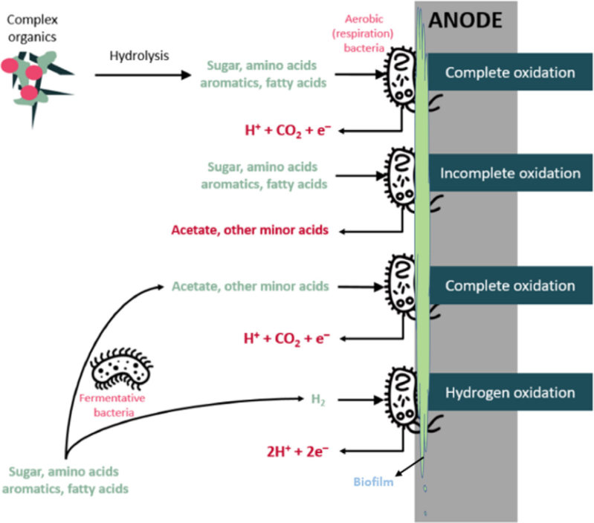

Figure 1.Oxidation process of organic substrate on the anode surface in the presence of a biofilm to generate the electron and proton (A. A. Yaqoob, Ibrahim, & Guerrero-Barajas, 2021).

**2.2. Mechanism of Electron Transfer from Bacteria to Anode Electrode**

Microorganisms that transfer the electrons extracellular are classified as exoelectrogens and some species that have the ability to transfer electrons in this way are: Geobacterlovleyi, Geothrixfermentans,Thermincolacarboxydophila,Geobactersulfurreducens,Shewanellaoneidensis, Rhodopseu domonaspalustris, Thermincolapotens, E. coli, and Shewanella putrefaciens (Abbas, Rafatullah, Ismail, & Syakir, 2017). For current generation, exoelectrogens can transfer electrons from microbes to electrodes through some mechanisms that have been clearly stated such as short-range electron transfer via shuttling molecules (also known as redox mediators), electron transfer through redox-active proteins, long-range electron transport by conductive pili and direct interspecies electron transfer as shown inFig.2

.

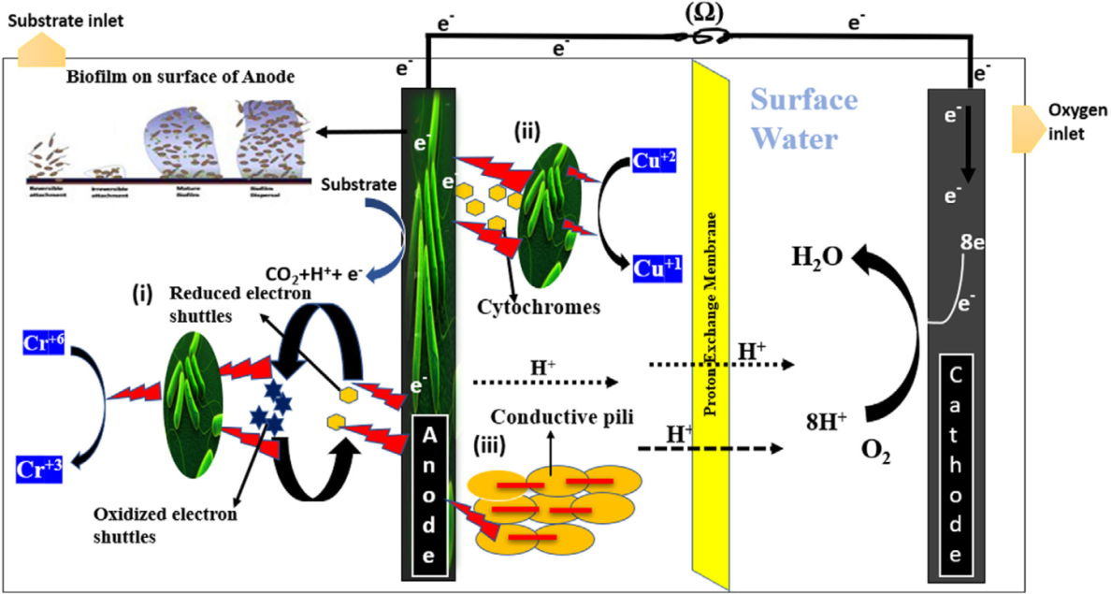

Figure 2. Schematic presentation of MFCs and electron transfer mechanisms from exoelectrogens to electrodes. (i) Short range electron transfer (ii) Redox active proteins (iii) Long range transfer via conductive pili (Ramanujam & Annamalai, 2017).

**2.3. Reduction Mechanism of Pollutant (Heavy Metals)**

To date, several chemical, physical, analytical, and biological approaches have been introduced for the remediation of the heavy metals. Among all, MFCs is the feasible, cost-effective, and eco-friendly approach, which can remove the heavy metals with simultaneous generation of energy. The biological mechanisms are very significant in remediation of heavy metals in MFCs. The microorganism properties to accept electrons from (anode and cathode) electrodes are known as electrotrophs (Xiong et al., 2019). This fact gives a new direction for treatment of heavy metals via reduction. The heavy metals are removed through the reduction reaction at cathode while organic substrates are oxidized at anode and serve as electron donor and carbon source to the microorganisms (Ucar, Zhang, & Angelidaki, 2017). There are many types of bacteria with the property of gaining electrons directly from electrodes. Recently, many studies have reported that Geobacter species can accept electrons directly from electrodes (Saratale et al., 2017). There are many toxic heavy metals like chromium ion, Ni, Zn, Hg, Pb, Cu, V, etc. that are reduced by different microorganisms by following the same mechanisms, i.e., G. sulfurreducens accepts electrons directly from electrodes and reduces the U(VI) into U(IV) form (soluble to insoluble). The U (IV) is insoluble, and it is adsorbed on the electrodes studied G. sulfurreducens that has the capability of reducing Cr (VI) to Cr (III), it can convert the highly toxic oxidation state of chromium to the less toxic form. The reduction of Cr (VI) depends on the oxidation of substrate (acetate) at the anode electrode to transfer the electrons to microorganisms and the reduction of chromium occurs at the cathode.

The reduction reaction can be written as:

Cr2O7-2 + 14H+ + 6e- → 2Cr3+ + 7H2O

(Tizaoui, Benguella, & Makhoukhi, 2019) studied the removal of vanadium with microorganisms such as Enterobacter, Macellibacteroides and Lactococcus, these authors demonstrated that vanadium removal presented a 93.6% efficiency and a high current density of 543.4 mW/m2. However, the most toxic heavy metal mercury can be reduced via MFCs. The Hg2+redox potential is-320 mV, it can be taken as electron acceptor. The removal mechanism of Hg2+ in precipitate form occurs in the presence of chloride (Cl-) ions and the reduction through electrons occurs at the cathode electrode as shown below:

2Hg2+ + 2Cl-→Hg2Cl2(s)

Hg2Cl2(s) + 2e- → 2Hg (l) + 2Cl-

The final product HgCl2is deposited at the bottom of the cathode and elemental Hg on the surface of cathode. During this process, the achieved maximum power density was of 433.1 mW/m2.Similarly, the reduction mechanism of Cu2+to Cu can be written as:

Cu2+ + 2e- → Cu

2Cu2+ + H2O + 2e- → Cu2O + 2H+

Cu2O + 2e- + 2H+ → 2Cu + H2O

As a result of the Cu2+reduction in MFCs operation, two major products may be formed at the cathode: Cu2O or Cu, whereas the electrons come from the oxidation process of organic substrate that occurs at the anode compartment (A. A. Yaqoob, Khatoon, et al., 2020). After an extensive review, we found that there is no proper molecular mechanism known to describe how the microorganisms can accept electrons from electrodes.

**2.4. Biochemical Cell Reactions and Electrochemical Measurements**

During the MFCs operation, the organic substrates such as glucose, acetate sucrose etc. is oxidized by bacteria to generate the electrons. The oxidation reaction is carried out at the anode and the reduction reaction at the cathode, some examples of these reactions can be written as follows with different organic substrates.

1. If glucose is used as organic substrate;

Oxidation reaction at anode: C6H12O6 + 6H2O → 6CO2 + 24H+ + 24e-

Reduction reaction at cathode: 24H+ + 24e- +6O2 →12H2O

Overall reaction: C6H12O6 + 6O2 → 6CO2 + 6H2O + Electricity + Biomass

1. If acetate is used as organic substrate;

Oxidation reaction at anode: CH3COOH + 2H2O → 2CO2 + 8H+ + 8e-

Reduction reaction at cathode: 8H+ + 8e- + 2O2 → 4H2O

Overall reaction: CH3COOH + 2O2 → 2CO2 + 2H2O + Electricity + Biomass

1. If sucrose is used as organic substrate;

Oxidation reaction at anode: C12H22O11 + 13H2O → 12CO2 + 48H+ + 48e-

Reduction reaction at cathode: 4H+ + 4e- + O2 →2H2O

Overall reaction: C12H22O11 + 12O2 → 12CO2 + 11H2O + Electricity + Biomass

**2.4. Anode Material**

The anode material is significant in MFCs. But the selection criteria of anode materials are quite difficult due to several issues such as cost, long term stability of anode etc. The anode material choice exerts a direct influence on other MFCs parameters such as substrate oxidation, electron transformation, bacterial adhesion, biofilm characteristics, biofilm structure, and growth of bacteria (Hao et al., 2015). The other parameters of the MFCs are also very important but they all directly depend on the performance of the anode material. Therefore, to achieve a high energy output, the anode material should be ideal. Although the selection criteria of cathode are quite different from those for the anode. Therefore, after a wide literature review, some anodic properties have been identified as responsible for achieving a high performance of MFCs, they are listed as follows (Khudzari, Gariépy, Kurian, Tartakovsky, & Raghavan, 2019).

**i. Material surface area**: The energy generation through MFCs is seriously inhibited by the material of the surface area of the anode. The electrode resistances are directly proportional to ohmic losses. Therefore, an increase of a proper material on the surface area, for example, by utilizing modern materials or modified materials to minimize the resistance is desirable to attain better results. A higher surface area provides a more active site for the reactions to occur, which enhances the electron generation and movement. All biological and electrochemical reactions occur on the anode electrode; therefore, the surface area tremendously influences the MFCs performance (Gajda, Greenman, & Ieropoulos, 2020). tested two different surface area-based electrode materials in the presence of microalgae Scenedesmusobliquus as biocatalyst in MFCs operation. They concluded that the graphite electrode with larger surface area (13.6cm2), rather than a smaller surface area (5cm2), delivered a higher energy output. The 13.6 cmbased graphite rod yielded 109 ± 2µA, whereas other yielded 37± 5µA. They proved that the larger surface area of the anode electrode exerted a major impact on MFCs performance.

**ii. Biocompatibility of material**: The bacteria are used to form a biofilm around the anode surface and oxidize the organic substrate. The material should be biological favorable, chemically stable, and toxic free for healthy bacterial growth. A toxic nature of the anode material inhibits the healthy growth and respiration of bacteria, which in turn fails in the generation of protons and electrons as a result. Different characterizations such as SEM images, EDX and chemical toxicity tests are carried out to ensure the biocompatibility of the material.

**iii. Electrical conductivity**: The material conductivity properties are essential because electrons are travelling from anode to cathode, which requires a conductive anodic material. The highly conductive anode material promotes the flow of electrons better and this minimizes the resistance of the electrode and leads to a good outcome. Therefore, the material conductivity is one of the most significant parts in order to achieve high performance.

**iv. Material stability and durability**: The long-term stability and durability is still an issue in modern research since the anode stability is a key factor in achieving the goal of sustainable MFCs. The oxidizing environment on the surface of the anode leads to corrosion, swelling and decomposition of the materials. These issues cause fouling, which minimizes the anode stability for a long-term operation of MFCs (Gonzalez Olias, Cameron, & Di Lorenzo, 2019). Studied the neem wood waste derived biochar which was modified with PEDOT/NiFe2Oto enhance the material properties particularly durability and stability. They reported the 350h durability of the prepared modified anode. Additionally, in a recent research document (Rani, Sharma, & Kumar, 2019) reported a 90-day durability and stability for graphene derived modified anode in MFCs. Thus, the anode material must be mechanical, chemical, thermally stable, and durable in both, acidic and basic conditions in the MFCs.

**v. Material availability and cost**: To implement the MFCs systems at large scale, the material availability and its cost must be feasible. For a commercial setup, the MFCs electrode materials must be easily available at low cost. For example, gold, platinum, silver etc. are very expensive and they are not available everywhere. The composites anode might be another way to meet this criterion for large scale applications of MFCs in the future. Recently, ongoing investigations are focused on the development of anode materials to improve the MFCs approach to an industrial level. However, some progress and development for the anode configurations have been considered in this article, particularly in two broad types, the so-called conventional anode materials, and the modern anode materials.

**2.5.1. Modern Anode Material**

The modern anode materials are further sub-classified into two categories, which have exhibited their significant importance in generation of energy as well as in wastewater treatment concerns. The subcategories of modern anode materials are natural biomass-based carbon anode material and composite-based material that includes metal/metal oxides, carbon-based materials and conducting polymers (G. Yang et al., 2019). The modern materials are considered as a low-cost alternative for the anode over a conventional material and with the advantage of having excellent properties. Several studies have explained the value of modern anode materials that have been used in MFCs. A description of these modern materials is included in the following sub-sections.

**2.5.2. Natural Biomass-Based Anode Material**

The natural recyclable sources provide a potential green method for producing the valuable bio energy from natural waste and sustainability. The plant waste is the most frequently utilized natural precursor for carbon-based anodes. This is commonly known as natural waste-derived anode material. However, the porous carbon material is generally achieved through direct carbonization of plant precursors at very high temperatures (1050C). In the preparation process, the plant hetero atoms act as natural dopants, subsequently as self-doped material, whereas the water evaporation throughout the carbonization (at 1050C) leads to the development of a porous structure in the carbon material synthesized the 3D micro porous material by using bread pieces via direct carbonization process in presence of self-doped carbon foam (N, P and S) (Xiong et al., 2019).

**2.5.3. Composite-Based Anode Material**

The composite-based anode material is categorized into different classes such as metal/metal oxides, conductive polymers, and carbon-based composites with each other. In fact, the improved bacterial adhesion and decrement in ohmic losses are greatly influenced by metal/metal oxide- carbon-based material composites (Sevda et al., 2018). The metal oxide/carbon composite gained great interest due to several reasons because metal-based material alone is facing a corrosion problem and carbon-based are suffering of lower conductivity. Therefore, the composite addresses these two factors and offers a perfect model anode for MFCs performance used natural egg white protein (EWP) waste to prepare a carbon anode, modified it withTiO2(titanium oxide) and offered a 3D nanostructure modified anode for MFCs. (Rani et al., 2019)

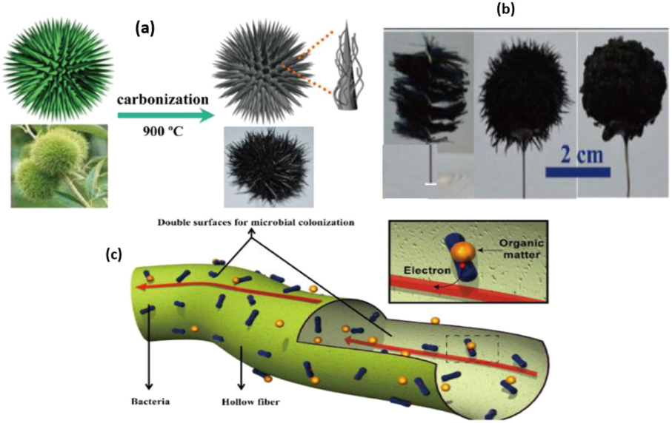

Figure 3 .(a) Graphic mechanism of chestnut shell anode preparation. (b) images of GB and chestnut shell-based anode. (c) hollow structure fibers-based material (A. A. Yaqoob, Ibrahim, Yaakop, et al., 2021)

**2.6. Challenges in MFCs**

Several factors affect the operation of an MFC including, system conﬁguration, substrates, microorganism, anode/cathode materials, electrode surface area, mediators, cation exchange membrane, pH and operating conditions, each of which requires great understanding for system optimization. A typical MFC conﬁguration comprises of two chambers an anodic and a cathodic chamber, which are connected by a half-cell separator, which is commonly a PEM, salt bridge or ceramic. This separator allows the protons to move freely to the cathode due to a potential gradient whilst mitigating the diffusion of oxygen (or the electron acceptor utilized in the cathodic compartment) to the anode, where it can have a potential detrimental effect on the bacteria present. The structural design of the compartmentscan varies dramatically and affects the power output of the MFC. Two-compartment MFCs are typically utilized with a deﬁned medium (such as glucose or acetate) and run in batch mode. A widely used and simple design is a two-chambered H-shaped MFC, usually consisting of two bottles connected together by a tube containing a separator, which is usually a cation exchange membrane (CEM), such as Naﬁon.

MFCs can also be operated in the continuous mode and are currently used in laboratories to optimize the power output. Examples of two-compartment MFC designs include conventional rectangular shaped MFCs, cylindrical shaped MFCs, miniature MFCs, up ﬂow mode conﬁgurations and ﬂat plate MFCs. The reactor conﬁguration is signiﬁcant since the internal resistance can be reduced while using an air cathode containing single chambered MFC rather than dual chambered. The biocatalyst also important and the availability is widespread that can be obtained from various sources of wastewater resources. Among all MFC components, the electrode materials play a crucial role in electricity generation since the electrode cost will be a key factor deciding the implementation of the MFC technology at a large scale.

**2.7. Electrode Material**

Electrode materials are vital for microbial fuel cells as electron transfer plays a key role in the MFCs performance. In general, carbonaceous, metal materials, or their combination with polymers are used as electrodes in MFC. The carbon-polymer composite materials have gained interest due to its stability, biocompatibility and chemical/environmental inertness whereas the metal electrode materials are corrosive and unstable in aqueous environment. The general requisites of anode and cathode are given below.

**2.7.1. Anode**

The basic requirements for an anode material are: highly conductive, non-corrosive, non-fouling, large surface area, non-toxic for microorganisms and low cost. The electrons generated within the anode chamber must be able to ﬂow from the solution to the surface of the anode material. For that, the microorganisms must be able to attach to the surface and form a bioﬁlm so that good electron transport can be achieved (Chen et al., 2018). Therefore, some materials like stainless steel are not suitable for power generation in an MFC despite their good conducting properties. Carbon-based electrode materials are economical alternatives to metal-based anode materials. Thus, for large-scale economic wastewater treatment and the enhancement of electron transfer, using carbon-based materials is preferable as they cost very low and promote the necessary bacterial growth.

**2.7.2. Cathode**

Carbon-based materials that are usually preferred for the cathode have the same basic material as that of an anode. However, the major challenge is with the reactions that require a catalyst (e.g. Pt) to take place on the surface of a cathode, such as oxygen reduction reaction. Pt is mostly used as the cathode catalyst. However, the uses of these types of cathode catalyst are neither sustainable nor cheaper. Therefore, to minimize the electrode expenses in large-scale applications, the Pt catalyst needs to be replaced with cheaper metal compounds such as transitional metal oxides and Fe, Co, Ni metal center macro cyclic organic compounds (Santoro et al., 2017).

**2.8. Conductive Polymer**

The CPs exhibits electrical properties that are comparable to those of metals and semi-conductors. These polymers possess high electron mobility, stability, biocompatibility, anticorrosion nature, excellent electro kinetic properties. They are more attractive than conventional polymers due to their facile synthesis and that may be due to the chance of chemical surface modiﬁcation with physiologically active species to enhance the biocompatibility and the functionality of the electrodes which is crucial for microbial fuel cell electrodes (Kaur et al., 2020).

In general, CPs can be synthesized either chemically or electrochemically. Chemical synthesis generally uses either condensation polymerization or addition polymerization. A variety of CPs can be synthesized through the chemical synthesis method offered by various probable methods (i.e., addition or condensation polymerization) and hence, is most commonly used for the manufacture CPs. Several novels CPs with modiﬁed monomers can only be synthesized using chemical polymerization and the electrochemical way of synthesis is limited to certain polymeric materials. Since, in some cases, the monomer may get oxidized to form reactive radical ion intermediates upon application of potential for polymerization. Among the several CPs, PANI acts as potential candidates for various applications in the preparation of biosensors, super capacitors, batteries, actuators, chemical sensors, electronic devices and fuel cell applications due to the fascinating properties which includes environmental stability, non-biodegradable, ease of synthesis and high conductivity at room temperature.

In addition to the electrode conductivity, several other factors like surface area, redox potential suited to bacterial metabolism and biocompatibility are considered in the electrode fabrication for MFCs (Kaur et al., 2020). Therefore, a lot of research in the bulk or surface modiﬁcation of insulating and semiconducting/conducting polymers has been emerged over the past few years. This review deals with the currently available data and knowledge on microbial fuel cells incorporating carbon-polymer based composite electrodes. A comparison of their performances has also been presented to substantiate the selection of materials for this study. Hence, this section describes the various methods of fabrication and electrode materials involved in MFCs. Carbon-polymer based composite electrodes have commonly used for microbial fuel cells and are broadly classiﬁed into two types:

• Bulk modiﬁed carbon-based electrodes (BMEs)

• Surface modiﬁed carbon-based electrodes (SMEs)

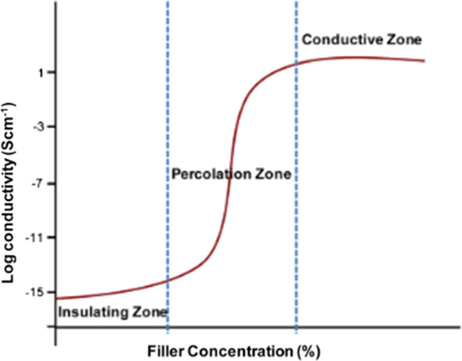

Figure 4.Electrical conductivity as a function of ﬁllers concentration source[49]

.

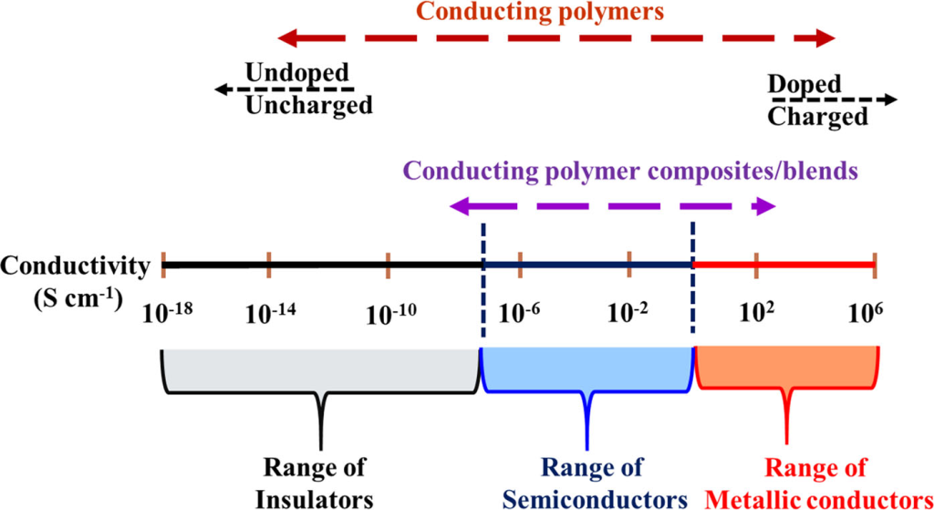

Figure 5.Conductivity range of the conducting polymers[49]**.**

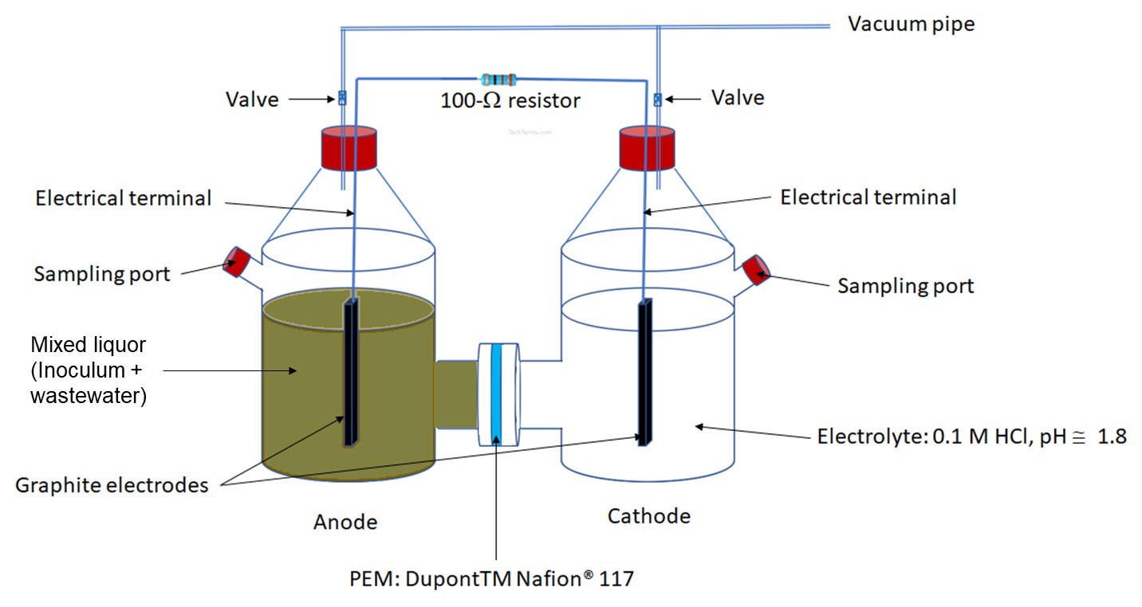

Figure 6.Schematic representation of Inoculum and waste water in anode chamber and tap water in cathode chamber (J. Li et al., 2017).

**3. METHODOLOGY**

**3.1. Materials and Chemicals**

The materials included wastewater effluents obtained from a nearby pond at Mattu University, sweet potato waste material (a gift from the local market in Mattu town, Ethiopia), and Enseteventricosum corm waste material (a gift from Kaffa Zone, Southwest Ethiopia). Chemicals used for the experiments included Ammonium per sulfate (98%), Ferric chloride (97%), Ferrous chloride (99%), Potassium permanganate, Sodium nitrate purchased from Sigma-Aldrich Chemical Co. Ltd. Aniline monomer (99.5%), Sulfuric acid (98%), Hydrochloric acid (37%, Merck), Nitrogen (N2) gas, Sodium hydroxide (NaOH, Merck), Lead(II) nitrate solution (R&M Chemicals), and Chromium(VI) nitrate (R&M Chemicals).In the microbial fuel cell (MFC) tests, all of the chemicals, nutrients, and substrates employed were analytical grade and didn't require any additional purification. Note that all measurements were made at room temperature, and that all solutions were prepared and electrochemical tests were carried out using doubly distilled water.

**3.2. Synthesis of Ensetventricosum Corm-Derived Graphene Oxide (GO)**

Based on earlier report (Kahsay, Belachew, Tadesse, & Basavaiah, 2020), some adjustments were made to the synthesis of Ensetventricosum corm-derived graphene oxide (E-GO). The isolated corm from Ensetventricosum was first cleaned with deionized water and then allowed to dry for 24 hours at 105°C in an oven. To produce calcined corm carbon for the synthesis of E-GO, the dried corm was first finely pulverized in a grinder and then calcined for three hours at 900°C in a nitrogen environment in a furnace. In a standard reaction, 150 mL of concentrated H2SO4was combined with 5 g of powdered Enseteventricosum and 6 g of NaNO3, which were then constantly agitated for 60 minutes. Subsequently, the solution was continuously agitated for three hours at a temperature between 0°C and 5°C in an ice bath while 15 g of KMnO4 was added gradually. After agitating the reaction mixture for a further twenty-four hours at room temperature to complete the oxidation process, the color changed from black to violet-brown. 150 mL of distilled water was then added to the mixture after it had been heated to 90°C for 20 minutes, creating a dark brown solution. Once the mixture had cooled to room temperature, 200 mL more water was gradually added. To halt the reaction and eliminate extra KMnO4, 20 mL of H2O2 was then added drop by drop. The produced E-GO was dried in an oven set at 40°C for 36 hours after being cleaned with distilled water and ethanol until the pH was neutral (pH = 7).

**3.3. Reduction of Ensetventricosum corm Derived Graphene Oxide (E-GO)**

The graphene oxide (E-GO) produced from ensetventricosum was reduced using sodium borohydride as a reducing agent. The graphene oxide was exfoliated into sheets by ultrasonically sonication 100 mg of E-GO powder in 100 mL of distilled water for an hour in order to produce a stable aqueous dispersion. 200 mg of NaBH4 was then added to the dispersion while being magnetically swirled, and the mixture was continually agitated for three hours at 125°C. In the end, a black precipitate (E-rGO) was created, filtered out, and vacuum-dried at 60°C (BhaskaraRao et al., 2023; Shin et al., 2009).

**3.4. Synthesis of E-rGO/Fe3O4 Nanocomposites**

Magnetic (Fe3O4) nanoparticle production and reduction of GO were carried out simultaneously using a one-pot co-precipitation method to produce E-rGO/Fe3O4 magnetic nanocomposites. 50 mg of E-GO was first combined with 150 mL of deionized water, and the combination was ultrasonically dispersed using an ultrasonicator for two hours. The E-GO solution was then supplemented with 176 mg of FeCl3.6H2O and 130 mg of FeCl₂.4H₂O (molar ratio of Fe³⁺ to Fe²⁺ = 1:1) that had been dissolved in 50 mL of deionized water. The pH was then raised to 10 by adding drops of NaOH solution. The mixture was stirred constantly for two hours at 80°C. The resulting E-rGO/Fe3O4 nanocomposite was separated by using a magnet, washed several times with distilled water and ethanol, and then dried at 60 °C (Habibi, Seyyedi, & Ayati, 2022).

**3.5. Synthesis of E-rGO/Fe3O4/PANI Nanocomposite**

On the surface of pre-synthesized E-rGO/Fe3O4, PANI was polymerized in-situ to create the ternary E-rGO/Fe3O4/PANI nanocomposite. Usually, 50 mL of 1 M H2SO4 was used to dissolve 500 mg of E-rGO/Fe3O4 powder while being vigorously stirred. One milliliter of aniline was then added to the solution, which was subsequently shaken. With the use of an ice bath, the solution was cooled to -4°C. After that, 3 mL of a 1 M ammonium persulphate ((NH4)2S2O8) solution was added, and for eight hours, the mixture was kept swirling. Following the process of filtering and washing, the final product was dried at 60°C (Charandabinezhad, Asgharzadeh, & Arsalani, 2021). The schematic illustrated in Figure 1 depicts the conversion of ensetventricosum corm into inset-rGO, leading to the formation of E-rGO/Fe3O4/PANI

.

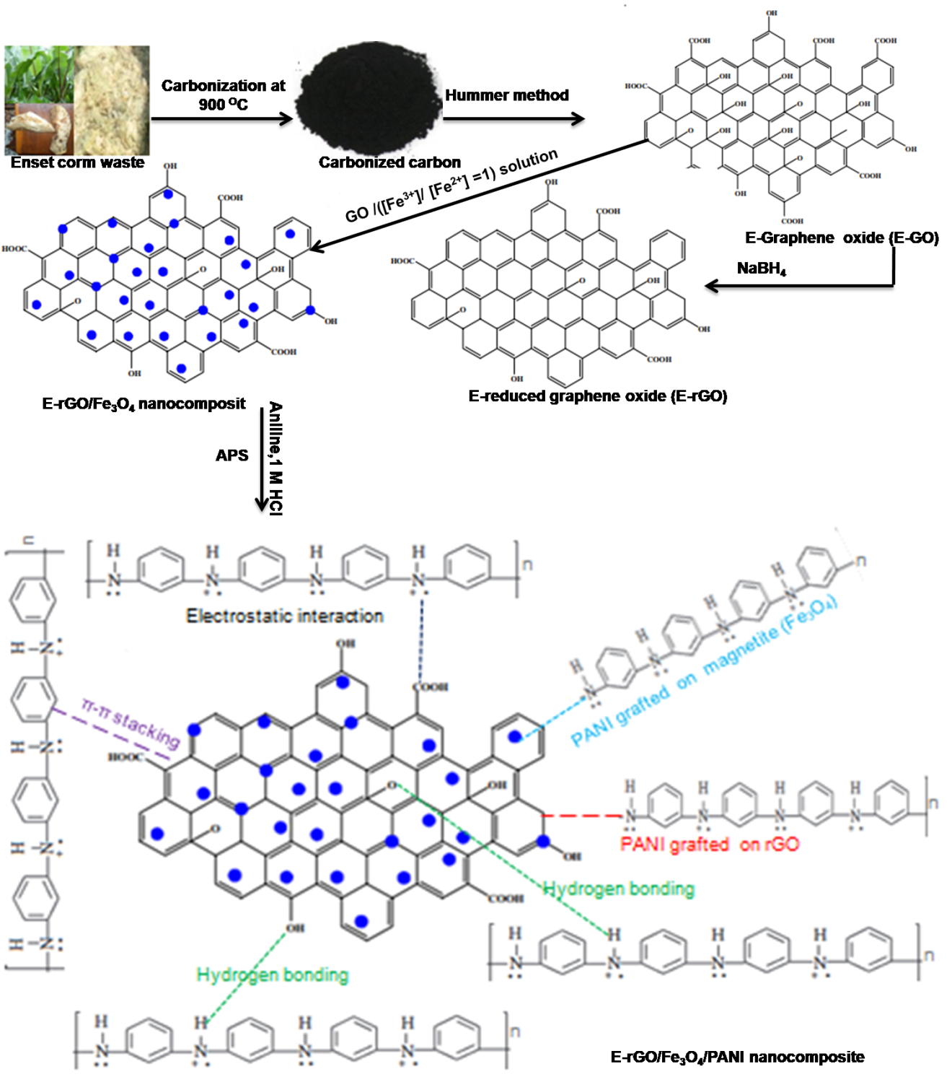

Figure 7: Conversion of ensetventricosum corm to enset-rGO which leads to the formation of E-rGO/Fe3O4/PANI.

**3.6. Fabrication of Anode**

Since conveying charge carriers from the positive electrode to the negative electrode chamber enables the circuit to function, the anode is the most crucial part of an MFC arrangement. Anode electrode modification was performed with some modifications were reported by previous works (Dessie & Tadesse, 2022; Harshiny, Samsudeen, Kameswara, & Matheswaran, 2017; Patade et al. 2016). The MFC setup involved soaking the bare graphite electrodes in distilled water for 24 hours before modification, and then washing them with 200 mM phosphate buffer solution (PBS). Following that, the drop-cast coating process was used to create an equivalent quantity of synthetic (E-rGO, E-rGO/Fe3O4, and E-rGO/Fe3O4/PANI nanocomposites) and polyvinyl alcohol (PVOH) polymer binder solution (to boost bonding force between the produced nanocomposite catalyst and bare graphite electrode). After adding the necessary quantity of nanocomposites to a beaker along with deionized water, the mixture was left in an ultrasonic water bath for 15 minutes at room temperature in order to create a homogenous solution.10 mL of deionized water was used to dissolve the 15:85 (PVOH to (E-rGO, E-rGO/Fe3O4, and E-rGO/Fe3O4/PANI nanocomposites catalysts wt/wt%) ratio, which was then magnetically stirred for an hour at 90°C.To ensure that the nanocatalyst was distributed evenly, the mixture was ultrasonically sonicated before coating on the naked graphite electrode. Using a micro syringe and the drop-cast technique, the 300μL suspension was applied to the bare graphite electrode surface. To increase bonding energy and interface stability, the mixture was subsequently dried in an oven at 60°C for 12 hours.

**3.7. Material Characterizations**

Several methods were used to characterize the synthesized materials (E-rGO, E-rGO/Fe3O4, and E-rGO/Fe3O4/PANI). The functional groups, morphology, and optical properties of the produced materials were examined using UV-visible spectroscopy, Fourier transform infrared (FTIR) spectroscopy, and field emission scanning electron microscopy (FE-SEM). X-ray diffraction (Bruker D2) was employed with a Cu Kα radiation source at λ=1.54Å to determine the phase and crystal structure. To evaluate molecular vibration states and structural flaws, a Raman spectrometer (IHR550) equipped with a 532 nm laser was utilized. Thermal gravimetric analysis (TGA) was used to assess the materials' thermal stability.

Electrochemical measurements were conducted using EC-Lab for Windows v10.36 software in a three-electrode, one-compartment system connected to an electrochemical workstation (Biologic SP-300, Canada). Working, reference, and counter electrodes were Ag/AgCl and Pt wire, respectively, within a potential window between 0 V and +1.5V using the EC-Lab software for Windows v10.36. Bare graphite (Gr), E-rGO, E-rGO/Fe3O4, and E-rGO/Fe3O4/PANI modified graphite electrodes were tested in an aqueous electrolyte solution of 2M H2SO4 at a scan rate of 5 mV/s. Measurements using electrochemical impedance spectroscopy (EIS) were conducted over the frequency range 100 kHz–10 mHz, with a 10V applied potential vs. Ag/AgCl electrode).

**3.8. MFCs Setup and Operation**

The device used in the study was a double-chamber microbial fuel cell (DMFC) measuring 12 cm long by 6.5 cm in diameter. The total volume of each chamber was approximately 1000 mL, with a working volume of 750 mL. The anode chamber contained 150 g of sweet potato waste and 150 ppm chromium and lead ion-treated pond wastewater. The cathode chamber contained 50 mM KMnO4 and 0.1 M phosphate buffer. The pH of the anode was 6.45 and the pH of the cathode was 7, both maintained in phosphate buffer. The anode chamber was sealed, with no external inlet, and the cathode was supplied with external oxygen. The anode was sealed because it did not require an external substrate. For each reaction, a prepared anode electrode was used, and a graphite rod of similar size was used as the cathode electrode. Salt bridges were prepared according to the method reported in a previous study (Dessie & Tadesse, 2022).That is, 3 grams of agar was added to 100 mL of boiling water and stirred until the agar dissolved. To this mixture was added 12 grams of KCl. The solution was filled into a high-density polyethylene plastic pipe 9 cm long and 2 cm in diameter. One end of the compression fitting was tightly covered with a glass stopper. The solution was allowed to cool for two hours. To prove the electro catalytic activity of the nanocomposites compared to bare graphite rod electrodes, three double-chambered MFCs were constructed. Bare graphite rods, E-rGO, and E-rGO/Fe3O4 modified electrodes were used as anodes for three different reactions, and graphite rods were used as cathodes for all reactions. The MFCs were operated continuously for 30 days at room temperature. In all cases (GR, E-rGO, E-rGO/Fe3O4), the electrodes were connected using copper wires with different external resistance. Physicochemical properties of pond wastewater before MFC operation, Cr (VI), and Pb (II) addition are shown in Table 1. The pH of the wastewater samples was measured using a pH meter, while a thermometer was employed to determine the temperature. Additionally, an electrical conductivity meter was used to assess the conductivity of the samples.

Table1.Thephysicochemical properties of wastewater collected from the pond in Mattu University, Mattu, Ethiopia.

|  |  |  |
| --- | --- | --- |
| Parameters | Raw wastewater | Cr(III) and Pb(II) supplemented pond  Wastewater |
| PH | 7.02 | 6.45 |
| Temperature | 24-25 $℃$ | 25-26 $℃$ |
| Color | Brown | Brown |
| Electrical conductivity | 3.18 mS/cm | 35.4 mS/cm |
| Cr(VI) | 0ppm | 150ppm |
| Pb (II) | 0ppm | 150ppm |

**3.9. MFCs Tests (Electrochemical, Remediation Efficiency, and Microbial Analysis)**

Electrochemical characterization began by obtaining a stable open-circuit voltage (OCV) and then drawing a polarization curve by varying the external resistance (10,000, 1000, 500, 300, 100-50 Ω) at 30-minute intervals. The voltage drops across the external resistance were recorded every 30 minutes using a digital multimeter (DT830D, Haoyue, China) for data collection. Conversion from voltage to current (measured in milliamps) was done by applying Ohm's law. Voltage output (V), power density (PD), current density (CD), and internal resistance (r) were obtained using the following equations [1-5].

V = IR (1)

P = VI (2)

PD = $\frac{VI }{A}$ (3)

CD = $\frac{I}{A}$ (4)

$r=\left(\frac{E-V}{V}\right)R$ (5)

Where V is the voltage output, I is the current, R is the external resistance, r is the internal resistance, E is the electromotive force (emf), and A is the cross-sectional area. The cross-sectional area of the graphite electrode was calculated using the straight cylinder formula (A = 2πr2 + 2πrh,). The electromotive force is expressed in terms of open circuit voltage (OCV). Polarization curves were generated when the reaction reached a quasi-steady state at the optimum voltage. Atomic absorption spectrophotometer (BUCK SCIENTIFIC Model 210, USA) was used to determine the reduction efficiency of Cr (VI) and Pb (II). From the sampling interval (15 days) schedule, 1.0 mL of solution was removed from the anode chamber and analyzed for Cr and Pb. The % reduction efficiency was calculated using equation (6).

$RE= \frac{M initial-M final}{M initial}×100$ (6)

Where, RE % = remediation efficiency, M initial = initial concentration of metal (Pb), M final = final concentration of the metal after MFCs operation.

**4. RESULTS AND DISCUSSION**

**4.1. Material characterization E-rGO, E-rGO/Fe3O4 and E-rGO/Fe3O4/PANI**

**4.1.1. SEM –EDS Analysis**

The morphological characteristics of the synthesized E-rGO, E-rGO/Fe3O4, and E-rGO/Fe3O4/PANI nanocomposites were investigated by SEM. Figure 8(a)shows that there was enough surface area for the fictionalization of the thin layer-like sheets of two-dimensional E-rGO with an interconnected network (Kailasa et al., 2020). To increase surface area and enhance the electron transfer process, the synthesized Fe3O4 nanoparticles were anchored on the E-rGO surface (Figure 8(b)).According to this study, electrostatic interactions between the positively charged Fe3+ and the negatively charged E-rGO nanosheet were caused by the tightly connected Fe3O4 nanoparticle (Kahsay et al., 2020). The SEM image of the E-rGO/Fe3O4/PANI nanocomposite presented in Figure 8(c) illustrates the formation of nanowire-like morphology of PANI on the surface of the magnetite-anchored reduced graphene oxide (E-rGO/Fe3O4) nanocomposite. It is observed that PANI was well-coated and grafted onto E-rGO/Fe3O4 (Luo, Shen, Yao, Jiang, & Xu, 2016; Li Wang et al., 2013).The chemical composition of each produced nonmaterial was analyzed using an energy-dispersive X-ray spectrum (EDS). The existence of the elements C and O was verified by the EDS analysis of E-rGO (Figure 8(ai)). The EDS analysis of E-rGO/Fe3O4 confirmed the presence of C, Fe, and O components in the composite, as well as a uniform distribution of magnetic nanoparticles on E-rGO sheets and the final product's chemical composition (Figure 8(bi)). C, O, N, and Fe elements were detected in the EDS pattern of the E-GO/Fe3O4/PANI NCs (Figure 8 (ci), confirming the corresponding composite synthesis.

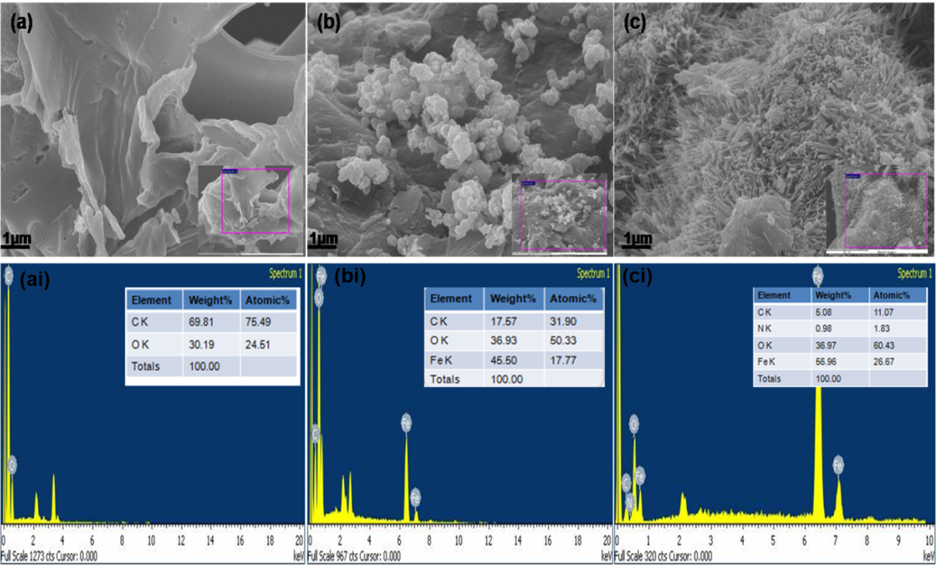

Figure 8: SEM images and EDX spectra of the enset derived reduced graphite oxide (E-rGO) (a), E-rGO/Fe3O4 (b) and E-rGO/Fe3O4/PANI nanocomposites.

**4.1.2. XRD and UV–Vis Analyses**

The average size, orientation, and spacing of crystallites in atomic layers can be found using the non-destructive technique of X-ray diffraction (XRD). To confirm the formation of the synthesized E-GO, E-rGO, E-rGO/Fe3O4, and E-rGO/Fe3O4/PANINCs, XRD studies have been conducted in this study (Figure9). The efficient oxidation of carbonized carbon is responsible for the strong and intense peak with a lattice reflection of (001) in the XRD pattern of E-GO at 2θ = 10° (Figure 9(a)) (A. A. Yaqoob, Mohamad Ibrahim, Umar, et al., 2020). The widespread XRD signal with a reflection peak at a 2θ value of 25.7° and a lattice reflection of (002), suggesting the production of rGO, indicated the successful conversion of graphene oxide (GO) into reduced graphene oxide (rGO) by using sodium borohydride (NaBH4) as a reducing agent (Kailasa et al., 2020). Furthermore, the (002) plane of GO disappeared in the rGO, suggesting the in situ reduction of GO to rGO (Rana & Malik, 2012). A similar broad peak was observed in the angle range between 15–30 during the synthesis of rGO using heated coconut shells (Nugraheni, Nasrullah, Prasetya, Astuti, & Darminto, 2015). The XRD pattern of the binary E-rGO/Fe3O4NCs showed diffraction peaks of Fe3O4 nanoparticles at 2θ = 30.5°, 35.57°, 43.55°, 54.1°, 57.34°, 63.00°, and 74.66°. These correspond to the crystal planes of the face-centered cubic (FCC) Fe3O4 structure at (220), (311), (400), (422), (511), (440), and (533). The Fe3O4 nanoparticles that were detected by (JCPDS card no. 19-0629) are confirmed to be present by these peaks. Additionally, a broad diffraction peak at approximately 26.7°, had been observed corresponding to the (002) plane of E-rGO, providing further evidence of the successful reduction of E-GO nanosheet and their hybridization with Fe3O4 nanoparticles. This peak also indicates that Fe3O4 NPs were attached to the surfaces of E-rGO nanosheet (Kahsay et al., 2020).

The E-rGO/Fe3O4/PANI nanocomposites exhibit diffraction peaks of magnetite and Polyaniline, demonstrating the effective hybridization of the composite's constituent materials. The main reason for the lack of a distinct peak had been corresponding to E-rGO would be made overlapping of the (002) plane of E-rGO with the (200) plane of PANI. When comparing the ternary composite's XRD pattern to that of the individual samples, the reduced intensity of the Fe3O4 and PANI peaks confirmed that the strong coupling between its components (Charandabinezhad et al., 2021; R.-B. Song et al., 2016; Li Wang et al., 2013).In the synthesized samples, the Scherrer equation was used to estimate the crystallite size (D) of the magnetite powder (Kahsay et al., 2020),

D = $\frac{kλ}{βCosθ}$, (7)

where B is the full-width at half-maximum (FWHM) of the XRD peak, λ is the Bragg angle, K is the crystallite shape factor (0.9), and k is the wavelength of the Cu Kα radiation (0.15406 nm). The equivalent crystallite sizes for the E-rGO, E-rGO/Fe3O4, and E-rGO/Fe3O4/PANI powders were determined to be 29.1, 22.7, and 22.7 nm, respectively. This finding suggests that whereas the hybridization of E-rGO/Fe3O4 with PANI had a negligible impact on the crystallite size of the magnetite nanoparticles, the hybridization of E-rGO with Fe3O4 resulted in a minor decrease in crystallite size.A UV-vis spectrophotometer was used to show the absorption peaks of the synthesized E-rGO, E-rGO/Fe3O4, and E-rGO/Fe3O4/PANINCs as shown in Figure 3(b). At a wavelength of 245 nm, the absorption peak of E-rGO was ascribed to π→π * transitions of aromatic C=C bonds. In the E-rGO/Fe3O4 binary NCs, the peak of E-rGO shifted to 265 nm, indicating the successful formation of the binary composite. Additionally, the E-rGO/Fe3O4/PANI ternary composite exhibited three peaks at wavelengths 271, 376, and 459 nm.

The aromatic C = C bond's π→π ∗ transitions were identified as the cause of the absorption peak from E-rGO at 271 nm. PANI is present in the composite, as evidenced by the final two distinct peaks at 376 nm and 459 nm. They correspond to π→π ∗ transitions of C = C in the benzenoid ring, π → polarons (radical cation) transition, and polarons (radical cations) to π transition, respectively (Charandabinezhad et al., 2021).Interestingly, when radical cations (polarons) or dictations (bipolarons) formed on the backbone of the PANI polymer, the quick delocalization of charges through different PANI polymer subunits by the creation of a conductive state improved electrical conductivity and other electrochemical properties. Consequently, the presence of all required peak absorption and the shift of PANI absorption peaks to a higher wavelength in the ternary composite demonstrate the interaction and strong relationship between PANI, E-rGO, and Fe3O4. As a result, the E-rGO/Fe3O4/PANI ternary composite was successfully formed.

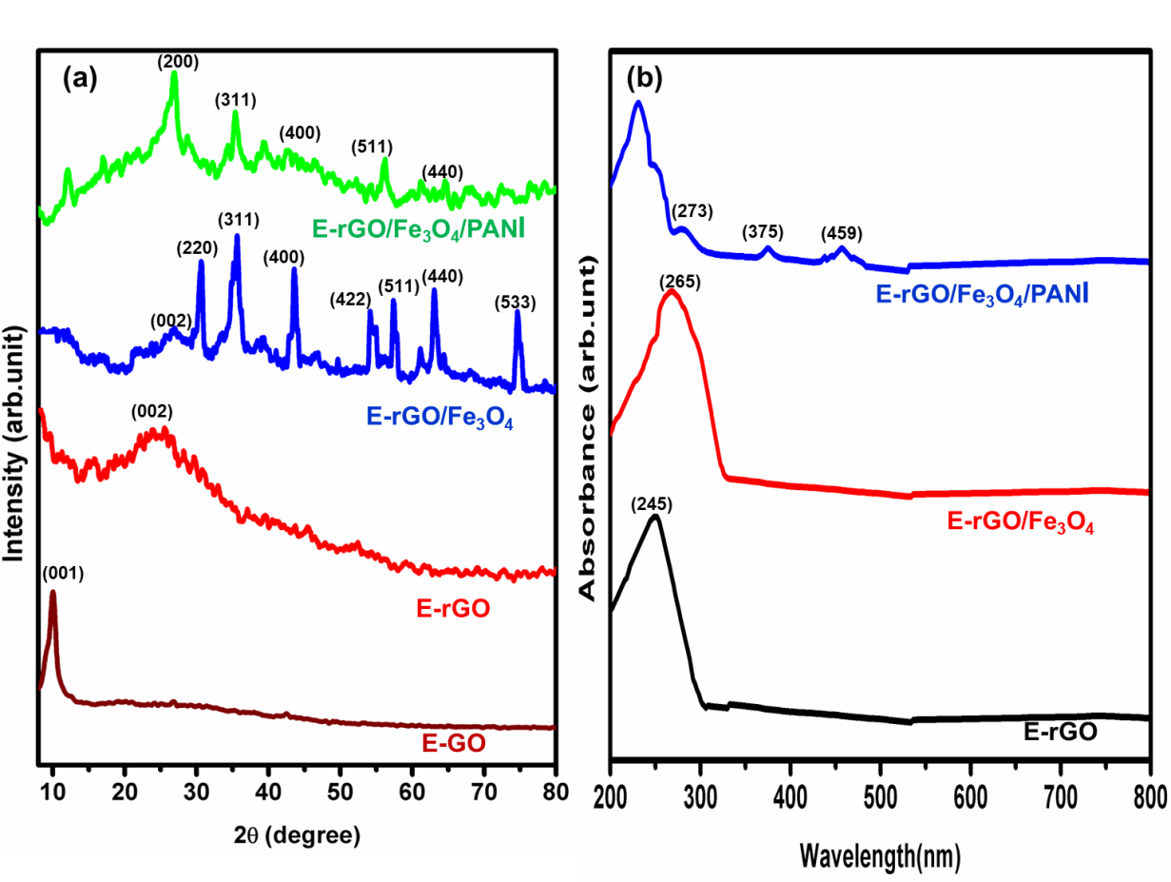

Figure 9: (a) XRD patterns of E-GO, E-rGO, E-rGO/Fe3O4 and E-rGO/Fe3O4/PANI and (b) UV−vis spectra of a water-dispersed solution.

**4.1.3. FT-IR and Raman Spectra Analyses**

FTIR analyses of the nanocomposites were carried out to confirm the production of E-rGO, E-rGO–Fe3O4, and E-rGO–Fe3O4/PANIN as shown in Figure 10(a). The characteristic peaks of the synthesized E-rGO spectra were determined by C–H stretching, C=C stretching, C–H bending, C–O stretching of alkoxy groups, C–O stretching vibrations of C–O–C, C-OH stretch of alcohol group, and OH out-of-plane bend at 3060, 1566, 1339, 1098, 1224 cm-1, and 599.28 cm−1, respectively(Emiru & Ayele, 2017; Hosseine, Naghib, & Khodadadi, 2024; Tienne et al., 2022; Wei et al., 2017; Y. Yang, Zhang, Liu, Cui, & Deng, 2018). Although the functional groups are likewise present in E-rGO–Fe3O4, they have different peak sharpness and are red-shifted in the bond sites, particularly when it comes to aromatic C=C bonding. This implies that distinct functional groups in E-rGO–Fe3O4 are functioning within distinct coordinating environments. Fe-O stretching vibrations are detected in E-rGO/Fe3O4 nanocomposites at a wavelength of around 564 cm-1. The distinctive peak located at 820 and 794-883 cm-1 is caused by C-H binding. The decreased peak intensities of OH and C=O stretching vibrations of GO sheets made it possible for Fe3+/Fe2+ ions to electro statically engage with E-rGO sheets and for GO and Fe3+ ions to simultaneously be reduced. It is proposed that the shift in peak location and the alteration in C=C bonding in E-rGO favor covalent bonding(Kahsay et al., 2020; L. Li, Dou, Wang, Luo, & Liang, 2014).

The FTIR spectrum of rGO-Fe3O4/PANI NCs showed vibration bonds linked to its constituents, such as the C–N stretching and bending vibrations at 1098 and 1318 cm-1, the F–O stretching vibration at 578 cm-1, the benzene rings bond at 718 cm-1, the C=C/C–C stretching vibrations in aromatic polymer rings at 1404 and 1569 cm-1, and the C–H stretching and CH2 vibrations at 2860 and 2924 cm-1. Along with Polyaniline stretching C–N vibration (1288 cm-1), the quinoid and benzenoid rings' C=N (1592 cm-1), C–H stretching vibration (873 cm-1), and C=C were also seen. For the Polyaniline of PANI, the C–H outer plane bending vibration is responsible for the absorption band at 794 cm-1. It was verified that PANI successfully integrated with E-rGO and Fe3O4.The broad and strong band at 3400 cm−1 is related to the stretching of O–H (Bhattacharya et al., 2014; L. Wang, Huang, Li, Chen, & Sun, 2015; Li Wang et al., 2013).

The matching results of the Raman studies of E-rGO, E-rGO/Fe3O4, and E-rGO/Fe3O4/PANI are shown in Figure 4(b). There are two inherent peaks in the Raman spectra of E-rGO, which are caused by the D and G bands and appear at 1346 and 1575 cm−1, respectively. The in-plane bond-stretching motion of the pairs of C sp2 atoms (the E2g phonons) was associated with the G band, whereas the D band indicated the transition from a sp2-hybridized carbon to a sp3-hybridized carbon. Because of the flaws and somewhat disorganized structure of the E-rGO, the D band's intensity was greater than the G band's (Ma et al., 2020; L. Wang et al., 2013).

Two large peaks that represent the D and G modes, respectively, can be seen in the RGO's Raman spectrum at 1339 and 1591 cm-1. Here, the G band displays the in-plane bond-stretching motion of the pairs of C sp2 atoms (the E2g phonons), whereas the D band relates to breathing modes of rings or K-point phonons of A1gsymmetry.The D and G bands were visible in the E-rGO/Fe3O4NCs Raman spectra, but they were more intense. This implies a greater number of defects in the E-rGO nanosheet had been formed mostly due to the accumulation of magnetite nanoparticles and the chemical reduction of GO by sodium borohydride. A few additional peaks were detected at lower Raman shift values (224, 289, 395, 485, and 648 cm-1) in the rGO/Fe3O4NCs scenario. These could be related to the vibration modes of the Fe–O bonds of the Fe3O4 nanoparticles and the Fe–C bonds at the E-rGO surface (Mishra & Sundara, 2011). In addition, the blue shift of the G band in E-rGO/Fe3O4 by 0.12 cm−1 relative to E-rGO and the rise in the ID/IG ratio of E-rGO from 1.27 to 1.39 in E-rGO/Fe3O4 are observed to indicate a disordered graphitic crystal structure of E-rGO due to the interaction and charge transfer between E-rGO and Fe3O4. PANI was successfully integrated into the NCs component, as evidenced by the D/G band ratio as well as the presence of peaks in the PANI spectra in E-rGO/Fe3O4/PANI that correlated to the in-plane C−H bending of the quinoid ring (1176 cm−1), in-plane C−H bending of the benzenoid ring (1255 cm−1), C−C stretching of the quinoid ring (1398 cm−1), and C=C (1689 cm−1)(Charandabinezhad et al., 2021; kumar, Kirubaharan, Yoo, & Kim, 2016; Mondal, Rana, & Malik, 2017b; Qiu, Peng, He, Wang, & Chen, 2018).

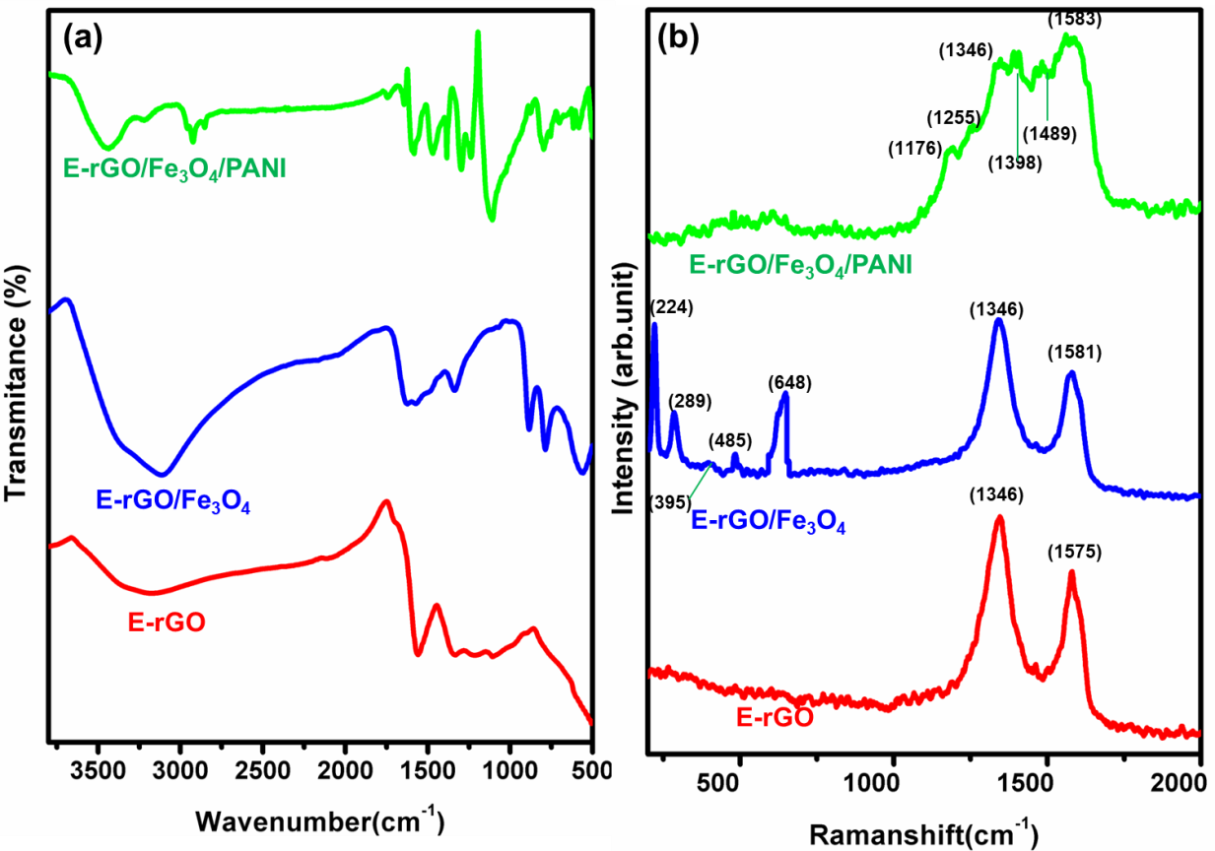

Figure 10 :(a) FTIR spectra and (b) Raman spectra of synthesized E-rGO, E-rGO/Fe3O4, and E-rGO/Fe3O4/PANI NCs.

**4.1.4. Thermal stability analysis**

Thermo gravimetric analysis (TGA) was used to examine the thermal stability of the E-rGO, E-rGO/Fe3O4, and E-rGO/Fe3O4/PANI nanocomposites (Figure 11). E-rGO's TGA curve shows a mass loss that begins before it reaches 100 °C and lasts until 200 °C because of loosely attached water molecules that are present between the sheets. The breakdown of surface functional groups such as carboxylic acid, and hydroxide was the cause of the second loss at 100–200 °C(BhaskaraRao et al., 2023; Habibi et al., 2022). The first significant loss that follows produces CO, CO2, and reduction process byproducts. The third mass loss is caused by the release of reduction process byproducts and the loss of C=O and C-O single-bonded oxygen groups, which occur between 200 and 590 °C. The mass loss after 590 °C is caused by the quick breakdown of oxygen species, indicating that rGO is thermally stable up to 800 °C(Ms et al., 2020). Due to the presence of fewer oxygen-containing groups, E-rGO/Fe3O4 degrades thermally more slowly than E-rGO in the 150–200 °C range, which indirectly supports the production of E-rGO from E-GO in situ. The evaporation of absorbed water is responsible for the minor mass loss below 100 °C. The removal of water vapor and labile oxygen-containing functional groups caused by the breakdown of oxygenated functional groups is the reason for the sample's subsequent steady weight loss between 200 and 600 °C. This shows that graphene oxidizes and breaks down in air, producing Fe3O4. After 600 °C, the remaining weight corresponds to Fe3O4 in the reduced graphene oxide (rGO).Water is lost from E-rGO/Fe3O4/PANI nanocomposites before 100 °C, and a second disappearance between 100 and 220 °C is attributed to the deprotonation of the PANI backbone, the loss of the dopant, the surfactant, and the doping of rGO from the PANI main chain. The third weight loss occurs between 335 and 490 °C due to the breakdown of PANI. After 560 °C, the E-rGO/Fe3O4/PANI nanocomposites temperature degradation values rise. As a result, the TGA analysis indicates that E-rGO/Fe3O4/PANI nanocomposites are more thermally stable than pure E-rGO and E-rGO/Fe3O4(Mondal, Rana, & Malik, 2017a; Tapas et al., 2012).

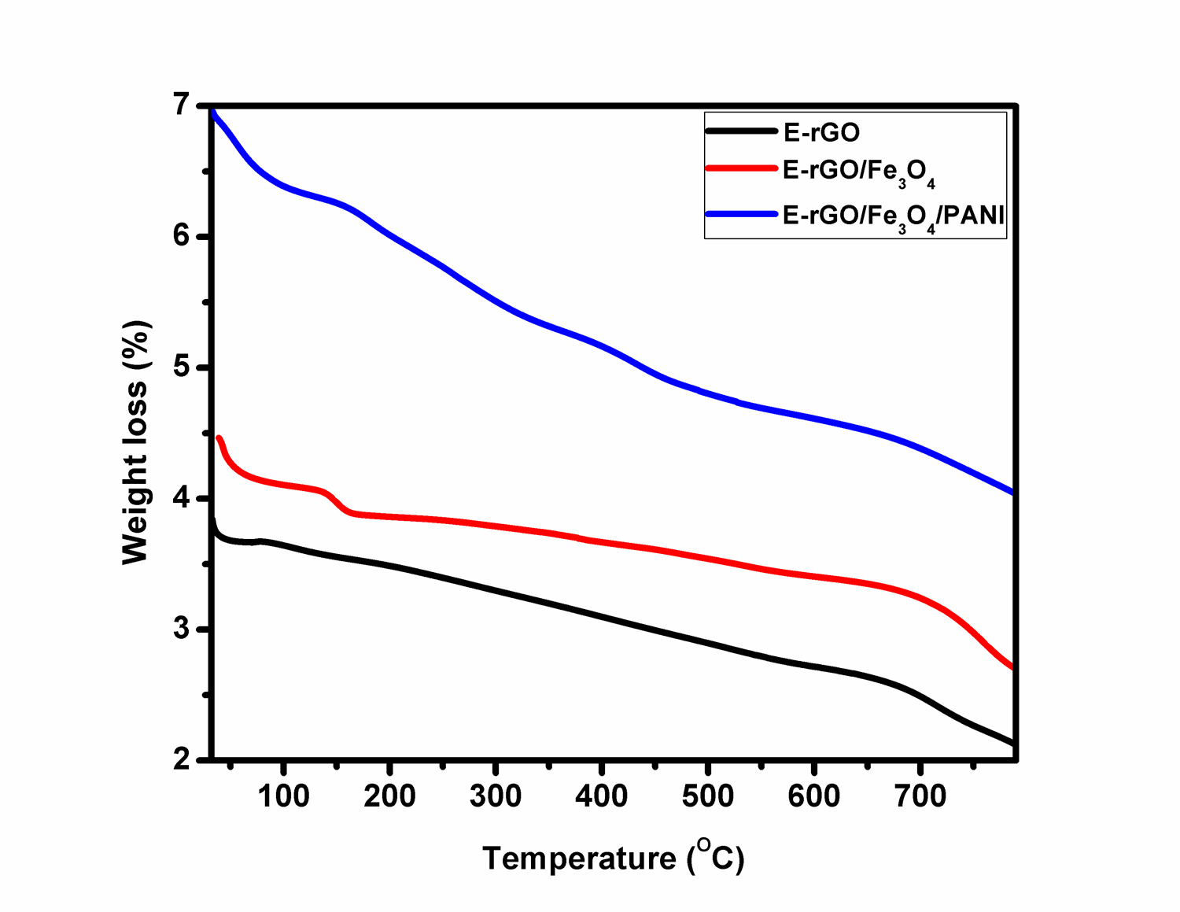

Figure11: TGA of E-rGO, E-rGO/Fe3O4, and E-rGO/Fe3O4/PANI nanocomposites

**4.2. Electrochemical Characterization**

**4.2.1 CV and EIS analysis**

As illustrated in Figure 12 (a), the bare graphite (Gr) anode electrode verified that no apparent redox peaks or currents were observed because of its limited electrical conductivity. Utilizing a cyclic voltammeter (CV) in a 1 M H2SO4 supporting electrolyte solution, the electro-catalytic activities of the produced compounds were evaluated. However, the E-rGO, E-rGO/Fe3O4, and E-rGO/Fe3O4/PANI NCs modified bare graphite electrode CV plots showed clearly visible redox peaks that might be attributed to the electrolytes' electrochemical reaction. However, the addition of PANI to the E-rGO/Fe3O4NCs increased its conductivity and expanded the active surface for electron acceptance, resulting in a significantly higher peak current for the E-rGO/Fe3O4/PANI NCs than for the E-rGO/Fe3O4modified electrode. Furthermore, the E-rGO/Fe3O4/PANI NCs modified electrode showed improved electrochemical and capacitive performance, as evidenced by a much greater area under the CV curve than the E-rGO and E-rGO/Fe3O4 modified electrodes.

Nowadays, a non-destructive method for obtaining valuable data regarding the electrochemical characteristics of electrode surfaces and the reactions that occur there is electrochemical impedance spectroscopy (EIS). All of the electrodes had comparable impedance spectra, as seen in Figure 6(b), which included a straight line and a clearly defined semicircle. At the electrode-electrolyte interface, the diameter of the semicircle serves as the electron transfer resistance (Rct), while the second straight line represents the electrolyte's diffusive resistance, also referred to as the Warburg impedance (W). A smaller Rct indicates a faster electron transfer rate (Demeku et al., 2024; He & Mansfeld, 2009; R. B. Song et al., 2017).In contrast to the other modified electrodes, the virgin graphite electrode displayed a big semicircle, suggesting that the poor electron transfer kinetics at the electrode/electrolyte interface resulted in a substantial charge-transfer resistance (Rct).The Rct value was reduced, as was also the case when the bare Gr was modified, E-rGO, E-rGO/Fe3O4, and E-rGO/Fe3O4/PANINCs with values of 123, 62, 51, and 45 ohms, respectively as shown in Table 2. A reduced Rct was shown by the E-rGO/Fe3O4/PANINCs modified electrode, suggesting higher electrochemical activity because of its increased specific surface area, which improves diffusion and charge transfer mechanisms(Xue et al., 2021).

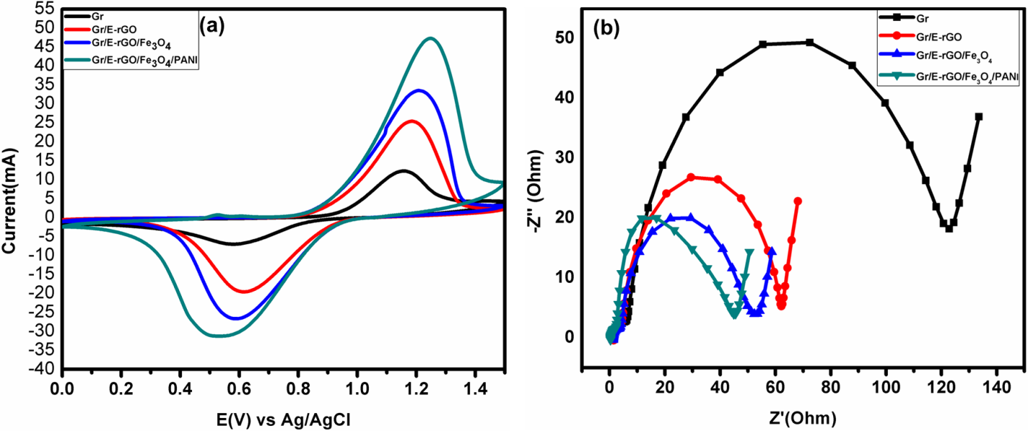Figure 12: (a) CV curves of Gr, E-rGO, E-rGO/Fe3O4 and E-rGO/Fe3O4/PANI (b) Nyquist plots of the Gr, E-rGO, E-rGO/Fe3O4 and E-rGO/Fe3O4/PANI and the corresponding Rs and Rct values.

Table 2: Solution resistance and charge transfer resistance values of, bare Gr, E-rGO/Gr, E-rGO/Fe3O4/Gr and E-rGO/Fe3O4/PANI/Gr respective electrode

|  |  |  |
| --- | --- | --- |
| Electrode | Rs/EIS(Ohm) | RCt (Ohm) |
| Bare Gr | 1.27 | 123 |
| E-rGO/Gr | 1.46 | 62 |
| E-rGO/Fe3O4/Gr | 1.34 | 51 |
| E-rGO/Fe3O4/PANI/Gr | 0.34 | 45 |

**4.3. Performances of E-rGO, E-rGO/Fe3O4 and E-rGO/Fe3O4/PANI Anodes in MFCs**

**3.3.1. Open Circuit Voltage and Current versus Time**

The efficiency of bare graphite (Gr), E-rGO, E-rGO/Fe3O4, and E-rGO/Fe3O4/PANI-modified electrodes in DMFCs was evaluated using OCV and CCV testing. To improve MFC performance, it is essential to look into the produced materials' catalytic activity, with the OCV serving as a critical parameter. The experiment on open circuit voltage was carried out without connecting the anode and cathode to any specific load. Each experiment lasted 30 days with organic waste (sweet potato waste) as the substrate. The voltage generated in the bare Gr and E-rGO, E-rGO/Fe3O4, and E-rGO/Fe3O4/PANI modified electrode MFCs had been increased gradually but consistently in the first days, reaching maximum open circuit voltages of 439, 500, 960, and 1080 mV in 15 days, respectively, according to Figure 7(a).

Initially, the population of exoelectrogens was shown to be limited. Nevertheless, it would eventually rise as a result of building an adhering biofilm and absorbing the nutrients inside the anodic compartment in anaerobic circumstances. This process leads to an increase in current production and subsequently, an increase in the open-circuit voltage (OCV) (Masoudi, Rahimnejad, & Mashkour, 2021). The efficient adherence of electrogenic bacteria on the modified anode electrode, which results in the formation of a conductive biofilm, is responsible for the maximum OCV of 1080 mV attained by E-rGO/Fe3O4/PANI NCs modified Gr. The increased charge density capability following the development of the bio-anode could potentially be the cause of these phenomena. By expanding its active surface area on the electrode surfaces, these interactions encourage the development of a conductive biofilm, which improves the rapid electron transfer rates during MFC operations. PANI's introduction improves electron transport and is biocompatible, meaning it poses no threat to living microbes (A. A. Yaqoob, Ibrahim, Yaakop, et al., 2021).

Prior to the voltage trend slowing down, the electrodes continued to function. After day 15, the voltage generated by all electrodes exhibited a decreasing trend. An inadequate supply of organic substrate was the cause of this. Only 15 days were needed to generate the maximum amount of voltage using the organic substrate that was supplied. Subsequently, the oxidation process's low carbohydrate content decreased bacterial activity, which in turn led to reduced electron production. As illustrated in Figure 7(b), the highest current for the bare Gr, E-rGO, E-rGO/Fe3O4, and E-rGO/Fe3O4/PANI NCs modified electrodes were 1.97, 3.74, and 4.26 mA, respectively, in relation to 50Ω external impedance. In contrast to previous reports in the literature, the E-rGO/Fe3O4/PANI NCs modified electrode MFC circuit connection showed a maximum current of 4.26 mA (A. A. Yaqoob, Mohamad Ibrahim, Umar, et al., 2020)

.

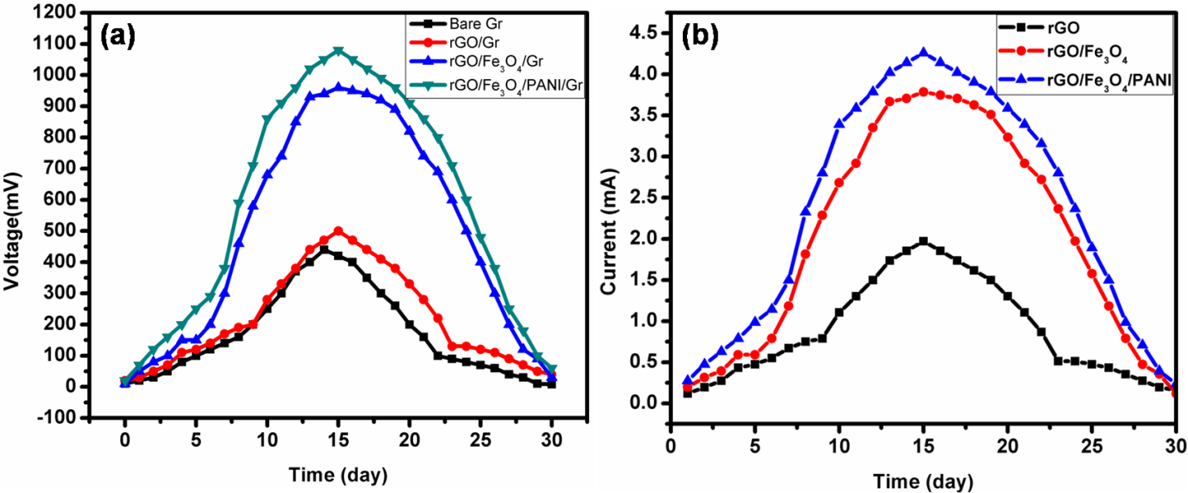Figure 7: Open circuit voltage versus time graph (a) bare and modified and (b) Maximum current versus time graph for each modified electrode.

**4.3.2. Polarization Behavior and Internal Resistance**

Another crucial parameter for characterizing MFC performance had been shown the polarization curve, which indicates that the voltage as a function of current and power density (Agarry, 2017). The proper resistance and current relationship can be found with the aid of this curve. Where the external resistances were eliminated prior to polarization tests and all cells were maintained in an open circuit mode for a full day until a steady Open Circuit Voltage (OCV) was reached. Each naked and modified anode electrode in the DCMFC was linked to a range of resistances from 10kΩ to 50 Ω in order to record voltage, current density, and power density. Each cell was maintained at each resistance level for 30 minutes to obtain consistent readings. Due to the absence of biofilm at the beginning of operation, microorganisms are initially unable to withstand the load imposed by low resistance, which is why a larger external resistance is started and then progressively decreased. A smaller resistance has been employed to encourage a dense biofilm and diminish the stationary phase once biofilm formation has taken place. It is significant to note that because of the shorter conductive channel at greater external resistances, the demand for electron production was lower than what microorganisms could provide. Consequently, a larger external resistance resulted in a longer stationary phase than one with a lower resistance.

Furthermore, microbial oxidation of substrate wastewater was expected to occur at a higher rate when using lower resistances in the circuit compared to higher resistances. This implies because electrons flow faster through lower resistances than through higher ones (Masoudi et al., 2021). Consequently, limited power generation was observed in the circuit connection with high external resistance, but rapid voltage stability was observed. However, power output was high, and voltage stabilization was delayed when external resistance was low. The voltage also destabilized quite quickly in comparison to the high external resistances. High power and current density with poor potential stability were created by fast electron transport to the cathode, which in turn led to severe voltage instability at low resistance. Comparable power developments also received little attention in the literature (Mateo, Cañizares, Rodrigo, & Fernandez-Morales, 2018; P. J. Sarma & Mohanty, 2018).

MFCs using E-rGO, E-rGO/Fe3O4, and E-rGO/Fe3O4/PANI anodes achieved maximum power densities of 8.75, 39.77, and 63 mW m−2 with 434, 416 and 382 Ω internal resistances, respectively, as shown in figure 8((a), (b), and (c)). There were three equivalent current densities at 50 Ω external resistances: 609, 1171, and 1312 mA m−2.A significant improvement in current and power density performance was shown by the complete NCs modified electrode because of its ability to facilitate a fast electron transfer rate between microbial colonies and the electrode surface. This resulted in comparable to literature reported by (Agrahari & Rani, 2022). Specifically, the results indicated that electrodes modified with E-rGO/Fe3O4/PANI NCs were exhibited favorable electrochemical performance, making them a potential modifier for the anode. The low internal resistance and effective charge transfer capability of E-rGO are responsible for the enhanced electrochemical performance of E-rGO/Fe3O4/PANI [59]. The doping effect, in which strong contacts between nanoparticles and the quinoid sites of PANI enabled charge transfer and increased electron transport capabilities, is responsible for the E-rGO/Fe3O4/PANI configuration's better performance as shown in figure (8d).Furthermore, as observed in SEM image shown in Figure 2,the interaction between PANI and E-rGO/Fe3O4NCsresulted in significant changes in electrode morphology, including increased defect sites, high porosity, and a rough surface, ultimately enhancing electrode surface area (Rajesh, Noori, & Ghangrekar, 2020). When the microorganisms were immobilized, the porous surface facilitates direct electron transfer in an effective manner. By indirectly increasing the anode's surface area, it increased in the nanocomposites porosity encouraged the growth of bacteria and biofilm. According to these results, PANI and E-rGO/Fe3O4 are employed in concert to enhance electron transport mechanisms and boost electrochemical activity, which in turn improves MFC performance. Notably, the generated anode materials are utilized to reduce Pb (II) and Cr (VI) from concentrated effluent while also producing energy. By creating composites in near-neutral solutions, E-rGO and Fe3O4NPs significantly improved the specific capacitance and cycling stability on the graphite anodic surface. The combined effect was also very beneficial in preventing PANI's swelling and shrinking behavior under neutral settings. Moreover, a large number of active surface sites and surface areas were supplied by Fe3O4 and E-rGO for the polymerization development of PANI. In earlier research, a similar pattern in the polarization investigations was described [69]. The theoretical aspect relation of voltage and current with the external loads are shown in figure 8(e, and f). Table 3 compares the anodes' current density efficiency in MFCs with that of other anodes that have been previously reported.

Table3.A comparative summary of the anode electrodes in double chamber microbial fuel cells.

|  |  |  |  |  |  |  |
| --- | --- | --- | --- | --- | --- | --- |
| Anode material | Substrate | Inoculation  Source | Surface Area | Power Density(mWm-2) | Current Density  Efficiency(mAm-2) | References |
| PPy-co-PANI/MNPs | Acetate |  | 18 mm | 4.9 ± 0.5 | 14.04 | (M. K. Sarma, Quadir, Bhaduri, Kaushik, & Goswami, 2018) |
| Graphene/PEDOT/ CP |  | Escherichia coli | 22.5cm2 |  | 3.59 mA/m2 | (Y. Wang, Zhao, Sun, Zhang, & Zhu, 2013) |
| AC/PANI/D-CSA/ GF |  | Domestic Wastewater |  |  | 110 mA/m2 | (Scott, Rimbu, Katuri, Prasad, & Head, 2007) |
| Fe3O4/AC/SSM |  | Preacclimated Effluent | 7 cm2 |  | 1.9 A/m2 | (Peng, Yu, Ai, Li, & Wang, 2013) |
| CP/HAPNW |  | ShewanellaLoihica |  |  | 2.9 mA /cm2 | (Zhao, Nakanishi, Watanabe, & Hashimoto, 2011) |
| Graphite activated |  | Mix culture | 3.14 m2 |  | 25 mA/m2 | (Karra et al., 2014) |
| GO-PANI/GE | Sweet potato | Cd (II) and Pb(II)supplemented  wastewater | 0.007 m2 | 1.1 | 87.71 mA/cm2 | (A. A. Yaqoob, Mohamad Ibrahim, Umar, et al., 2020) |
| L-GO/ZnO/GR | glucose | Pd (II) ion supplemented wastewater | 76.0 cm2 |  | 142.98 | (A. A. Yaqoob, Ibrahim, Yaakop, et al., 2021) |
| E-rGO/GR | Sweet potato | Cr(VI) and Pd (II) ion | 40 m2 | 8.75 | 609 | This work |
| E-rGO/Fe3O4/GR |  | supplement | 40 m2 | 39.77 | 1171 | This work |
| E-rGO/Fe3O4/PANI/GR |  | wastewater | 40 m2 | 63 | 1312 | This work |

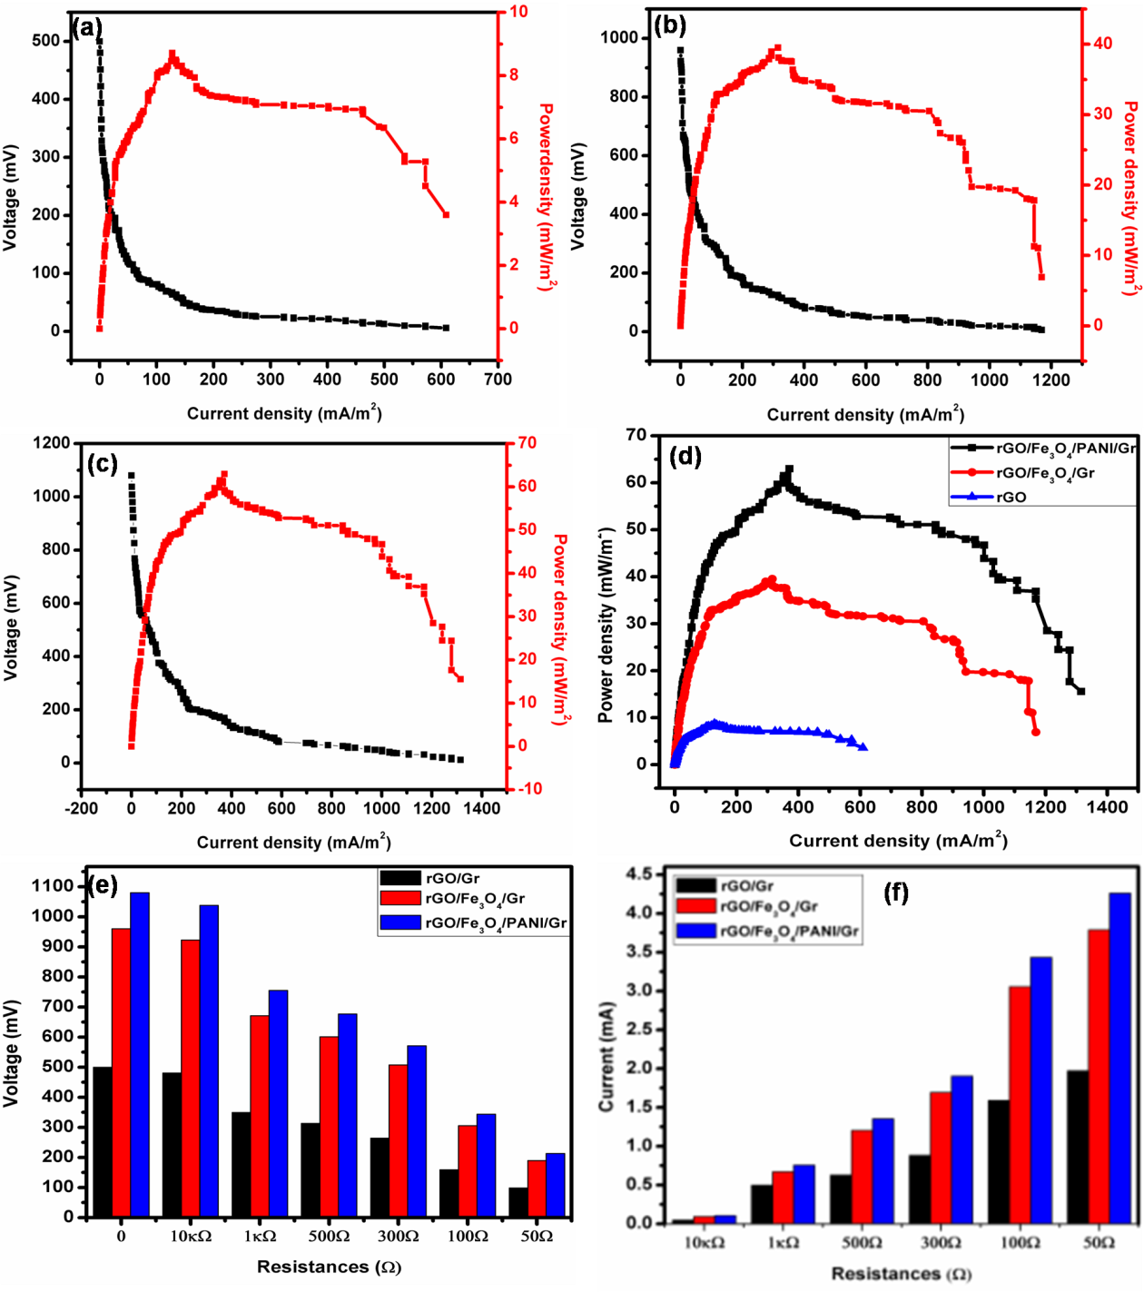

Figure 8: The voltage generation trends of E-rGO(a), E-rGO/Fe3O4(b) E-rGO/Fe3O4/PANI(c) anodes and CD verses P.D, comparation of C.D and P.D, (d) voltage verses external load, (e) and current verses external load (f).

**4.3.3. Bioremediation of Cr (VI) and Pb (II) Ions Supplemented Waste Water**

Previous studies have demonstrated that using microbial fuel cells (MFCs) for metal remediation was an innovative method for reducing water pollution (A. A. Yaqoob, Ibrahim, Yaakop, et al., 2021). According to research conducted by [40], the choice of anode material and proton exchange source significantly influenced both energy production and pollutant removal. However, in this study only the bioremediation of Cr (VI) and Pb (II) ions were focused using DMFCs. All the E-rGO, E-rGO/Fe3O4 and E-rGO/Fe3O4/PANI electrodes were used as anode to compare their efficiency as shown in Table 4. The bioremediation of Cr (VI) and Pb (II) ions supplemented wastewater solution was conducted for 30 days using DMFCs. According to the findings, the E-rGO, E-rGO/Fe3O4, and E-rGO/Fe3O4/PANI electrodes enabled bacterial growth on 40 m2 of surface area, resulting in remediation efficiencies of 70.6%, 79.2%, and 88.3% for Cr (VI), respectively. These electrodes demonstrated higher remediation efficiency for Cr (VI) compared to the unmodified Graphite anode (63.5%). Anodes made with E-rGO, E-rGO/Fe3O4, and E-rGO/Fe3O4/PANI NCs demonstrated remediation rates of 65.1%, 73.8%, and 86.5%, respectively, demonstrating a comparable effect in the remediation of Pb (II). In comparison, the unmodified graphite anode showed a removal efficiency of 55.5% for Pb (II). The removal effectiveness of the materials was influenced by the conductivity of the material utilized. More stability for bacterial respiration was provided by the E-rGO/Fe3O4/PANI anode electrode in comparison to E-rGO, E-rGO/Fe3O4, and bare graphite felt (Gr). The remediation efficiency of L-GO was 54.05% and that of L-GO/ZnO was 65.03% by the time the reaction was halfway through (30 days). When all electrodes were considered, the E-rGO/Fe3O4/PANI performed better for both metals in terms of energy production and pollutant removal using MFCs. In comparison to other electrodes, this suggests that PANI's introduction has demonstrated superior biocompatibility for the bacterial community's growth.

In general, both electrodes' biological compatibility for the development of bacteria and metabolism was enhanced. It's interesting to note that among previously published research, this one had the largest lowering rates of Cr (VI) and Pd (II) [13, 28, and 30]. Chromium is reduced by microorganisms from the extremely hazardous Cr (VI) oxidation state to the less harmful Cr (III) state by directly accepting electrons from electrodes. Similarly, they could lead ions from the soluble Pb (II) state to the insoluble Pb state. Table 5 and Figure 9 shows a comparative profile with the previous literature was tabulated based on bioelectro chemical fuel cells with MFC results and the proposed harmful pollutant bioremediation and energy generation mechanism.

Table 4. The performance of anode material in DMFCs for the remediation of Cr (VI) and Pd (II) ions.

|  |  |  |  |  |  |
| --- | --- | --- | --- | --- | --- |
| Type of  Anode | Target  metal | Inoculation  Source | Days of  Operation | Initial concentration of  metal in wastewater (ppm) | Remediation  Efficiency (%) |
| Bare Gr |  |  | 0 |  | 0 |
|  |  |  | 15 |  | 45 |
|  |  |  | 30 |  | 64 |
| E-rGO |  |  | 0 |  | 0 |
|  |  |  | 15 |  | 50 |
|  |  |  | 30 | 150 | 71 |
| E-rGO/Fe3O4 | Cr(VI) | Synthetic | 0 |  | 0 |
|  |  | Wastewater | 15 |  | 56 |
|  |  |  | 30 |  | 79 |
| E-rGO/Fe3O4/PANI |  |  | 0 |  | 0 |
|  |  |  | 15 |  | 58 |
|  |  |  | 30 |  | 88 |
| Bare Gr |  |  | 0 |  | 0 |
|  |  |  | 15 |  | 43 |
|  |  |  | 30 |  | 56 |
| E-rGO |  | Synthetic | 0 | 150 | 0 |
|  |  | wastewater | 15 |  | 45 |
|  |  |  | 30 |  | 65 |
| E-rGO/Fe3O4 |  |  | 0 |  | 0 |
|  |  |  | 15 |  | 50 |
|  | Pd(II) |  | 30 |  | 74 |
| E-rGO/Fe3O4/PANI |  |  | 0 |  | 0 |
|  |  |  | 15 |  | 54 |
|  |  |  | 30 |  | 87 |

Table 5. List of most recent work on Cr (VI) and Pd (II) removal from literature compared with present work

|  |  |  |  |  |  |  |  |  |
| --- | --- | --- | --- | --- | --- | --- | --- | --- |
| Fuel cell reactors | Organic substrate | Inoculation medium | Targeted metals | Initial con….(ppm) | Anode material | Cathode material | Remediation performance (%) | References |
| MFC | Glucose | Anaerobic digester sludge | Cr (VI) | 20 | Graphite felt | Graphite felt | 79 | (Wu et al., 2015) |
| MFC | Sodium acetate | Anaerobic sludge bed | Cr (VI) | 100 | Graphite plate | Graphite plate | 82 | (F. Li, Jin, Choi, & Lim, 2019; H. Wang, Song, Zhang, Tan, & Kong, 2020) |
|  | Glucose | Anaerobic sludge | Cr (VI) |  | Graphite brushes | Carbon clot | 99 | (H. Wang et al., 2020) |
| BMFC | Sweet potatoes wastes | Wastewater | Pd (II) | 50 | Graphene oxide | Graphite rod | 60.33 | (A. Yaqoob, Fadzli, Ibrahim, & Yaakop, 2023) |
| BMFC | Sweet potatoes wastes | Wastewater | Pd (II) | 50 | Graphene oxide/PANI | Graphite rod | 65.51 | (A. Yaqoob et al., 2023) |
| MFC | Oil palm trunk sap | Wastewater | Pd (II) | 100 | Graphene oxide/ZnO | Graphite rod | 91.07 | (A. A. Yaqoob, Ibrahim, Yaakop, et al., 2021) |
| MFC | sugar cane juice | Synthetic wastewater | Pd (II) | 100 | GO/PANI/Ag | Graphite rod | 78.10 | (A. A. Yaqoob et al., 2022) |
|  |  |  | Cr(VI) |  | E-rGO | Graphite rod | 70.6 | This work |
| MFC | Sweet potatoes wastes | Synthetic wastewater |  | 150 | E-rGO/Fe3O4 | Graphite rod | 79.2 | This work |
|  |  |  |  |  | E-rGO/Fe3O4/PANI | Graphite rod | 88.3 | This work |
| MFC | Sweet potatoes wastes | Synthetic wastewater | Pd (II) | 150 | E-rGO | Graphite rod | 65.1 | This work |
|  |  |  |  |  | E-rGO/Fe3O4 | Graphite rod | 73.8 | This work |
|  |  |  |  |  | E-rGO/Fe3O4/PANI | Graphite rod | 86.5 | This work |

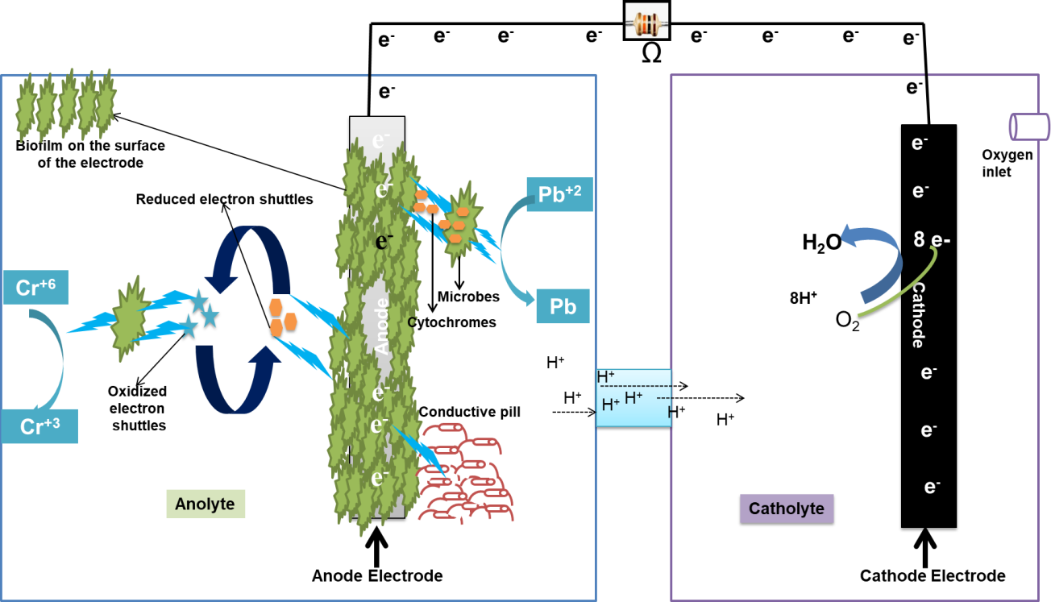

Figure 9: remediation mechanism pollutant ion in microbial fuel cell

**5. CONCLUSION**

In this study, the E-rGO, E-rGO/Fe3O4, and E-rGO/Fe3O4/PANI NCs modified anodes were synthesized using agricultural biomass waste. Several approaches were used to examine the morphological and structural properties of the produced materials. The E-rGO, E-rGO/Fe3O4, and E-rGO/Fe3O4/PANI composites demonstrated appropriate structural morphology for use as an electrode for electrical conductivity. The present modified anode material was the most advantageous for producing the anode for MFCs at a fair price and a means of reducing the toxicity of environmental waste. Using MFCs, the produced anode showed remarkable remediation effectiveness for the removal of Cr (VI) and Pb (II) ions from supplemented wastewater while simultaneously generating remarkable energy. The E-rGO/Fe3O4/PANI composite anode was shown to be more efficient than the E-rGO and E-rGO/Fe3O4 anodes. The composite anode material exhibited great thermal stability, strength, biocompatibility, superior conductivity, and surface area for the reproduction of bacteria.

**CRediT authorship contribution statement**

G.S.W conceived the research. D.A, T.T, G.S.W and A.M.D conducted the experiments. G.S.W, D.A. S.A., N.M.D., B.A.H., A.M.D, E.T.G and C.T.H. analyzed the results. G.S.W., D.A., E.T.G and T.T. prepared the manuscript. All authors reviewed the manuscript.

**Declaration of Competing Interest**

The authors declare no competing financial interests. We confirm that the manuscript has been read and approved by all named authors. We confirm that the order of authors listed in the manuscript has been approved by all named authors.

**Acknowledgements**

We thank Mattu University department of chemistry for conducting the experiments.

**6. REFERENCE**S

Abbas, S. Z., Rafatullah, M., Ismail, N., & Syakir, M. I. (2017). A review on sediment microbial fuel cells as a new source of sustainable energy and heavy metal remediation: mechanisms and future prospective. International Journal of Energy Research, 41(9), 1242-1264.

Agarry, S. (2017). Bioelectricity generation and treatment of petroleum refinery effluent by Bacillus cereus and Clostridium butyricum using microbial fuel cell technology. Nigerian Journal of Technology, 36(2), 543-551.

Agrahari, R., & Rani, R. (2022). Electrochemical behavior of a multi modular microbial fuel cell operated using cow dung enriched inoculum: Enhanced energy recovery using electrochemical optimization. Journal of Cleaner Production, 374, 133901.

Ahmed, J., & Kim, S. (2024). Polyaniline nanofiber: an excellent anode material for microbial fuel cells. RSC advances, 14(46), 34498-34503.

BhaskaraRao, B., Pabba, D. P., Aepuru, R., Akbari-Fakhrabadi, A., Lokhande, P., Udayabhaskar, R., . . . Espinoza-González, R. (2023). Fe3O4 nanoparticles intercalated reduced graphene oxide nanosheets for supercapacitor and lithium-ion battery anode performance. Journal of Materials Science: Materials in Electronics, 34(28), 1910.

Bhattacharya, P., Dhibar, S., Hatui, G., Mandal, A., Das, T., & Das, C. K. (2014). Graphene Decorated with Hexagonal Shaped M-type Ferrite and Polyaniline Wrapper: a Potential Candidate for Electromagnetic Wave Absorbing and Energy Storage Device Applications. RSC Adv., 4, 17039.

Bhowmick, G., Das, S., Verma, H., Neethu, B., & Ghangrekar, M. (2019). Improved performance of microbial fuel cell by using conductive ink printed cathode containing Co3O4 or Fe3O4. Electrochimica acta, 310, 173-183.

Cai, T., Meng, L., Chen, G., Xi, Y., Jiang, N., Song, J., . . . Huang, M. (2020). Application of advanced anodes in microbial fuel cells for power generation: A review. Chemosphere, 248, 125985.

Charandabinezhad, S. R., Asgharzadeh, H., & Arsalani, N. (2021). Synthesis and characterization of reduced graphene oxide/magnetite/polyaniline composites as electrode materials for supercapacitors. Journal of Materials Science: Materials in Electronics, 32(2), 1864-1876.

Chen, Q., Pu, W., Hou, H., Hu, J., Liu, B., Li, J., . . . Yang, C. (2018). Activated microporous-mesoporous carbon derived from chestnut shell as a sustainable anode material for high performance microbial fuel cells. Bioresource Technology, 249, 567-573.

Demeku, A. M., Kabtamu, D. M., Chen, G.-C., Ou, Y.-T., Huang, Z.-J., Chiang, T.-C., . . . Wang, C.-H. (2024). Surface Electroactive Sites of Tungstated Zirconia Catalysts for Vanadium Redox Flow Batteries. ACS Applied Materials & Interfaces, 16(6), 7047-7056.

Dessie, Y., & Tadesse, S. (2022). Optimization of polyvinyl alcohol binder on PANI coated pencil graphite electrode in doubled chamber microbial fuel cell for glucose biosensor. Sensing and Bio-Sensing Research, 36, 100484.

Du, Z., Li, H., & Gu, T. (2007). A state of the art review on microbial fuel cells: a promising technology for wastewater treatment and bioenergy. Biotechnology advances, 25(5), 464-482.

Emiru, T. F., & Ayele, D. W. (2017). Controlled synthesis, characterization and reduction of graphene oxide: A convenient method for large scale production. Egyptian Journal of Basic and Applied Sciences, 4(1), 74-79.

Erable, B., Byrne, N., Etcheverry, L., Achouak, W., & Bergel, A. (2017). Single medium microbial fuel cell: stainless steel and graphite electrode materials select bacterial communities resulting in opposite electrocatalytic activities. International journal of hydrogen energy, 42(41), 26059-26067.

Fang, C., & Achal, V. (2019). The potential of microbial fuel cells for remediation of heavy metals from soil and water—review of application. Microorganisms, 7(12), 697.

Firdous, S., Jin, W., Shahid, N., Bhatti, Z., Iqbal, A., Abbasi, U., . . . Ali, A. (2018). The performance of microbial fuel cells treating vegetable oil industrial wastewater. Environmental technology & innovation, 10, 143-151.

Gajda, I., Greenman, J., & Ieropoulos, I. (2020). Microbial Fuel Cell stack performance enhancement through carbon veil anode modification with activated carbon powder. Applied Energy, 262, 114475.

Gonzalez Olias, L., Cameron, P. J., & Di Lorenzo, M. (2019). Effect of electrode properties on the performance of a photosynthetic microbial fuel cell for atrazine detection. Frontiers in Energy Research, 7, 105.

Habibi, F., Seyyedi, M., & Ayati, B. (2022). Synthesis and application of reusable and magnetic RGO/Fe3O4 nanocomposites in BR46 removal from an aqueous solution; future prospects of an efficient adsorption platform. J Mater Environ Sci, 13(08), 900-913.

Hao, L., Zhang, B., Tian, C., Liu, Y., Shi, C., Cheng, M., & Feng, C. (2015). Enhanced microbial reduction of vanadium (V) in groundwater with bioelectricity from microbial fuel cells. Journal of power sources, 287, 43-49.

Harshiny, M., Samsudeen, N., Kameswara, R. J., & Matheswaran, M. (2017). Biosynthesized FeO nanoparticles coated carbon anode for improving the performance of microbial fuel cell. International journal of hydrogen energy, 42(42), 26488-26495.

He, Z., & Mansfeld, F. (2009). Exploring the use of electrochemical impedance spectroscopy (EIS) in microbial fuel cell studies. Energy & Environmental Science, 2(2), 215-219.

Hein, J. R., Evans, J., & Jones, P. (2008). Mobile methodologies: Theory, technology and practice. Geography compass, 2(5), 1266-1285.

Hindatu, Y., Annuar, M., & Gumel, A. (2017). Mini-review: Anode modification for improved performance of microbial fuel cell. Renewable and Sustainable Energy Reviews, 73, 236-248.

Hosseine, M., Naghib, S. M., & Khodadadi, A. (2024). Label-free electrochemical biosensor based on green-synthesized reduced graphene oxide/Fe3O4/nafion/polyaniline for ultrasensitive detection of SKBR3 cell line of HER2 breast cancer biomarker. Scientific Reports, 14(1), 11928.

Jawaid, M., Ahmad, A., Ismail, N., & Rafatullah, M. (2021). Environmental remediation through carbon based nano composites: Springer.

Kahsay, M. H., Belachew, N., Tadesse, A., & Basavaiah, K. (2020). Magnetite nanoparticle decorated reduced graphene oxide for adsorptive removal of crystal violet and antifungal activities. RSC advances, 10(57), 34916-34927.

Kailasa, S., Reddy, R. K. K., Reddy, M. S. B., Rani, B. G., Maseed, H., Sathyavathi, R., & Rao, K. V. (2020). High sensitive polyaniline nanosheets (PANINS)@ rGO as non-enzymatic glucose sensor. Journal of Materials Science: Materials in Electronics, 31, 2926-2937.

Karra, U., Muto, E., Umaz, R., Kölln, M., Santoro, C., Wang, L., & Li, B. (2014). Performance evaluation of activated carbon-based electrodes with novel power management system for long-term benthic microbial fuel cells. International Journal of Hydrogen Energy, 39(36), 21847-21856.

Kaur, R., Marwaha, A., Chhabra, V. A., Kim, K.-H., & Tripathi, S. K. (2020). Recent developments on functional nanomaterial-based electrodes for microbial fuel cells. Renewable and Sustainable Energy Reviews, 119, 109551.

Khudzari, J. M., Gariépy, Y., Kurian, J., Tartakovsky, B., & Raghavan, G. V. (2019). Effects of biochar anodes in rice plant microbial fuel cells on the production of bioelectricity, biomass, and methane. Biochemical engineering journal, 141, 190-199.

Kirubaharan, C. J., Kumar, G. G., Sha, C., Zhou, D., Yang, H., Nahm, K. S., . . . Yong, Y.-C. (2019). Facile fabrication of Au@ polyaniline core-shell nanocomposite as efficient anodic catalyst for microbial fuel cells. Electrochimica acta, 328, 135136.

kumar, G., Kirubaharan, C., Yoo, D. J., & Kim, A. (2016). Graphene/poly(3,4-ethylenedioxythiophene)/Fe3O4 nanocomposite – An efficient oxygen reduction catalyst for the continuous electricity production from wastewater treatment microbial fuel cells. International Journal of Hydrogen Energy, 41. doi:10.1016/j.ijhydene.2016.05.099

Li, F., Jin, C., Choi, C., & Lim, B. (2019). SIMULTANEOUS REMOVAL AND/OR RECOVERY OF Cr (VI) AND Cr (III) USING A DOUBLE MFC TECHNIQUE. Environmental Engineering & Management Journal (EEMJ), 18(1).

Li, J., Li, H., Zheng, J., Zhang, L., Fu, Q., Zhu, X., & Liao, Q. (2017). Response of anodic biofilm and the performance of microbial fuel cells to different discharging current densities. Bioresource Technology, 233, 1-6.

Li, L., Dou, Y., Wang, L., Luo, M., & Liang, J. (2014). One-step synthesis of high-quality N-doped graphene/Fe3O4 hybrid nanocomposite and its improved supercapacitor performances. RSC Adv. 4: 25658–25665. In.

Logan, B. E. (2009). Exoelectrogenic bacteria that power microbial fuel cells. Nature Reviews Microbiology, 7(5), 375-381.

Luo, J., Shen, P., Yao, W., Jiang, C., & Xu, J. (2016). Synthesis, characterization, and microwave absorption properties of reduced graphene oxide/strontium ferrite/polyaniline nanocomposites. Nanoscale research letters, 11, 1-14.

Ma, J., Shi, N., & Jia, J. (2020). Fe3O4 nanospheres decorated reduced graphene oxide as anode to promote extracellular electron transfer efficiency and power density in microbial fuel cells. Electrochimica Acta, 362, 137126.

Malitha, S. B., Mahmudunnabi, D. M., Mazumder, S., Hossain, K. S., Nurnabi, M., & Alam, M. Z. (2025). Rapid adsorptive removal of Pb 2+ ions from aqueous systems using a magnetic graphene oxide calcium alginate composite: optimisation, isotherms, and kinetics. Environmental Science: Advances.

Masoudi, M., Rahimnejad, M., & Mashkour, M. (2021). Enhancing operating capacity of microbial fuel cells by using low-cost electrodes and multi anode-cathode connections in a membrane-less configuration. International Journal of Hydrogen Energy, 46(11), 8226-8238.

Mateo, S., Cañizares, P., Rodrigo, M. A., & Fernandez-Morales, F. J. (2018). Driving force of the better performance of metal-doped carbonaceous anodes in microbial fuel cells. Applied Energy, 225, 52-59.

Mathuriya, A. S., & Yakhmi, J. (2014). Microbial fuel cells to recover heavy metals. Environmental chemistry letters, 12, 483-494.

Mishra, A., & Sundara, R. (2011). Nano magnetite decorated multiwalled carbon nanotubes: A robust nanomaterial for enhanced Carbon Dioxide adsorption. Energy Environ. Sci., 4, 889-895. doi:10.1039/C0EE00076K

Mondal, S., Rana, U., & Malik, S. (2017a). Reduced graphene oxide/Fe3O4/polyaniline nanostructures as electrode materials for an all-solid-state hybrid supercapacitor. The Journal of Physical Chemistry C, 121(14), 7573-7583.

Mondal, S., Rana, U., & Malik, S. (2017b). Reduced Graphene Oxide/Fe 3 O 4 /Polyaniline Nanostructures as Electrode Materials for All-Solid-State Hybrid Supercapacitor. The Journal of Physical Chemistry C, 121. doi:10.1021/acs.jpcc.6b10978

Ms, N. A. D., Ms, S. N., Mr, S. S., Ms, R. B., Ms, S. R., Mr, W. I. S., & Swain, B. P. (2020). Investigation of chemical bonding and supercapacitivity properties of Fe3O4-rGO nanocomposites for supercapacitor applications. Diamond and Related Materials, 104, 107756.

Nugraheni, A. Y., Nasrullah, M., Prasetya, F. A., Astuti, F., & Darminto, D. (2015). Study on phase, molecular bonding, and bandgap of reduced graphene oxide prepared by heating coconut shell. Paper presented at the Materials Science Forum.

Olad, A., & Nabavi, R. (2007). Application of polyaniline for the reduction of toxic Cr (VI) in water. Journal of hazardous materials, 147(3), 845-851.

Palanisamy, G., Jung, H.-Y., Sadhasivam, T., Kurkuri, M. D., Kim, S. C., & Roh, S.-H. (2019). A comprehensive review on microbial fuel cell technologies: Processes, utilization, and advanced developments in electrodes and membranes. Journal of cleaner production, 221, 598-621.

Patade, S., Silveira, K., Babu, A., Mhatre, Y., Saini, V., Rajput, R., . . . Birmole, R. (2016). Bioremediation of dye effluent waste through an optimised microbial fuel cell. International Journal of Advanced Research in Biological Sciences, 3(3), 214-226.

Peng, X., Yu, H., Ai, L., Li, N., & Wang, X. (2013). Time behavior and capacitance analysis of nano-Fe3O4 added microbial fuel cells. Bioresource Technology, 144, 689-692.

Qiu, Z., Peng, Y., He, D., Wang, Y., & Chen, S. (2018). Ternary Fe3O4@C@PANi nanocomposites as high-performance supercapacitor electrode materials. Journal of Materials Science, 53(17), 12322-12333. doi:10.1007/s10853-018-2451-9

Rahimnejad, M., Adhami, A., Darvari, S., Zirepour, A., & Oh, S.-E. (2015). Microbial fuel cell as new technology for bioelectricity generation: A review. Alexandria Engineering Journal, 54(3), 745-756.

Rajesh, P., Noori, M. T., & Ghangrekar, M. (2020). Improving performance of microbial fuel cell by using polyaniline-coated carbon–felt anode. Journal of Hazardous, Toxic, and Radioactive Waste, 24(3), 04020024.

Ramanujam, B., & Annamalai, P. K. (2017). Conducting polymer–graphite binary and hybrid composites: Structure, properties, and applications. In Hybrid Polymer Composite Materials (pp. 1-34): Elsevier.

Rana, U., & Malik, S. (2012). Graphene oxide/polyaniline nanostructures: transformation of 2D sheet to 1D nanotube and in situ reduction. Chemical Communications, 48(88), 10862-10864.

Rani, R., Sharma, D., & Kumar, S. (2019). Optimization of operating conditions of miniaturize single chambered microbial fuel cell using NiWO4/graphene oxide modified anode for performance improvement and microbial communities dynamics. Bioresource Technology, 285, 121337.

Santoro, C., Arbizzani, C., Erable, B., & Ieropoulos, I. (2017). Microbial fuel cells: From fundamentals to applications. A review. Journal of power sources, 356, 225-244.

Saratale, G. D., Saratale, R. G., Shahid, M. K., Zhen, G., Kumar, G., Shin, H.-S., . . . Kim, S.-H. (2017). A comprehensive overview on electro-active biofilms, role of exo-electrogens and their microbial niches in microbial fuel cells (MFCs). Chemosphere, 178, 534-547.

Sarma, M. K., Quadir, M. G. A., Bhaduri, R., Kaushik, S., & Goswami, P. (2018). Composite polymer coated magnetic nanoparticles based anode enhances dye degradation and power production in microbial fuel cells. Biosensors and Bioelectronics, 119, 94-102.

Sarma, P. J., & Mohanty, K. (2018). Epipremnum aureum and Dracaena braunii as indoor plants for enhanced bio-electricity generation in a plant microbial fuel cell with electrochemically modified carbon fiber brush anode. Journal of bioscience and bioengineering, 126(3), 404-410.

Scott, K., Rimbu, G., Katuri, K., Prasad, K., & Head, I. (2007). Application of modified carbon anodes in microbial fuel cells. Process Safety and Environmental Protection, 85(5), 481-488.

Sevda, S., Sharma, S., Joshi, C., Pandey, L., Tyagi, N., Abu-Reesh, I., & Sreekrishnan, T. (2018). Biofilm formation and electron transfer in bioelectrochemical systems. Environmental Technology Reviews, 7(1), 220-234.

Shin, H. J., Kim, K. K., Benayad, A., Yoon, S. M., Park, H. K., Jung, I. S., . . . Choi, J. Y. (2009). Efficient reduction of graphite oxide by sodium borohydride and its effect on electrical conductance. Advanced Functional Materials, 19(12), 1987-1992.

Sonawane, J. M., Yadav, A., Ghosh, P. C., & Adeloju, S. B. (2017). Recent advances in the development and utilization of modern anode materials for high performance microbial fuel cells. Biosensors and bioelectronics, 90, 558-576.

Song, R.-B., Zhao, C.-E., Jiang, L.-P., Abdel-Halim, E. S., Zhang, J.-R., & Zhu, J.-J. (2016). Bacteria-affinity 3D macroporous graphene/MWCNTs/Fe3O4 foams for high-performance microbial fuel cells. ACS applied materials & interfaces, 8(25), 16170-16177.

Song, R. B., Zhao, C. e., Gai, P. P., Guo, D., Jiang, L. P., Zhang, Q., . . . Zhu, J. J. (2017). Graphene/Fe3O4 nanocomposites as efficient anodes to boost the lifetime and current output of microbial fuel cells. Chemistry–An Asian Journal, 12(3), 308-313.

Song, T.-S., Wang, D.-B., Wang, H., Li, X., Liang, Y., & Xie, J. (2015). Cobalt oxide/nanocarbon hybrid materials as alternative cathode catalyst for oxygen reduction in microbial fuel cell. International journal of hydrogen energy, 40(10), 3868-3874.

Tan, R. K. L., Reeves, S. P., Hashemi, N., Thomas, D. G., Kavak, E., Montazami, R., & Hashemi, N. N. (2017). Graphene as a flexible electrode: review of fabrication approaches. Journal of Materials Chemistry A, 5(34), 17777-17803.

Tapas, K., Kumar, M. A., Partha, K., Hoon, K. N., Elias, U. M., & Hee, L. J. (2012). Facile Method for the Preparation of Water Dispersible Graphene using Sulfonated Poly (ether–ether–ketone) and Its Application as Energy Storage Materials.

Thambidurai, S., & Pandiselvi, K. (2018). Polyaniline/natural polymer composites and nanocomposites. In Polyaniline Blends, Composites, and Nanocomposites (pp. 235-256): Elsevier.

Tienne, L. G. P., da Silva Candido, L., da Cruz, B. d. S. M., Gondim, F. F., Ribeiro, M. P., Simão, R. A., . . . Monteiro, S. N. (2022). Reduced graphene oxide synthesized by a new modified Hummer's method for enhancing thermal and crystallinity properties of Poly (vinylidene fluoride). journal of materials research and technology, 18, 4871-4893.

Tizaoui, K., Benguella, B., & Makhoukhi, B. (2019). Selective adsorption of heavy metals (Co2+, Ni2+, and Cr3+) from aqueous solutions onto natural marne clay. Desalination and Water Treatment, 142, 252-259.

Ucar, D., Zhang, Y., & Angelidaki, I. (2017). An overview of electron acceptors in microbial fuel cells. Frontiers in microbiology, 8, 643.

Wang, H., Song, X., Zhang, H., Tan, P., & Kong, F. (2020). Removal of hexavalent chromium in dual-chamber microbial fuel cells separated by different ion exchange membranes. Journal of hazardous materials, 384, 121459.

Wang, L., Huang, Y., Li, C., Chen, J., & Sun, X. (2015). Hierarchical composites of polyaniline nanorod arrays covalently-grafted on the surfaces of graphene@Fe3O4@C with high microwave absorption performance. Composites Science and Technology, 108, 1-8. doi:<https://doi.org/10.1016/j.compscitech.2014.12.011>

Wang, L., Ye, Y., Lu, X., Wen, Z., Li, Z., Hou, H., & Song, Y. (2013). Hierarchical nanocomposites of polyaniline nanowire arrays on reduced graphene oxide sheets for supercapacitors. Scientific reports, 3(1), 3568.

Wang, L., Ye, Y., Lu, X., Wen, Z., Li, Z., Hou, H., & Song, Y. (2013). Hierarchical nanocomposites of polyaniline nanowire arrays on reduced graphene oxide sheets for supercapacitors. Sci Rep, 3, 3568. doi:10.1038/srep03568

Wang, Y., Zhao, C. e., Sun, D., Zhang, J. R., & Zhu, J. J. (2013). A graphene/poly (3, 4‐ethylenedioxythiophene) hybrid as an anode for high‐performance microbial fuel cells. ChemPlusChem, 78(8), 823-829.

Wei, J., Zang, Z., Zhang, Y., Wang, M., Du, J., & Tang, X. (2017). Enhanced performance of light-controlled conductive switching in hybrid cuprous oxide/reduced graphene oxide (Cu 2 O/rGO) nanocomposites. Optics letters, 42(5), 911-914.

Wu, X., Zhu, X., Song, T., Zhang, L., Jia, H., & Wei, P. (2015). Effect of acclimatization on hexavalent chromium reduction in a biocathode microbial fuel cell. Bioresource Technology, 180, 185-191.

Xiong, J., Zhao, T., Cheng, H., Li, S., Wang, S., & Chen, G. (2019). The assessment on the heavy metal pollution and health risks in the Liujiang River under the Xijiang River region. Desalination and Water Treatment, 149, 315-322.

Xue, J., Jiang, Y., Zhang, Z., Zhang, T., Han, C., Liu, Y., . . . Dai, L. (2021). A novel catalyst of titanium boride toward V3+/V2+ redox reaction for vanadium redox flow battery. Journal of Alloys and Compounds, 875, 159915.

Yang, G., Huang, L., Yu, Z., Liu, X., Chen, S., Zeng, J., . . . Zhuang, L. (2019). Anode potentials regulate Geobacter biofilms: new insights from the composition and spatial structure of extracellular polymeric substances. Water research, 159, 294-301.

Yang, W., & Chen, S. (2020). Biomass-derived carbon for electrode fabrication in microbial fuel cells: a review. Industrial & Engineering Chemistry Research, 59(14), 6391-6404.

Yang, Y., Zhang, W., Liu, R., Cui, J., & Deng, C. (2018). Preparation and photocatalytic properties of visible light driven Ag-AgBr-RGO composite. Separation and Purification Technology, 190, 278-287.

Yaqoob, A., Fadzli, F., Ibrahim, M., & Yaakop, A. (2023). Benthic microbial fuel cells: A sustainable approach for metal remediation and electricity generation from sapodilla waste. International Journal of Environmental Science and Technology, 20(4), 3927-3940.

Yaqoob, A. A., Ahmad, H., Parveen, T., Ahmad, A., Oves, M., Ismail, I. M., . . . Mohamad Ibrahim, M. N. (2020). Recent advances in metal decorated nanomaterials and their various biological applications: a review. Frontiers in chemistry, 8, 341.

Yaqoob, A. A., Ibrahim, M. N. M., & Guerrero-Barajas, C. (2021). Modern trend of anodes in microbial fuel cells (MFCs): an overview. Environmental technology & innovation, 23, 101579.

Yaqoob, A. A., Ibrahim, M. N. M., Yaakop, A. S., Umar, K., & Ahmad, A. (2021). Modified graphene oxide anode: a bioinspired waste material for bioremediation of Pb2+ with energy generation through microbial fuel cells. Chemical Engineering Journal, 417, 128052.

Yaqoob, A. A., Khatoon, A., Mohd Setapar, S. H., Umar, K., Parveen, T., Mohamad Ibrahim, M. N., . . . Rafatullah, M. (2020). Outlook on the role of microbial fuel cells in remediation of environmental pollutants with electricity generation. Catalysts, 10(8), 819.

Yaqoob, A. A., Mohamad Ibrahim, M. N., Rafatullah, M., Chua, Y. S., Ahmad, A., & Umar, K. (2020). Recent advances in anodes for microbial fuel cells: an overview. Materials, 13(9), 2078.

Yaqoob, A. A., Mohamad Ibrahim, M. N., Umar, K., Bhawani, S. A., Khan, A., Asiri, A. M., . . . AlAmmari, A. M. (2020). Cellulose derived graphene/polyaniline nanocomposite anode for energy generation and bioremediation of toxic metals via benthic microbial fuel cells. Polymers, 13(1), 135.

Yaqoob, A. A., Serrà, A., Bhawani, S. A., Ibrahim, M. N. M., Khan, A., Alorfi, H. S., . . . Umar, K. (2022). Utilizing biomass-based graphene oxide–polyaniline–ag electrodes in microbial fuel cells to boost energy generation and heavy metal removal. Polymers, 14(4), 845.

Yong, Y.-C., Dong, X.-C., Chan-Park, M. B., Song, H., & Chen, P. (2012). Macroporous and monolithic anode based on polyaniline hybridized three-dimensional graphene for high-performance microbial fuel cells. ACS nano, 6(3), 2394-2400.

Zhao, Y., Nakanishi, S., Watanabe, K., & Hashimoto, K. (2011). Hydroxylated and aminated polyaniline nanowire networks for improving anode performance in microbial fuel cells. Journal of bioscience and bioengineering, 112(1), 63-66.